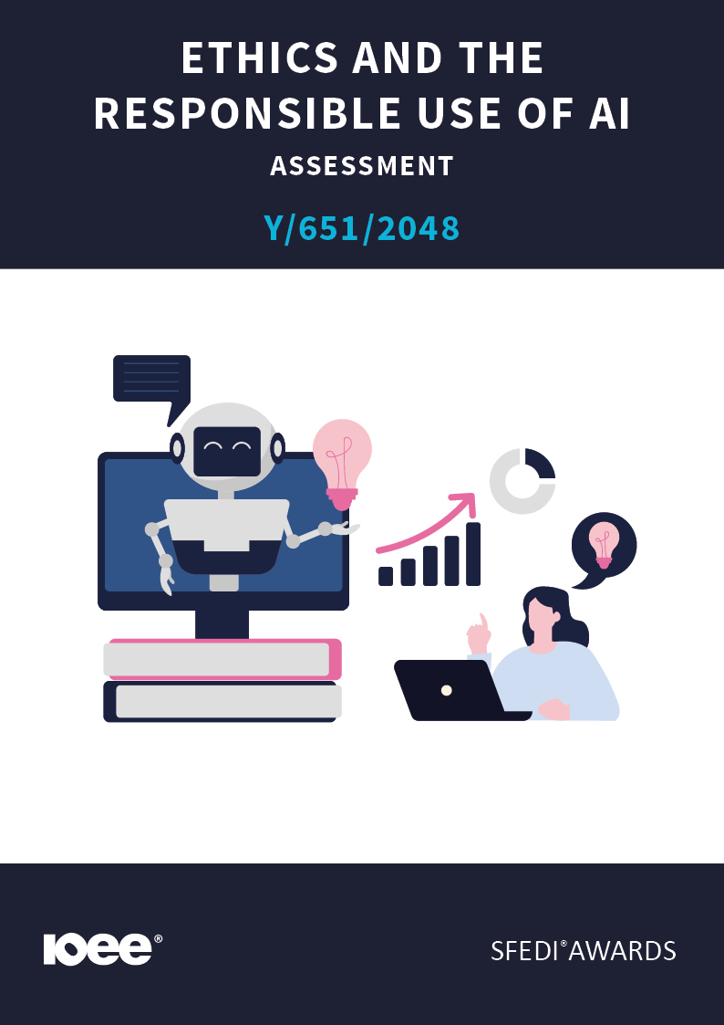
Introduction
This learning content has been developed so that you are able to understand and explore the topic at hand. This will allow you to complete the activity book and activities to earn the qualification. The workbook will allow you to demonstrate your knowledge and skills in relation to the ethics and responsible use of Artificial Intelligence (AI).
There are different sections that make up the workbook in order to make sure you are able to complete all of the tasks necessary, but you will be provided with support as you move along by your Assessor.
Further learning materials and support are available through your studying membership of the Institute of Enterprise and Entrepreneurs (IOEE). If you haven’t yet received your login, please speak to your Assessor who will be happy to sort this out for you.
This unit contains two learning outcomes and will support you to be able to:
- Understand ethical considerations in Artificial Intelligence.
Recognise the importance of responsible AI use in business and society.
The evidence within this workbook will be assessed by:
Assessor Name:
and will be quality assured by,
Internal Quality Assurer Name

Your Assessor will support you to plan how best to demonstrate your knowledge and skills which may be through the completion of the activities within this workbook or may include additional tasks best suited to you.

If any additional tasks are to be completed these will be listed in the table below with target dates for which you should try your best to complete each task listed.

Task | Target Date | Re-planned Target Date

Completion of the activities included within this workbook

By signing below, you agree to completing the work as detailed above and working with your Assessor to achieve this by the deadlines indicated.

Learner Name:

Signature:

Date:

Assessor Name:

Signature:

Date:

Activity One
AI is used to make decisions, analyse data, and communicate with people — but it can also raise important moral questions.
List at least three key ethical issues that can arise when using AI.
Explain briefly why each one could be a problem.
ISSUE
Why is it a problem?

ISSUE
Why is it a problem?

ISSUE
Why is it a problem?

Activity Two

Ethical AI use means thinking about fairness, honesty, and the impact decisions might have on people.
In your own words, explain why it is important to use AI ethically in business and society.
What could happen if AI is used unethically?

Activity Three
AI risks can often be reduced by planning ahead and using systems carefully.
Describe two ways that people or organisations can reduce or avoid ethical risks when using AI systems.
1
2

Activity Four
Being open about how AI is used builds trust and helps people understand when they are interacting with a computer, not a human.
Explain why businesses should be transparent about when and how they use AI (for example, chatbots, data analysis, or decision-making).

Activity Five
Even when AI makes mistakes, it’s still the people who use it who are responsible for the outcomes.
Why should people and businesses take responsibility for the results produced by AI systems? Give an example of how responsibility can be shown in practice.

WHY:

EXAMPLE:

Activity Six
Using AI responsibly helps ensure that technology supports people, rather than replacing or harming them.
List at least three best practices for using AI responsibly in business (for example, fairness, privacy, or human oversight). For each one, explain briefly why it matters.

BEST PRACTICE

WHY:

BEST PRACTICE

WHY:

BEST PRACTICE

WHY:

Activity Mapping

Assessment Criterion – The Learner can: | Activity Number: | Assessor Signed Off (✓/✗):
1.1 Identify key ethical issues related to AI. | 1
1.2 Explain the importance of ethical AI usage. | 2
1.3 Describe how to mitigate ethical risks in AI applications. | 3
2.1 Explain why it is important to be open and clear about how AI is used. | 4
2.2 Describe why it is important to take responsibility when using AI. | 5
2.3 Identify best practices for responsible AI use in a business setting. | 6

Assessor Feedback

Authenticity Declarations

Learner Declaration
By signing this declaration, you agree that the evidence provided within this workbook has been produced by you and meets the requirements of being authentic, sufficient, valid and current to the standards required.

Learner Signature:

Date:

Assessor Declaration
By signing this declaration, you agree that you have assessed all of the evidence produced within this workbook and have ensured that the work is that of the learner. You are also declaring that during the learning process you have ensured that the evidence is authentic, sufficient, valid and current to the standards required.

Assessor Signature:

Date:

IQA Signature (if applicable):

Date:

Additional Evidence Forms

