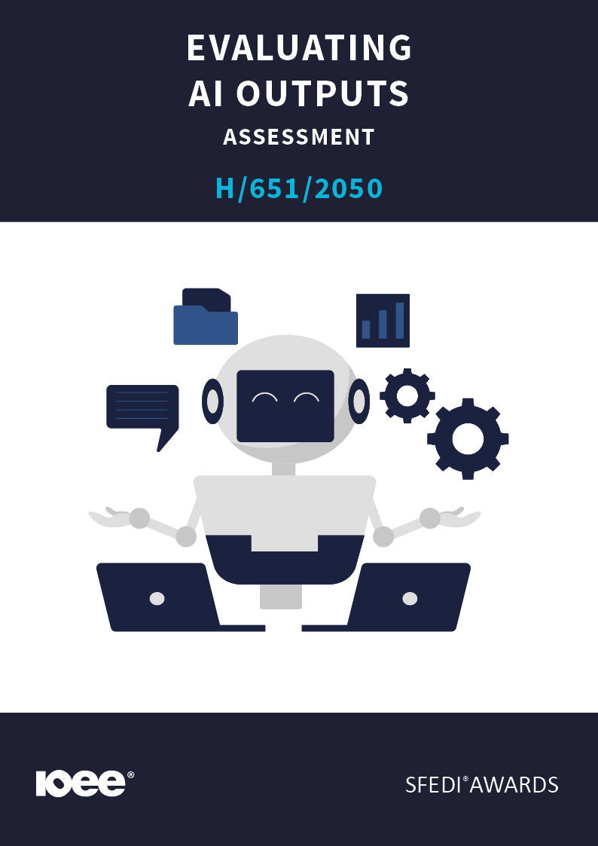
Introduction
This learning content has been developed so that you are able to understand and explore the topic at hand. This will allow you to complete the activity book and activities to earn the qualification. The workbook will allow you to demonstrate your knowledge and skills in relation to evaluating the quality and accuracy of AI outputs.
There are different sections that make up the workbook in order to make sure you are able to complete all of the tasks necessary, but you will be provided with support as you move along by your Assessor.
Further learning materials and support are available through your studying membership of the Institute of Enterprise and Entrepreneurs (IOEE). If you haven’t yet received your login, please speak to your Assessor who will be happy to sort this out for you.
This unit contains two learning outcomes and will support you to be able to:
- Understand how to assess AI-generated outputs for accuracy and reliability.
- Be able to evaluate and improve AI-generated outputs for business use.
The evidence within this workbook will be assessed by:
Assessor Name:
and will be quality assured by,
Internal Quality Assurer Name

Your Assessor will support you to plan how best to demonstrate your knowledge and skills which may be through the completion of the activities within this workbook or may include additional tasks best suited to you.

If any additional tasks are to be completed these will be listed in the table below with target dates for which you should try your best to complete each task listed.

Task | Target Date | Re-planned Target Date

Completion of the activities included within this workbook

By signing below, you agree to completing the work as detailed above and working with your Assessor to achieve this by the deadlines indicated.

Learner Name:

Signature:

Date:

Assessor Name:

Signature:

Date:

Activity One
AI tools can produce quick and detailed answers, but they’re not always correct.
In your own words, explain why it’s important to check AI-generated information before using it in a business or professional setting.

Activity Two

Sometimes AI can sound confident even when it’s wrong.
Describe two possible problems that could happen if AI-generated answers are used without being reviewed or verified.
1
2

Activity Three
There are clear signs that can help you decide whether an AI’s response is trustworthy.
List at least three things you should check to decide whether an AI’s answer is accurate, relevant, and useful for your purpose.
1
2
3

Activity Four
AI information should always be compared with reliable sources like websites, reports, or trusted data.
Choose an AI-generated response and explain how you checked it for accuracy using other trusted sources. What did you find out?

INPUT:

AI RESPONSE:

HOW DID YOU CHECK IT AND WHAT DID YOU FIND OUT? INCLUDE SCREENSHOTS WHERE RELEVANT:

Activity Five
AI outputs can often be improved by asking clearer questions or giving more detail.
Describe two ways you can improve AI’s answers so they meet business requirements more effectively.

1
2

Activity Mapping

Assessment Criterion – The Learner can: | Activity Number: | Assessor Signed Off (✓/✗):
1.1 Explain why it is important to check AI’s answers. | 1
1.2 Describe what could happen if AI outputs are not checked. | 2
2.1 List things to look for to decide if AI’s answers are correct and useful. | 3
2.2 Demonstrate how to check AI’s answers against reliable sources. | 4
2.3 Describe ways to make AI’s answers better for business needs. | 5

Assessor Feedback

Authenticity Declarations

Learner Declaration
By signing this declaration, you agree that the evidence provided within this workbook has been produced by you and meets the requirements of being authentic, sufficient, valid and current to the standards required.

Learner Signature:

Date:

Assessor Declaration
By signing this declaration, you agree that you have assessed all of the evidence produced within this workbook and have ensured that the work is that of the learner. You are also declaring that during the learning process you have ensured that the evidence is authentic, sufficient, valid and current to the standards required.

Assessor Signature:

Date:

IQA Signature (if applicable):

Date:

Additional Evidence Forms

