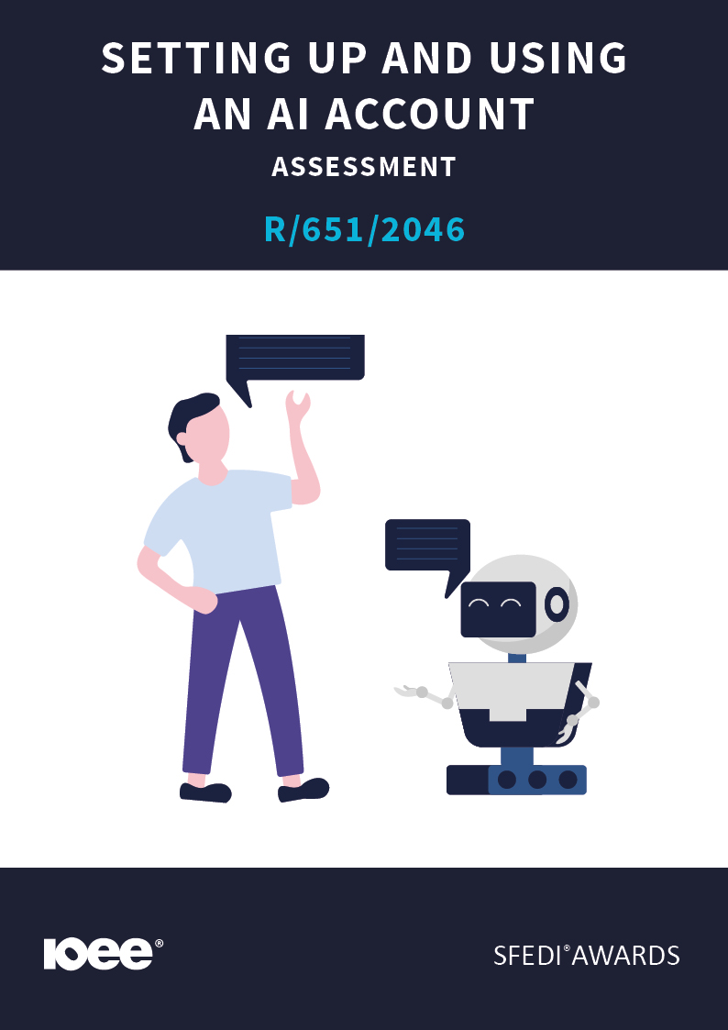
Introduction
This learning content has been developed so that you are able to understand and explore the topic at hand. This will allow you to complete the activity book and activities to earn the qualification. The workbook will allow you to demonstrate your knowledge and skills in relation to setting up and using an AI account.
There are different sections that make up the workbook in order to make sure you are able to complete all of the tasks necessary, but you will be provided with support as you move along by your Assessor.
Further learning materials and support are available through your studying membership of the Institute of Enterprise and Entrepreneurs (IOEE). If you haven’t yet received your login, please speak to your Assessor who will be happy to sort this out for you.
This unit contains two learning outcomes and will support you to be able to:
- Understand the process of setting up an AI account.
- Understand the basic functionalities of an AI platform.
The evidence within this workbook will be assessed by:
Assessor Name:
and will be quality assured by,
Internal Quality Assurer Name

Your Assessor will support you to plan how best to demonstrate your knowledge and skills which may be through the completion of the activities within this workbook or may include additional tasks best suited to you.

If any additional tasks are to be completed these will be listed in the table below with target dates for which you should try your best to complete each task listed.

Task | Target Date | Re-planned Target Date

Completion of the activities included within this workbook

By signing below, you agree to completing the work as detailed above and working with your Assessor to achieve this by the deadlines indicated.

Learner Name:

Signature:

Date:

Assessor Name:

Signature:

Date:

Activity One
Artificial Intelligence (AI) platforms come in many forms, such as chatbots, image generators, or business assistants.
Before exploring how to use them, it’s important to know what tools are available to you.
Identify some popular AI tools and platforms available for beginners:
1
2
3

Activity Two
Each AI platform has its own setup process. Some might require you to register with an email address or mobile number, while others might link to an existing account (e.g., Google or Microsoft).
Describe the steps needed to create an account on a chosen AI platform:

Activity Three
Most AI platforms will guide you through verification and setup, such as confirming your email address or accepting terms of use.
Demonstrate that you know how to navigate the account setup process, including verification and initial configuration. Include screenshots of your initial setup below.

ADD SCREENSHOTS BELOW:

NOTE: Witness Testimony Is Also Accepted To Demonstrate Your Skills.

Activity Four
Once your account is ready, it’s useful to understand the main parts of the user interface. This will help you navigate the system confidently.
Identify the main elements of the user interface on your chosen AI platform (for example: chat box, toolbar, history, settings):
Chatbox | Add Screenshot
History | Add Screenshot
Settings | Add Screenshot
Image/File Upload | Add Screenshot

Activity Five
Most AI platforms offer several built-in tools such as writing assistants, coding helpers, or idea generators.
Describe the basic features and tools available on the AI platform you are using:

Activity Six
Now that you’ve explored your AI platform, try completing some initial tasks. This will help you understand how it can support your work.
Demonstrate some initial tasks using your chosen AI platform, such as generating text or answering simple questions. Describe the task you performed and provide a screenshot of the output:

TASK

ADD SCREENSHOT

TASK

ADD SCREENSHOT

TASK

ADD SCREENSHOT

Activity Mapping

Assessment Criterion – The Learner can: | Activity Number: | Assessor Signed Off (✓/✗):
1.1 Identify popular AI tools and platforms available for beginners. | 1
1.2 Describe the steps to create an account on a chosen AI platform. | 2
1.3 Demonstrate how to navigate the account setup process, including verification and initial configuration. | 3
2.1 Identify the main elements of the user interface of an AI platform. | 4
2.2 Describe the basic features and tools available on an AI platform. | 5
2.3 Demonstrate initial tasks using the AI platform, such as generating text and answering simple questions. | 6

Assessor Feedback

Authenticity Declarations

Learner Declaration
By signing this declaration, you agree that the evidence provided within this workbook has been produced by you and meets the requirements of being authentic, sufficient, valid and current to the standards required.

Learner Signature:

Date:

Assessor Declaration
By signing this declaration, you agree that you have assessed all of the evidence produced within this workbook and have ensured that the work is that of the learner. You are also declaring that during the learning process you have ensured that the evidence is authentic, sufficient, valid and current to the standards required.

Assessor Signature:

Date:

IQA Signature (if applicable):

Date:

Additional Evidence Forms

