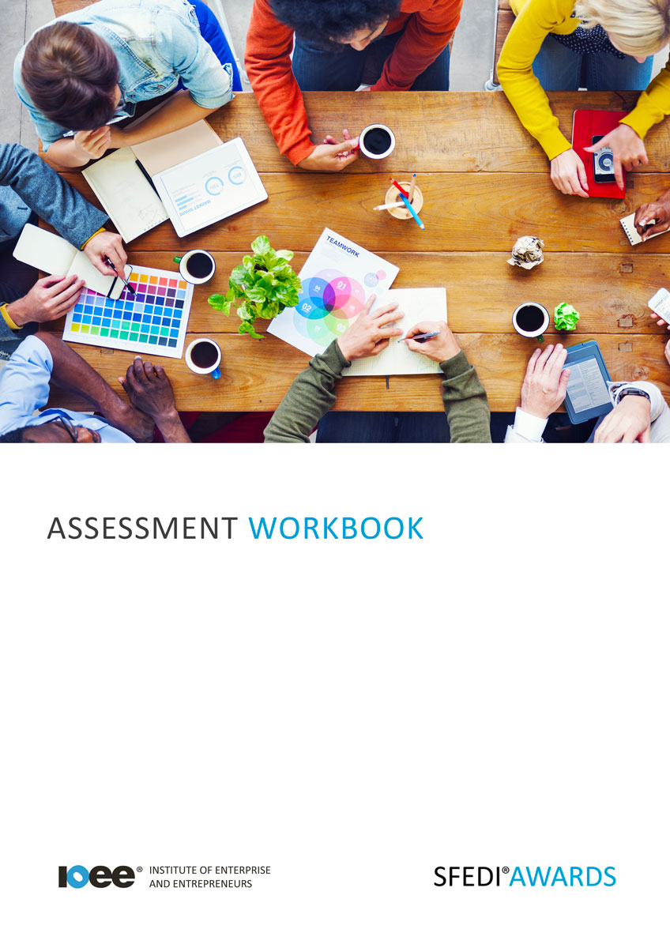

Being Safe and Healthy at Work
Y/615/2296

Copyright © 2020 SFEDI Enterprises Ltd

All rights reserved. This book or any portion thereof may not be reproduced or used in any manner whatsoever without the express written permission of the publisher (address below).

Approved SFEDI Awards centres and learners undertaking a SFEDI Awards qualification may photocopy this document free of charge and/or include a PDF version on its intranet where it is only done so for the purposes of the approved delivery of this qualification.

SFEDI Enterprises Ltd t/a SFEDI Awards
19 Victoria Road
Darlington
DL1 5SF
www.sfedigroup.com

Every effort has been made to ensure that the information contained in this publication is true and accurate at the time of publication. However, SFEDI Enterprises t/a SFEDI Awards strives to continually develop and improve our qualifications and, as such, there may be occasions where changes are required. SFEDI Enterprises t/a SFEDI Awards does not accept liability for any loss or damage arising from the use of the information contained within this publication.

Introduction

This workbook has been developed so that you are able to collect and present evidence that demonstrates your knowledge and skills in relation to being safe and healthy at work.

There are different sections that make up this workbook in order to make sure you are able to complete all of the tasks necessary but you will be provided with support as you move along by your Assessor.

Further learning materials and support is available through your studying membership of the Institute of Enterprise and Entrepreneurs. If you haven’t yet received your login please speak to your Assessor who will be happy to sort this out for you.
This unit contains two learning outcomes and will support you to be able to:

- Be aware of the health and safety rules and framework that governs own and group behaviour in places of work
- Demonstrate awareness of health and safety legislation relevant to themselves and others in a particular workplace
The evidence within this workbook will be assessed by,

Assessor Name:

and will be quality assured by,

Internal Quality Assurer Name:

Your Assessor will support you to plan how best to demonstrate your knowledge and skills which may be through the completion of the activities within this workbook or may include additional tasks best suited to you.

If any additional tasks are to be completed these will be listed in the table below with target dates for which you should try your best to complete each task listed.

Task | Target Date | Re-planned Target Date
Completion of the activities included within this workbook

By signing below you agree to completing the work as detailed above and working with your Assessor to achieve this by the deadlines indicated.

Learner Name: | Signature: | Date:
Assessor Name: | Signature: | Date:

Activities

Activity 1

Using the table below identify examples of safe and appropriate and unsafe and inappropriate behaviour within the workplace

Safe and Appropriate Behaviour | Unsafe and Inappropriate Behaviour
1 | 1
2 | 2

Using the examples of unsafe and inappropriate behaviour you have identified, list the types of
accidents or problems that they could cause within the workplace

Activity 3
Using the box below, identify ways in which an organisation can help to combat unsafe and inappropriate behaviours within the workplace and how this can help to reduce the risk of accidents or problems occurring

Now it’s time to put your understanding of safe and appropriate behaviour to practice. Your Assessor will now observe you behaving in a safe and appropriate manner in a professional setting and sign the below declaration once this has been completed.
As the Assessor for I confirm that I have witnessed them behave
consistently in a safe and appropriate manner in a professional setting.

Assessor Name: Signature: Date:

Activity Mapping

Now you have completed the activities to demonstrate your knowledge and skills it is time for your Assessor to map your work against the standards listed below.
By doing this they will be making sure that the work you have provided by completing the activities
meets the requirements for you to gain your certificate.

Your Assessor will provide you with feedback on how you have done and whether any more work may be required.

Assessment Criterion - The learner can: | Activity Number or Reference Number of Additional Activities: | Assessor Signed  Off (✓/✗):
Identify what constitutes safe and appropriate behaviour in places of work | 1
Recognise what constitutes inappropriate and unsafe behaviour in places of work | 1
Provide examples of the accidents or problems that can result of inappropriate behaviour in two different places of work | 2
Behave in a safe and appropriate manner in a place of work | 4
Review the risks associated with inappropriate behaviour in a particular place of work | 1/2/3

Assessor Feedback

Authenticity Declarations

Learner Declaration

By signing this declaration you agree that the evidence provided within this workbook has been produced by you and meets the requirements of being authentic, sufficient, valid and current to the standards required.

Learner Signature: Date:

Assessor Declaration

By signing this declaration you agree that you have assessed all of the evidence produced within this workbook and have ensured that the work is that of the learner. You are also declaring that during the learning process you have ensured that the evidence is authentic, sufficient, valid and current to the standards required.

Assessor Signature: Date:

IQA Signature (if applicable): Date:

Additional Evidence Forms

Use these additional forms in order to record additional evidence for the activities within this workbook where additional space is required.

Ensure that each piece of evidence entered on these forms is clearly labelled with the corresponding activity number.

SFEDI Awards
19 Victoria Road
Darlington
DL1 5SF

customerservices@sfediawards.com 0845 224 5928
@sfediawards

