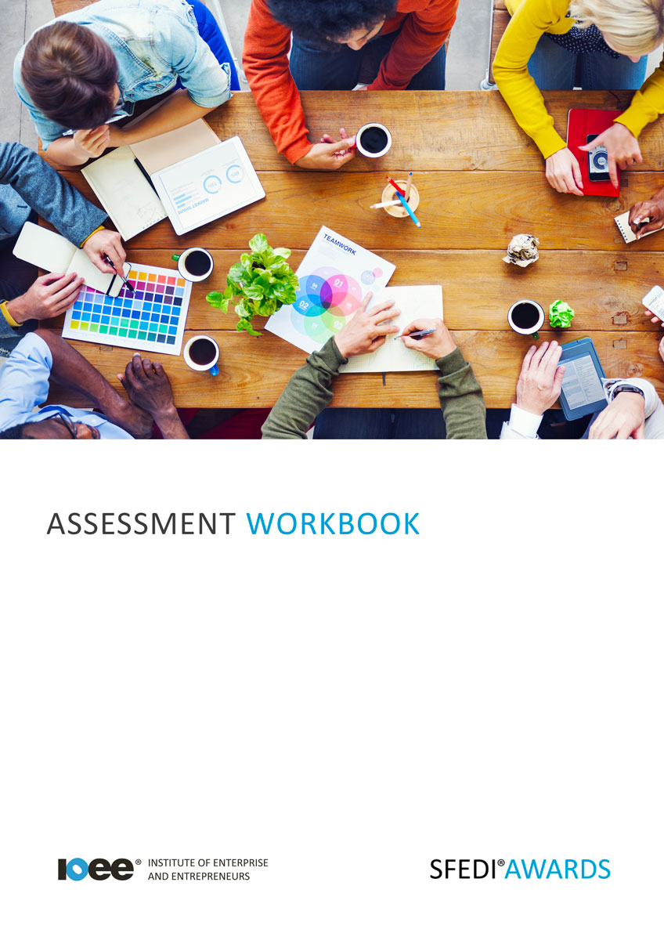

Communication Skills Y/615/2251

Copyright © 2020 SFEDI Enterprises Ltd

All rights reserved. This book or any portion thereof may not be reproduced or used in any manner whatsoever without the express written permission of the publisher (address below).

Approved SFEDI Awards centres and learners undertaking a SFEDI Awards qualification may photocopy this document free of charge and/or include a PDF version on its intranet where it is only done so for the purposes of the approved delivery of this qualification.

SFEDI Enterprises Ltd t/a SFEDI Awards
19 Victoria Road
Darlington
DL1 5SF
www.sfedigroup.com

Every effort has been made to ensure that the information contained in this publication is true and accurate at the time of publication. However, SFEDI Enterprises t/a SFEDI Awards strives to continually develop and improve our qualifications and, as such, there may be occasions where changes are required. SFEDI Enterprises t/a SFEDI Awards does not accept liability for any loss or damage arising from the use of the information contained within this publication.

Introduction

This workbook has been developed so that you are able to collect and present evidence that demonstrates your knowledge and skills in relation to communication skills.

There are different sections that make up this workbook in order to make sure you are able to complete all of the tasks necessary but you will be provided with support as you move along by your Assessor.

Further learning materials and support is available through your studying membership of the Institute of Enterprise and Entrepreneurs. If you haven’t yet received your login please speak to your Assessor who will be happy to sort this out for you.
This unit contains three learning outcomes and will support you to be able to:
- Understand what is meant by effective communication
- Understand the impact of effective communication
- Understand how to develop own communication skills
The evidence within this workbook will be assessed by,

Assessor Name:

and will be quality assured by,

Internal Quality Assurer Name:

Your Assessor will support you to plan how best to demonstrate your knowledge and skills which may be through the completion of the activities within this workbook or may include additional tasks best suited to you.

If any additional tasks are to be completed these will be listed in the table below with target dates for which you should try your best to complete each task listed.

Task | Target Date | Re-planned Target Date
Completion of the activities included within this workbook

By signing below you agree to completing the work as detailed above and working with your Assessor to achieve this by the deadlines indicated.

Learner Name: | Signature: | Date:
Assessor Name: | Signature: | Date:

Activities

Activity 1

Using the box below, provide a definition for the term ‘effective communication’ that would help another person to understand what it means. Make sure to use examples of what would be considered to be effective communication and explain why it is effective.

Effective communication is…

Activity 2

Effective communication can have an impact in many different situations and with many different people or groups of people. Using the boxes below, explain how effective communication can impact on:
Other people’s perceptions of your own character

Your own levels of self-esteem and self-belief

The achievement of your own personal goals

Activity 3

Think of the situations when you have applied your communication skills effectively and describe a situation, the skills you used and why it was effective. Think about what happened, how you applied the communication skills, how it had a positive impact and what you learnt in order to help you develop in the future

8

Activity 4

So far you have discussed the importance of effective communication and how you have used it to the benefit of yourself and others you live or work with but just because you are able to communicate effectively doesn’t mean you should stop developing. Everyone can always improve their skills in some way.

Use the table below to select aspects of your own communication skills that you would like to develop further and the reasons why you have selected those particular skills for development

Communication skill | Why have you selected this particular skill for development?

9

Activity 5

Now use the table below to plan how you can develop the communication skills you have identified. Think about the activities to be completed,
the timescales for the activities to take place and the method you can use to review how successful the activities are in helping you to develop

Communication skill | Activity to be completed | Deadline for completion | Method of reviewing success of the outcome on your own development

Activity Mapping

Now you have completed the activities to demonstrate your knowledge and skills it is time for your Assessor to map your work against the standards listed below.
By doing this they will be making sure that the work you have provided by completing the activities
meets the requirements for you to gain your certificate.

Your Assessor will provide you with feedback on how you have done and whether any more work may be required.

Assessment Criterion - The learner can: | Activity Number or Reference Number of Additional Activities: | Assessor Signed  Off (✓/✗):
Explain what is meant by effective communication | 1
Describe situations when own communication skills  were used effectively | 3
Explain how effective communication skills are important for the development of own enterprising character | 3/4/5
Explain how effective communication can have an  impact on:  - other people’s perceptions of own enterprising character  - own self-esteem and self-belief  - achievement of personal goals | 2
Select aspects of own communication skills to be developed | 4
Explain why these have been selected | 4
Plan activities to develop the aspects identified  including:  - activity to be completed  - timescales for the activity to take place  - method of reviewing the outcome of the activity | 5

Assessor Feedback

Authenticity Declarations

Learner Declaration

By signing this declaration you agree that the evidence provided within this workbook has been produced by you and meets the requirements of being authentic, sufficient, valid and current to the standards required.

Learner Signature: Date:

Assessor Declaration

By signing this declaration you agree that you have assessed all of the evidence produced within this workbook and have ensured that the work is that of the learner. You are also declaring that during the learning process you have ensured that the evidence is authentic, sufficient, valid and current to the standards required.

Assessor Signature: Date:

IQA Signature (if applicable): Date:

Additional Evidence Forms

Use these additional forms in order to record additional evidence for the activities within this workbook where additional space is required.

Ensure that each piece of evidence entered on these forms is clearly labelled with the corresponding activity number.

SFEDI Awards
19 Victoria Road
Darlington
DL1 5SF

customerservices@sfediawards.com 0845 224 5928
@sfediawards

