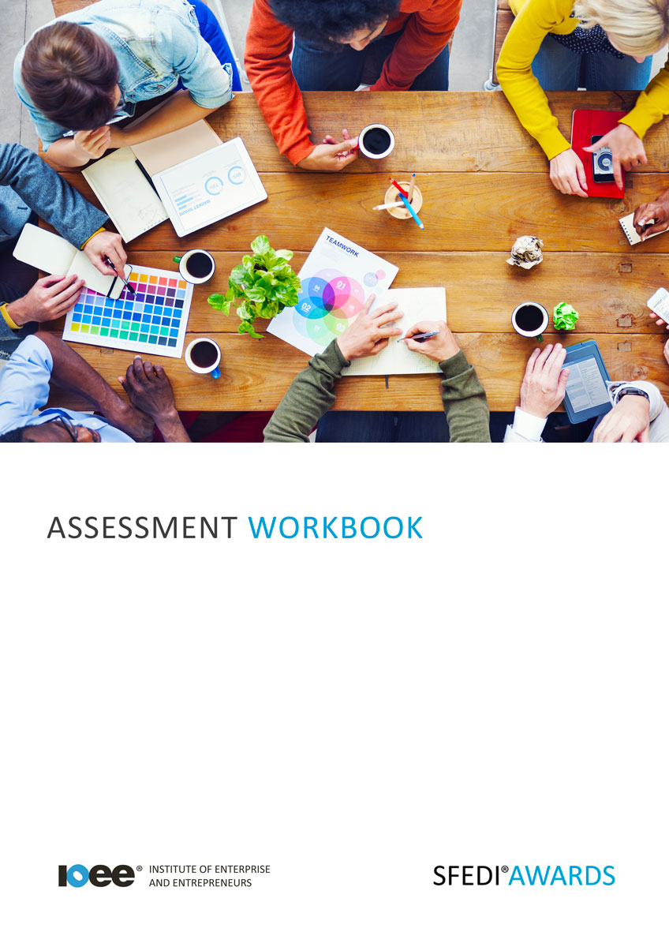

Completing Voluntary Work
H/615/2270

Copyright © 2020 SFEDI Enterprises Ltd

All rights reserved. This book or any portion thereof may not be reproduced or used in any manner whatsoever without the express written permission of the publisher (address below).

Approved SFEDI Awards centres and learners undertaking a SFEDI Awards qualification may photocopy this document free of charge and/or include a PDF version on its intranet where it is only done so for the purposes of the approved delivery of this qualification.

SFEDI Enterprises Ltd t/a SFEDI Awards
19 Victoria Road
Darlington
DL1 5SF
www.sfedigroup.com

Every effort has been made to ensure that the information contained in this publication is true and accurate at the time of publication. However, SFEDI Enterprises t/a SFEDI Awards strives to continually develop and improve our qualifications and, as such, there may be occasions where changes are required. SFEDI Enterprises t/a SFEDI Awards does not accept liability for any loss or damage arising from the use of the information contained within this publication.

Introduction

This workbook has been developed so that you are able to collect and present evidence that demonstrates your knowledge and skills in relation to completing voluntary work.

There are different sections that make up this workbook in order to make sure you are able to complete all of the tasks necessary but you will be provided with support as you move along by your Assessor.

Further learning materials and support is available through your studying membership of the Institute of Enterprise and Entrepreneurs. If you haven’t yet received your login please speak to your Assessor who will be happy to sort this out for you.
This unit contains two learning outcomes and will support you to be able to:
- Understand the role volunteers play in different volunteering situations
- Be able to complete voluntary work
The evidence within this workbook will be assessed by,

Assessor Name:

and will be quality assured by,

Internal Quality Assurer Name:

Your Assessor will support you to plan how best to demonstrate your knowledge and skills which may be through the completion of the activities within this workbook or may include additional tasks best suited to you.

If any additional tasks are to be completed these will be listed in the table below with target dates for which you should try your best to complete each task listed.

Task | Target Date | Re-planned Target Date
Completion of the activities included within this workbook

By signing below you agree to completing the work as detailed above and working with your Assessor to achieve this by the deadlines indicated.

Learner Name: | Signature: | Date:
Assessor Name: | Signature: | Date:

Activities

Activity 1

Using the table below, identify different situations where volunteers can be useful and explain why they are important in helping and what benefits they can bring

Example situation | Why are they important in helping and what benefits can  they bring

6

Activity 2

Using the table below, identify examples of different voluntary roles and list the abilities, behaviours, knowledge and skills that a person would require so that they could carry them out effectively

Example voluntary role | Abilities, behaviours, knowledge and skills required to carry out the role

7

Now think about your own current abilities, behaviours, knowledge and skills against those you have identified. How could you develop those
that you don’t currently have and so increase the chances of success when applying for a volunteering role?

Ability, behaviour, knowledge or skill to be developed | Activity to be completed | Deadline for completion | Method of reviewing success of the outcome on your own development

Activity 3

So now you understand the importance of volunteers and the benefits they can provide and you also understand the abilities, behaviours, knowledge and skills required to undertake a volunteering role. Now it’s time to apply for your own.

Where did you find the
volunteering opportunity?

Organisation name:

Description of the volunteer position
(What do they want you to do? Where is it based? How long will it last? Will you be working on your
own or in a team?)

Now it’s time to make that application but before you do, it’s important to have a punchy introduction for your application form or introductory letter to get the organisation to take notice of you. In the space below practice your opening statement so that it best demonstrates your positive points and how they match what they need in a volunteer.
Don’t forget to keep it short and to the point, you don’t want to lose their attention!

Now gather some feedback from others on your opening statement and make any changes that you
need to, writing the final statement below.

It’s time to complete your application for the volunteering opportunity and submit it using the method as set out in the advert.
As the Assessor for I confirm that I have witnessed them complete
and submit the application as required by the tasks having prepared fully to promote themselves positively against the requirements of the volunteering opportunity.

Assessor Name: Signature: Date:

Activity 4

Use the boxes below to keep a reflective diary of your work and experiences while carrying out the voluntary activity. What did you do? What did you learn about yourself and your abilities, behaviours, knowledge and skills? How did you develop as a person? How will you use this experience in the future?

Date:

Date:

Date:

Date:

Date:

Date:

Activity Mapping

Now you have completed the activities to demonstrate your knowledge and skills it is time for your Assessor to map your work against the standards listed below.
By doing this they will be making sure that the work you have provided by completing the activities
meets the requirements for you to gain your certificate.

Your Assessor will provide you with feedback on how you have done and whether any more work may be required.

Assessment Criterion - The learner can: | Activity Number or Reference Number of Additional Activities: | Assessor Signed  Off (✓/✗):
Identify different situations where volunteers are  used | 1
Explain why the role of volunteers is important in different volunteering situations | 1
Identify the skills required for different types of  voluntary work | 2
Apply for voluntary work, adhering to application requirements | 3
Complete a voluntary work activity according to a given brief | 4

Assessor Feedback

Authenticity Declarations

Learner Declaration

By signing this declaration you agree that the evidence provided within this workbook has been produced by you and meets the requirements of being authentic, sufficient, valid and current to the standards required.

Learner Signature: Date:

Assessor Declaration

By signing this declaration you agree that you have assessed all of the evidence produced within this workbook and have ensured that the work is that of the learner. You are also declaring that during the learning process you have ensured that the evidence is authentic, sufficient, valid and current to the standards required.

Assessor Signature: Date:

IQA Signature (if applicable): Date:

Additional Evidence Forms

Use these additional forms in order to record additional evidence for the activities within this workbook where additional space is required.

Ensure that each piece of evidence entered on these forms is clearly labelled with the corresponding activity number.

SFEDI Awards
19 Victoria Road
Darlington
DL1 5SF

customerservices@sfediawards.com 0845 224 5928
@sfediawards

