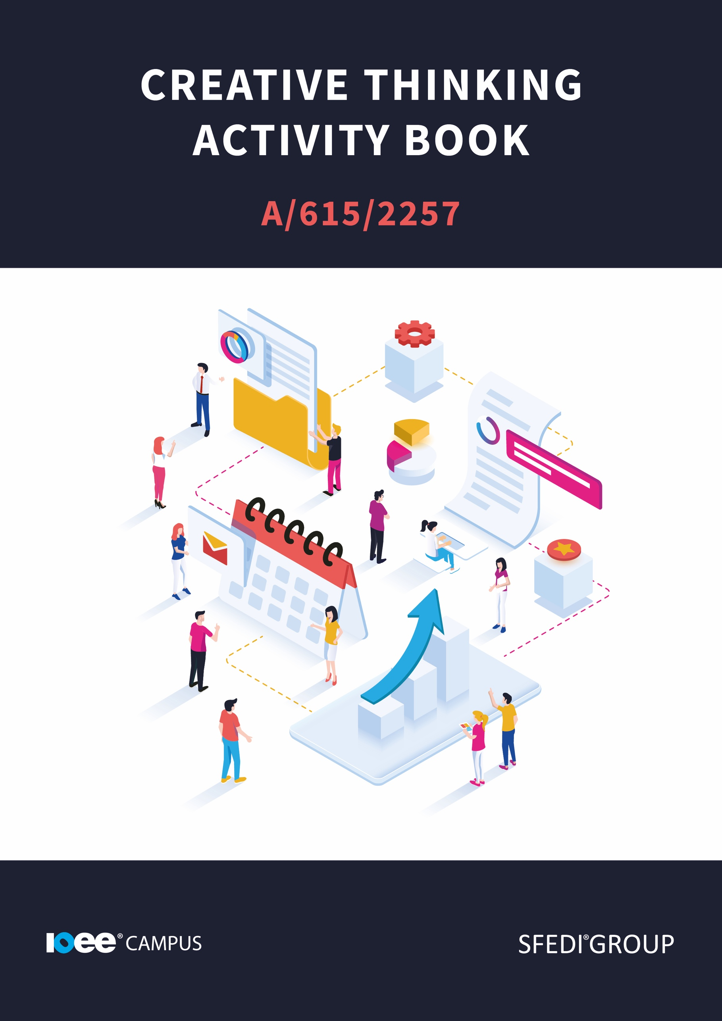

**Introduction**

This learning content has been developed so that you are able to understand and explore the topic at hand. This will allow you to complete the activity book, and activities to earn the qualification. The workbook will allow you to demonstrate your knowledge and skills in relation to creative thinking.

There are different sections that make up the workbook in order to make sure you are able to complete all of the tasks necessary, but you will be provided with support as you move along by your Assessor.

Further learning materials and support is available through your studying membership of the Institute of Enterprise and Entrepreneurs.

If you haven’t yet received your login, please speak to your Assessor who will be happy to sort this out for you.

This unit contains two learning outcomes and will support you to be able to:

* Understand why creative thinking might be or might not be appropriate in different contexts
* Understand how to use tools to come up with a creative idea

The evidence within this workbook will be assessed by,

**Assessor Name:**

and will be quality assured by,

**Internal Quality Assurer Name:**

Copyright © 2020 SFEDI Enterprises Ltd

All rights reserved. This book or any portion thereof may not be reproduced or used in any manner whatsoever without the express written permission of the publisher (address below).

Approved SFEDI Awards centres and learners undertaking a SFEDI Awards qualification may photocopy this document free of charge and/or include a PDF version on its intranet where it is only done so for the purposes of the approved delivery of this qualification.

SFEDI Enterprises Ltd t/a SFEDI Awards

19 Victoria Rd

Darlington

DL1 5SF

www.sfedigroup.com

Every effort has been made to ensure that the information contained in this publication is true and accurate at the time of publication. However, SFEDI Enterprises t/a SFEDI Awards strives to continually develop and improve our qualifications and, as such, there may be occasions where changes are required. SFEDI Enterprises t/a SFEDI Awards does not accept liability for any loss or damage arising from the use of the information contained within this publication.

**Introduction**

**What is Creative thinking?**

Creative thinking is a really important skill to have. When thinking about employability and enterprise, creative thinking is a really useful and quite valuable skill to have. Not only could it give you the edge on the competition, but it can make work more enjoyable, and therefore more efficient.

“Creative thinking is the ability to consider something in a new way. It might be a new approach to a problem, a resolution to a conflict between employees, or a new result from a data set.” (The Balance Careers, 2020).

Creative thinking is a skill that lets a person see things from someone else's point of view, or in a way that has never been considered before. You may know creative thinking by its nickname, thinking outside the box. By thinking outside of the box, you may be able to see new results or faster development of your ideas. But what is this ‘box’ and why do we need to think outside of it to be creative? When we say ‘think outside the box’ we mean, try to see things differently. Explore ideas that may not have been explored before and try to come up with something new.

This skill comes in handy when you are needing to find a solution to an issue you have never come across before, or when you are thinking of a new idea to pursue.

Creative thinking is a really useful skill for those who want to set up a business, but also for everyone to develop. Creative thinking is a useful skill for day-to-day life. It can help you get to work if you missed the bus, or it could help you become the next multi-millionaire.



Your Assessor will support you to plan how best to demonstrate your knowledge and skills which may be through the completion of the activities within this workbook or may include additional tasks best suited to you.

If any additional tasks are to be completed these will be listed in the table below with target dates for which you should try your best to complete each task listed.

|  |  |  |
| --- | --- | --- |
| **Task** | **Target Date** | **Re-planned Target Date** |
| Completion of the activities included within this workbook |  |  |
|  |  |  |
|  |  |  |
|  |  |  |
|  |  |  |
|  |  |  |

By signing below, you agree to completing the work as detailed above and working with your Assessor to achieve this by the deadlines indicated.

**Learner Name:**

**Signature:**

**Date:**

**Assessor Name:**

**Signature:**

**Date:**



**Activity One**

Before looking up a definition, what do you think creative writing is? Make a note of your own definition and see how it compares to the one we will provide later in the document.

Using the box below, provide a definition for the term ‘creative thinking’ that would help another person to understand what it means.

**Creative Thinking means:**

|  |
| --- |
|  |

**Activity Two**

Like all skills, sometimes creative thinking can be a benefit, and sometimes it can actually be a negative trait. This isn't meant to put you off, in fact it's the opposite. If we are aware of our creative thinking and the areas in which we are usually creative, we can identify the areas for development. We are also able to identify where we effectively used creative thinking to bring around those positive ideas or actions.

We have made a short list of some positives and negatives of creative thinking. This list does not include ALL of the positives and negatives, but they should help you to identify a list of your own.

Positives:

* Able to adapt to the project you are working on by thinking of new ideas or new ways of working.
* Can problem solve in ways that may not be the usual way out, but may work better.
* Allows you to see things from different perspectives and you may be able to predict responses to the idea.

Negatives:

* Your creativity may be too abstract and you may make your ideas too deep or they may become irrelevant to the project you are working on.
* Makes you overthink the smaller details so instead of working on the idea, you pinpoint the flaws in details and extras before the basics have been thought of.
* May make you develop ideas past the point of being productive.

Creativity is a great skill / trait to have and develop. Being creative is not only useful in certain situations, but it can also allow you to enjoy your jobs or tasks more. If you enjoy what you are doing, you are more likely to do it to a higher standard (USC, 2021). So finding ways to develop your creativity will allow you to enjoy your job more and come up with new ideas.

Using the table below, provide examples of when creative thinking can be both positive and negative.

|  |  |  |
| --- | --- | --- |
| **Example of creative thinking situation** | **Positive effect it could have** | **Negative effect it could have** |
|  |  |  |
|  |  |  |
|  |  |  |

**Activity Three**

When I think of creativity, I think back to my childhood. I think it is fair to say that most children are creative. As children we play, invent and create as part of our development. Children enjoy being creative, playing or inventing new games or rules. As adults, we may slowly lose this skill, unless we have to use creativity in our lives. An individual may not choose to use this skill if they do not feel like the skill is developed enough. Some people may not enjoy being creative, and so looking at new ways of doing things may be a bit scary for them. But creative thinking will take those ideas to the next level and make us aware of the opportunities that may be hidden if we think in an ordinary way. So what can we do to develop our creative thinking? How can we train ourselves to be creative, even if we may not want to be?

The first step in developing our creative thinking is working on our creativity levels. This could include many activities, from drawing and artistic expression to invention and idea making. In order to be a creative thinker we must be creative individuals, to some extent. Certain activities like photography, mood boards or mind mapping can increase your creativity and allow you to express your ideas.

In certain job roles, some people need to create things such as mood boards and story boards as part of their contribution to the business. These allow the individual to express their creativity and also their ideas. Thinking creatively and recording information creatively can help with engagement. Some people may pay more attention if the information is presented in a creative way.

Creative thinking also allows an individual to change their perspective. Not only in terms of seeing different ideas or coming up with a new idea. Changing perspective could actually mean physically changing your stance. Moving location, getting new inspiration or finding new ways of life / culture. These new perspectives could lead to new ideas or new ways of doing things.

**Reflection: Think back to a time where you have done something creative. What activities were you doing? Did you enjoy being creative?**

Various techniques can be used to encourage your own creative thinking and develop that skill.

Let's have a look over some examples.

**Artistic expression**

Exploring your artistic side is a great way to think creatively and get your ideas out there. Possibly one of the most direct means of creative thinking, artistic expression uses your artistic skills to convey a message or information. Creating mood boards, collages or even drawings can help express what you mean by an idea, whilst also being creative. By providing a visual tool, you are allowing your audience to see what you are thinking, they don't have to rely on hearing it. The visual tool also allows them to see things that you may miss off, if you were to rely on speech alone. So using your artistic skills to convey your message is a brilliant way to exercise your creative thinking skills. The use of a visual tool also allows those who may be hard of hearing or deaf to understand your idea. Adding extra layers of access for those who may need it will increase your reach and make sure that everyone you are talking to is able to access the information you are providing. People who may be listening to a speech or lecture may also disengage from the audio and their mind may wander. By providing a visual element to work alongside the speech you have prepared, you will engage with your listeners more and keep their attention on you.

**Out of the Box thinking**

One of the most well known examples of creative thinking, this skill requires you to think a bit differently. When some people see a broken watering can, an ‘out of the box’ thinker would see a plant pot. Being able to look at a situation or item and seeing many different potentials for that thing, that is out of the box thinking. It is taking the normal and making it into something extraordinary. The ability to see things in a different way, take yourself out of the box and allow yourself the creative freedom to explore and experiment is a really valuable skill.

**Problem solving**

Now, problem solving may not sound all that creative, but sometimes a problem may need you to work outside of your normal boundaries. Sometimes you may need to be creative to come up with a solution. Creative thinking really helps with problem solving, as you may be able to see the problem as an opportunity rather than a negative. This change in perspective may allow you to excel and pass your goal. And all of this came from a problem.

**Analytical mind**

Being analytical may not be the first thing you think of when you think about creativity. Analysis is quite a creative task, and can lead to some creative opportunities. Not only does analysis require you to read into data and try to understand what the results mean, but it also requires you to then work out a way to present your findings. The combination of both collecting and presenting data, is a really creative task and is one that would likely come up in most of our lives. From visiting a supermarket and needing to understand the deals and prices and then reflect that in our weekly budget, or in a meeting at work, data is all around us and we have to process it all of the time.

The added step that makes this creative thinking is the ability to communicate the findings of the data and sometimes being able to make the data work for you. Specifically in a work environment, sometimes if the data seems to confirm a theory, this data can stand alone as the proof that an idea will work.

Of course there are many other examples of creative thinking, but the short list above allows you to get a taste of creative thinking and should spark a bit of reflection.

**Reflection: can you think of other examples of creative thinking?**

Using the boxes below, identify at least three different ways that creative thinking can be encouraged in

order to come up with new ideas.

**Method One:**

|  |
| --- |
|  |

**Method Two:**

|  |
| --- |
|  |

**Method Three:**

|  |
| --- |
|  |

**Method Four:**

|  |
| --- |
|  |

**Activity Four**

The creative thinking techniques can come in really handy when faced with a challenge. Let's take a look at an example.

**Artistic expression saves the day**

Lauren works for a sales company. As part of her job, she must take orders, and produce a pitch-like discussion with her manager. Her most recent order was a bit more complicated than normal. Lauren tried to think of what she would say and how she would convey what she really needed to say. She spent quite some time on this and then realised that it was almost impossible for her to articulate her idea. She realised this order would need something else to help her explain her vision. This order required her to create a visual tool to help her explain the design. Lauren took a big pad of paper and a chunky marker and drew out the design, including all the measurements and the extra details she couldn’t explain verbally.

Lauren took this tool into the meeting with her and it was a hit. Her manager understood what she was getting at and was able to visually show her some of his own comments and alterations he would make. When the meeting ended, Laurens’s manager commented on her quick thinking and her ability to visually show what she meant.

Use the boxes below to describe the challenge you faced, the solution you designed and how you went about putting that solution into practice.

Don’t forget to be creative, you can use written, photography, videos, etc. as ways of presenting your evidence.

What is the challenge you faced?

|  |
| --- |
|  |

Which of the four methods of encouraging creative thinking did you select to use and why?

|  |
| --- |
|  |

What was the solution to the challenge you came up with and how did you put it into practice?

|  |
| --- |
|  |

Did you solve the challenge? Put an ‘X’ in the box.

**Yes [ ]**

**No [ ]**

What did you learn about yourself as a result of overcoming the challenge? Did you develop your abilities, behaviours, knowledge or skills? Would you have done anything differently?

|  |
| --- |
|  |

**Activity Mapping**

Now you have completed the activities to demonstrate your knowledge and skills it is time for your Assessor to map your work against the standards listed below.

By doing this they will be making sure that the work you have provided by completing the activities meets the requirements for you to gain your certificate.

Your Assessor will provide you with feedback on how you have done and whether any more work may be required.

|  |  |  |
| --- | --- | --- |
| **Assessment Criterion – The Leaner can:** | **Activity Number or Reference Number of Additional Activities:** | **Assessor Signed Off (✓/✗):** |
| Identify what is meant by creative thinking | 1 |  |
| Give an example of how creative thinking can be  positive | 2 |  |
| Give an example of when creative thinking might be inappropriate | 3 |  |
| List three different ways to encourage creative thinking and come up with an idea | 4 |  |
| Use one of these ways to come up with a creative idea to overcome a challenge | 4 |  |

**Assessor Feedback**

|  |
| --- |
|  |

**Authenticity Declarations**

**Learner Declaration**

By signing this declaration, you agree that the evidence provided within this workbook has been produced by you and meets the requirements of being authentic, sufficient, valid and current to the standards required.

**Learner Signature:**

**Date:**

**Assessor Declaration**

By signing this declaration, you agree that you have assessed all of the evidence produced within this workbook and have ensured that the work is that of the learner. You are also declaring that during the learning process you have ensured that the evidence is authentic, sufficient, valid and current to the standards required.

**Assessor Signature:**

**Date:**

**IQA Signature (if applicable):**

**Date:**

**Additional Evidence Forms**

Use these additional forms in order to record additional evidence for the activities within this workbook where additional space is required.

Ensure that each piece of evidence entered on these forms is clearly labelled with the corresponding activity number.

|  |
| --- |
|  |

|  |
| --- |
|  |

|  |
| --- |
|  |

**Helpful Resources & References**

**Useful resources:**

The Dark Side Of Creativity - <https://www.fastcompany.com/90305531/this-is-the-dark-side-of-creativity-that-we-dont-talk-about>

Reinventing Creative Thinking - <https://www.ted.com/talks/luc_de_brabandere_reinventing_creative_thinking#t-65789>

Advantages and Disadvantages of Creativity –

<http://creativityproductivethinking.blogspot.com/2011/04/advantages-disadvantages.html>

**References:**

Examples of creative thinking - <https://www.thebalancecareers.com/creative-thinking-definition-with-examples-2063744>

Liking your job will help you succeed - <https://appliedpsychologydegree.usc.edu/blog/how-liking-your-job-will-help-you-succeed/#:~:text=Being%20happy%20at%20work%20and,mistakes%2C%20and%20better%20business%20decisions>

Analytical Skills - <https://www.thebalancecareers.com/analytical-skills-list-2063729>

SFEDI Awards

19 Victoria Road

Darlington

County Durham

DL1 5SF

customerservices@sfediawards.com

0845 224 5928

@sfediawards