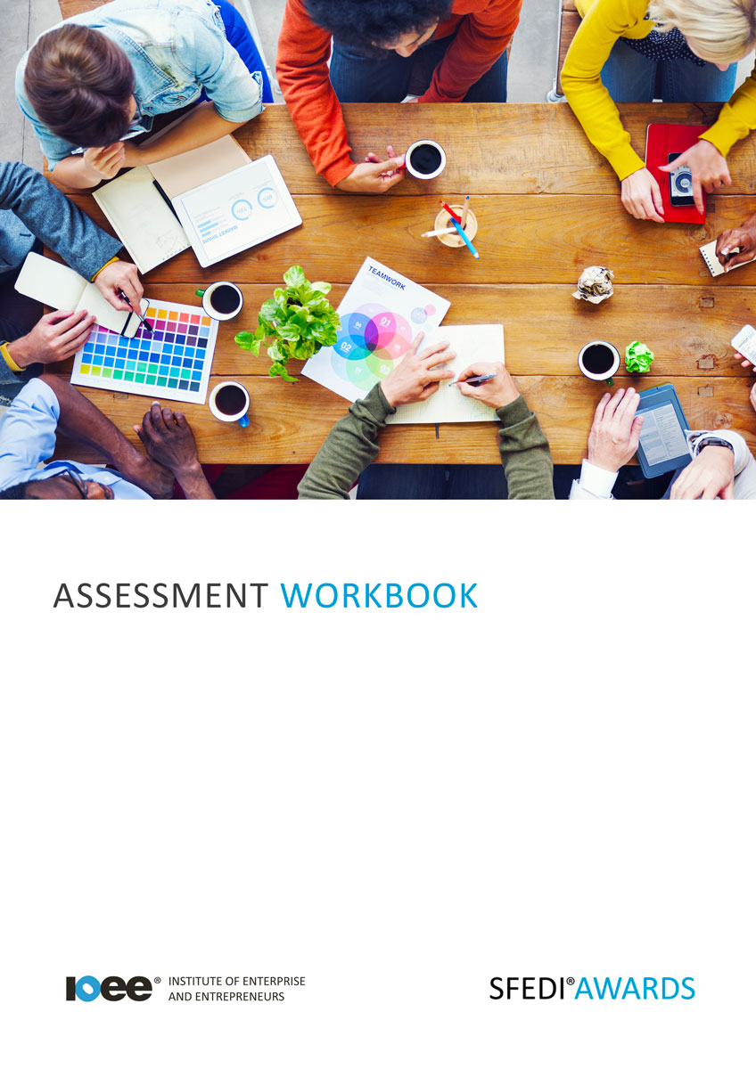

Disclosing Offenses
A/615/2291

Copyright © 2020 SFEDI Enterprises Ltd

All rights reserved. This book or any portion thereof may not be reproduced or used in any manner whatsoever without the express written permission of the publisher (address below).

Approved SFEDI Awards centres and learners undertaking a SFEDI Awards qualification may photocopy this document free of charge and/or include a PDF version on its intranet where it is only done so for the purposes of the approved delivery of this qualification.

SFEDI Enterprises Ltd t/a SFEDI Awards
19 Victoria Road
Darlington
DL1 5SF
www.sfedigroup.com

Every effort has been made to ensure that the information contained in this publication is true and accurate at the time of publication. However, SFEDI Enterprises t/a SFEDI Awards strives to continually develop and improve our qualifications and, as such, there may be occasions where changes are required. SFEDI Enterprises t/a SFEDI Awards does not accept liability for any loss or damage arising from the use of the information contained within this publication.

Introduction

This workbook has been developed so that you are able to collect and present evidence that
demonstrates your knowledge and skills in relation to disclosing offences.

There are different sections that make up this workbook in order to make sure you are able to complete all of the tasks necessary but you will be provided with support as you move along by your Assessor.

Further learning materials and support is available through your studying membership of the Institute of Enterprise and Entrepreneurs. If you haven’t yet received your login please speak to your Assessor who will be happy to sort this out for you.
This unit contains two learning outcomes and will support you to be able to:
- Understand what is meant by disclosure
- Understand the disclosure of offences
The evidence within this workbook will be assessed by,

Assessor Name:

and will be quality assured by,

Internal Quality Assurer Name:

Your Assessor will support you to plan how best to demonstrate your knowledge and skills which may be through the completion of the activities within this workbook or may include additional tasks best suited to you.
If any additional tasks are to be completed these will be listed in the table below with target dates for
which you should try your best to complete each task listed.

Task | Target Date | Re-planned Target Date
Completion of the activities included within this workbook

By signing below you agree to completing the work as detailed above and working with your Assessor
to achieve this by the deadlines indicated.

Learner Name: | Signature: | Date:
Assessor Name: | Signature: | Date:

Activities

Activity 1

Using the box below, provide a definition for the term ‘disclosure’ that would help another person to
understand what it means

Disclosure means…

Activity 2

Using the box below, explain the laws and requirements relating to the disclosure of offences, eg. as
part of job applications

Understanding where to find out information about an individual’s previous offences is important to ensure you can complete an accurate and full disclosure.
Using the boxes below, provide a minimum of two examples of where an individual can access details
of their offences and the process they should follow in which to do so.

Example 1:

Example 2:

Using the box below, provide a definition and an example for the terms ‘spent’ and ‘unspent’ offences
that would help another person to understand what they mean

Spent means…

Unspent means…

The differences between the two are…

Dependent on the workplace or the social setting an individual finds themselves in will depend on whether they have to make a disclosure.

Using the boxes below, provide examples of both workplace and social settings where a disclosure is required and not required

Disclosure required:

Disclosure not required:

Using the box below, provide a definition for the term ‘disclosure statement’ that would help another
person to understand what it means

A disclose statement is…

What are the benefits and negatives of producing a disclosure statement?

Positives | Negatives
The positives of disclosure statements: | The negatives of disclosure statements:

When in job interviews there are guidelines and legal requirements as to what can be asked and
discussed.

Using the box below, explain when disclosure in an interview could be discussed and the benefits to both the interviewer and the interviewee of discussing a disclosure statement.

Activity Mapping

Now you have completed the activities to demonstrate your knowledge and skills it is time for your
Assessor to map your work against the standards listed below.
By doing this they will be making sure that the work you have provided by completing the activities
meets the requirements for you to gain your certificate.
Your Assessor will provide you with feedback on how you have done and whether any more work may
be required.

Assessment Criterion - The learner can: | Activity Number or Reference Number of Additional Activities: | Assessor Signed  Off (✓/✗):
Explain what is meant by disclosure | 1
Identify the legislation and the requirements relating  to disclosure of offences | 2
Provide at least two examples of where an individual can access details of their conviction(s) | 3
Explain the difference between a spent and unspent  conviction and provide one example of each | 4
Identify a situation where an individual would have to disclose a conviction in relation to employment or a societal setting | 5
Identify the purpose of a disclosure statement and the benefits and negatives of producing such a document | 6
Identify scenarios when disclosure within an interview could be discussed and the benefits to both the interviewer and interviewee of discussing a disclosure statement | 7

Assessor Feedback

Authenticity Declarations

Learner Declaration

By signing this declaration you agree that the evidence provided within this workbook has been produced by you and meets the requirements of being authentic, sufficient, valid and current to the standards required.

Learner Signature: Date:

Assessor Declaration

By signing this declaration you agree that you have assessed all of the evidence produced within this workbook and have ensured that the work is that of the learner. You are also declaring that during the learning process you have ensured that the evidence is authentic, sufficient, valid and current to the standards required.

Assessor Signature: Date:

IQA Signature (if applicable): Date:

Additional Evidence Forms

Use these additional forms in order to record additional evidence for the activities within this
workbook where additional space is required.
Ensure that each piece of evidence entered on these forms is clearly labelled with the corresponding
activity number.

SFEDI Awards
19 Victoria Road
Darlington
DL1 5SF

customerservices@sfediawards.com 0845 224 5928
@sfediawards

