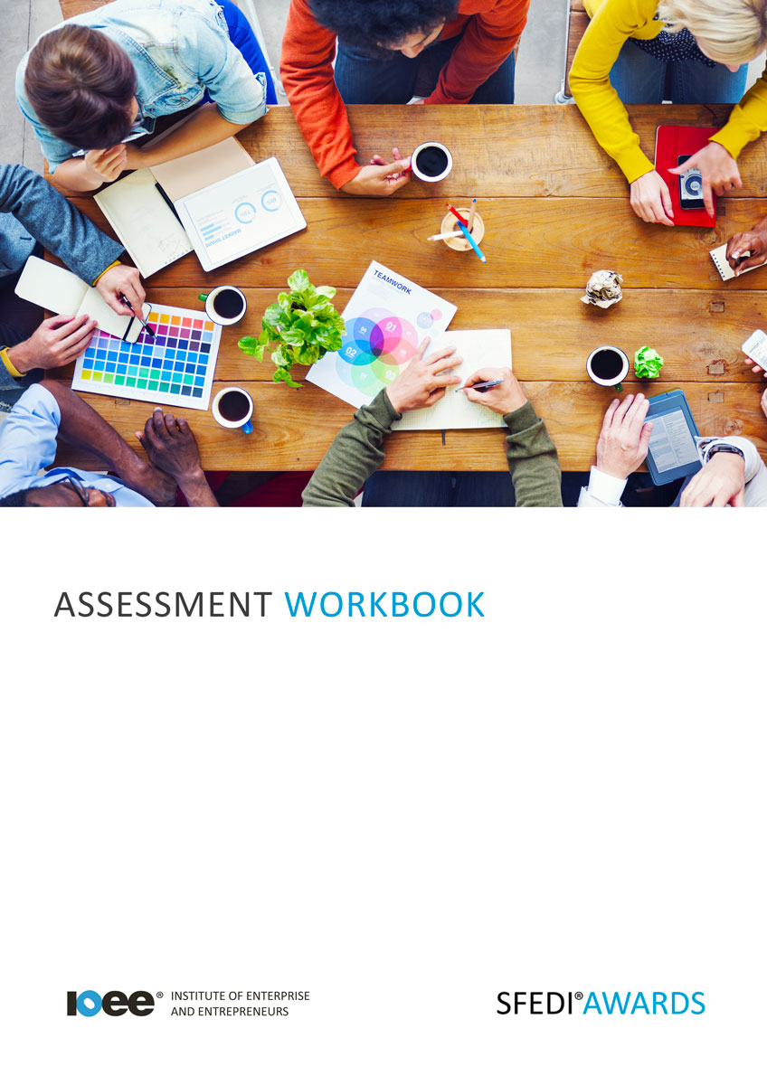

Emotional Intelligence and Anger Management T/615/2256

Copyright © 2020 SFEDI Enterprises Ltd

All rights reserved. This book or any portion thereof may not be reproduced or used in any manner whatsoever without the express written permission of the publisher (address below).

Approved SFEDI Awards centres and learners undertaking a SFEDI Awards qualification may photocopy this document free of charge and/or include a PDF version on its intranet where it is only done so for the purposes of the approved delivery of this qualification.

SFEDI Awards
19 Victoria Road
Darlington
DL1 5SF
www.sfedigroup.com

Every effort has been made to ensure that the information contained in this publication is true and accurate at the time of publication. However, SFEDI Enterprises t/a SFEDI Awards strives to continually develop and improve our qualifications and, as such, there may be occasions where changes are required. SFEDI Enterprises t/a SFEDI Awards does not accept liability for any loss or damage arising from the use of the information contained within this publication.

Introduction

This workbook has been developed so that you are able to collect and present evidence that demonstrates your knowledge and skills in relation to emotional intelligence and anger management.

There are different sections that make up this workbook in order to make sure you are able to complete all of the tasks necessary but you will be provided with support as you move along by your Assessor.

Further learning materials and support is available through your studying membership of the Institute of Enterprise and Entrepreneurs. If you haven’t yet received your login please speak to your Assessor who will be happy to sort this out for you.

This unit contains three learning outcomes and will support you to be able to:

- Understand how emotions can affect behavior
- Understand how anger can affect society
- Understand the connections between emotion, thoughts and behavior to help manage anger
The evidence within this workbook will be assessed by,

Assessor Name:

and will be quality assured by,

Internal Quality Assurer Name:

Your Assessor will support you to plan how best to demonstrate your knowledge and skills which may be through the completion of the activities within this workbook or may include additional tasks best suited to you.

If any additional tasks are to be completed these will be listed in the table below with target dates for which you should try your best to complete each task listed.

Task | Target Date | Re-planned Target Date
Completion of the activities included within this workbook

By signing below you agree to completing the work as detailed above and working with your Assessor to achieve this by the deadlines indicated.

Learner Name: | Signature: | Date:
Assessor Name: | Signature: | Date:

Activities

Activity 1

An ability to understand and manage emotions can increase our chances of success in all areas of life, we have all met very clever people who nonetheless had no idea about how to deal with people, and the reverse.

In the box below identify ways in which humans show emotion verbally and non-verbally

Verbal Emotion | Non-Verbal Emotion

In the box below explain what is meant by the term emotional intelligence

Emotional intelligence is…

Activity 2

Emotions not only impact individuals, emotion such as anger can impact society as a whole.

In the box below describe situations when anger has been used in society both positively and negatively

Positively | Negatively

Activity 3
Emotions impact our own thoughts and behavior, for example feeling angry can turn into physical behavior. In the box below describe the relationship between emotion, thought and behavior by describing how your own emotions and thoughts have influenced your own behavior both positively and negatively

Type of emotion | What types of thoughts did you have? | Positive impact on behaviour | Negative impact on behaviour

Activity 4
Emotions are a strong feeling which come from circumstances, mood or relationships with others. Anger management is a skill that can be learnt through many techniques, which can also be used for other emotions such as fear or sadness
In the box below explain why it is important to manage your own anger, and identify and explain techniques for managing your own anger, then select some of these techniques and use them on your own anger and comment on the results

Activity
Now you have completed the activities to demonstrate your knowledge and skills it is time for your Assessor to map your work against the standards listed below.

By doing this they will be making sure that the work you have provided by completing the activities meets the requirements for you to gain your certificate.

Your Assessor will provide you with feedback on how you have done and whether any more work may be required.

Assessment Criterion - The learner can: | Activity Number or Reference Number of  Additional Activities: | Assessor Signed Off (✓/✗):
Identify ways humans show emotions both verbally and non-verbally | 1
Explain what is meant by emotional intelligence | 1
Describe situations when anger has been used in society both positively and negatively | 2
Describe the relationship between emotion, thoughts and behavior | 3
Describe how own emotion, thoughts and behavior have influenced own behavior both positively and  negatively | 3
Explain why it is important to manage own anger | 4
Identify and explain suitable techniques for managing own anger | 4
Select and use a range of techniques to manage own anger and comment on the results | 4

Assessor Feedback

Authenticity Declarations

Learner Declaration

By signing this declaration you agree that the evidence provided within this workbook has been produced by you and meets the requirements of being authentic, sufficient, valid and current to the standards required.

Learner Signature: Date:

Assessor Declaration

By signing this declaration you agree that you have assessed all of the evidence produced within this workbook and have ensured that the work is that of the learner. You are also declaring that during the learning process you have ensured that the evidence is authentic, sufficient, valid and current to the standards required.

Assessor Signature: Date:

IQA Signature (if applicable): Date:

Additional Evidence Forms
Use these additional forms in order to record additional evidence for the activities within this workbook where additional space is required.

Ensure that each piece of evidence entered on these forms is clearly labelled with the corresponding activity number.

SFEDI Awards
19 Victoria Road
Darlington
DL1 5SF

customerservices@sfediawards.com
0845 224 5928

