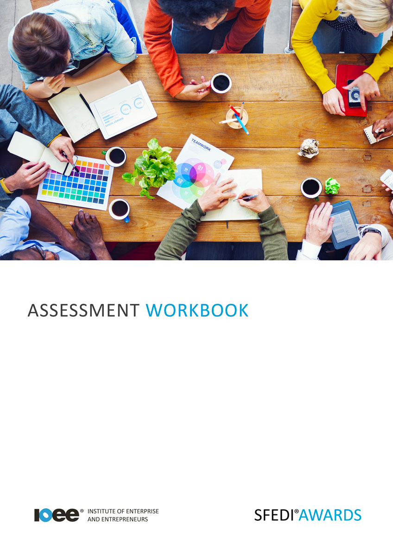

Online Etiquette and Safety
K/615/2268

Copyright © 2020 SFEDI Enterprises Ltd

All rights reserved. This book or any portion thereof may not be reproduced or used in any manner whatsoever without the express written permission of the publisher (address below).

Approved SFEDI Awards centres and learners undertaking a SFEDI Awards qualification may photocopy this document free of charge and/or include a PDF version on its intranet where it is only done so for the purposes of the approved delivery of this qualification.

SFEDI Enterprises Ltd t/a SFEDI Awards
19 Victoria Road
Darlington
DL1 5SF
www.sfedigroup.com

Every effort has been made to ensure that the information contained in this publication is true and accurate at the time of publication. However, SFEDI Enterprises t/a SFEDI Awards strives to continually develop and improve our qualifications and, as such, there may be occasions where changes are required. SFEDI Enterprises t/a SFEDI Awards does not accept liability for any loss or damage arising from the use of the information contained within this publication.

Introduction

This workbook has been developed so that you are able to collect and present evidence that demonstrates your knowledge and skills in relation to online etiquette and safety.

There are different sections that make up this workbook in order to make sure you are able to complete all of the tasks necessary but you will be provided with support as you move along by your Assessor.

Further learning materials and support is available through your studying membership of the Institute of Enterprise and Entrepreneurs. If you haven’t yet received your login please speak to your Assessor who will be happy to sort this out for you.
This unit contains three learning outcomes and will support you to be able to:
- Understand what is meant by the terms internet and online
- Understand the threats to personal safety and the security of personal information online
- Understand how to behave appropriately online

The evidence within this workbook will be assessed by,

Assessor Name:

and will be quality assured by,

Internal Quality Assurer Name:

Your Assessor will support you to plan how best to demonstrate your knowledge and skills which may be through the completion of the activities within this workbook or may include additional tasks best suited to you.

If any additional tasks are to be completed these will be listed in the table below with target dates for which you should try your best to complete each task listed.

Task | Target Date | Re-planned Target Date
Completion of the activities included within this workbook

By signing below you agree to completing the work as detailed above and working with your Assessor to achieve this by the deadlines indicated.

Learner Name: | Signature: | Date:
Assessor Name: | Signature: | Date:

Activities

Activity 1

Using the box below, describe what is meant by the internet and going online. Then provide examples of how people use the internet in the following boxes to put your description into context

Type of person that uses the internet:

How do they use the internet and why?

Type of person that uses the internet:

How do they use the internet and why?

Activity 2

There are many different types of social media, eg. Facebook, Twitter, YouTube, Instagram, Snapchat, and they all have different uses whether it be personal or work, creative or functional, and knowing which one to use for the right reason is a skill that everyone should have.
Using the boxes below, identify a minimum of two different social media sites that you can use and
explain what purpose they have

Type of social media?

Is it for personal or professional use?

What do people use this form of social media for?

Type of social media?

Is it for personal or professional use?

Type of social media?

Is it for personal or
professional use?

The internet and social media can be a fantastic experience for many people helping them to engage with each other and combating a feeling of being isolated but it can also have its downsides and understanding what these are and how to overcome them can mean the experience of being online is much more enjoyable for everyone.

Using the table below, identify the potential threats that can be experienced when online whether through personal or professional use and ways that you can guard against them.

Potential threat | Is it to information security (I) or user safety (U)? | How can you overcome this threat?
eg. someone could access my personal contact details  through my Facebook account | I/U | Use the privacy settings so that only confirmed friends can see my profile information and posts and only add friends that I have spoken to rather than approving anyone

Using the table below provide examples of appropriate and inappropriate online behaviour and describe why it is appropriate and inappropriate

Appropriate Behaviour
Example of behaviour | Why is it appropriate?
eg. showing care with spelling, grammar and using too much slang or technical language | If a post or message is full of spelling or grammatical errors it can make it difficult to read or may even mean someone takes it in a way that you didn’t intend and cause offence
Inappropriate Behaviour
Example of behaviour | Why is it inappropriate?
eg. writing hurtful comments about other people on Facebook or Twitter | Just because it isn’t face to face doesn’t mean that name calling can’t be hurtful especially online as others then join in and the situation gets worse

Using the box below, explain the consequences of behaving inappropriately online including to,
- Yourself,
- Others, and
- Society as a whole

Activity Mapping

Now you have completed the activities to demonstrate your knowledge and skills it is time for your Assessor to map your work against the standards listed below.
By doing this they will be making sure that the work you have provided by completing the activities
meets the requirements for you to gain your certificate.

Your Assessor will provide you with feedback on how you have done and whether any more work may be required.

Assessment Criterion - The learner can: | Activity Number or Reference Number of Additional Activities: | Assessor Signed  Off (✓/✗):
Describe what is meant by the internet and going online | 1
Explain why people use the internet | 1
Identify the purpose of online social media sites, eg.  Facebook, Twitter, YouTube, Instagram, Snapchat | 2
Identify the threats to information security when working online | 3
Identify the threats to user safety when working online | 3
Explain how to take appropriate safety and security precautions when working online | 3
Describe appropriate and inappropriate online behaviour and why it is appropriate and inappropriate | 4
Explain the consequences of behaving inappropriately online including to self, others and society | 5

Assessor Feedback

Authenticity Declarations

Learner Declaration

By signing this declaration you agree that the evidence provided within this workbook has been produced by you and meets the requirements of being authentic, sufficient, valid and current to the standards required.

Learner Signature: Date:

Assessor Declaration

By signing this declaration you agree that you have assessed all of the evidence produced within this workbook and have ensured that the work is that of the learner. You are also declaring that during the learning process you have ensured that the evidence is authentic, sufficient, valid and current to the standards required.

Assessor Signature: Date:

IQA Signature (if applicable): Date:

Additional Evidence Forms

Use these additional forms in order to record additional evidence for the activities within this workbook where additional space is required.

Ensure that each piece of evidence entered on these forms is clearly labelled with the corresponding activity number.

SFEDI Awards
19 Victoria Road
Darlington
DL1 5SF

customerservices@sfediawards.com 0845 224 5928
@sfediawards

