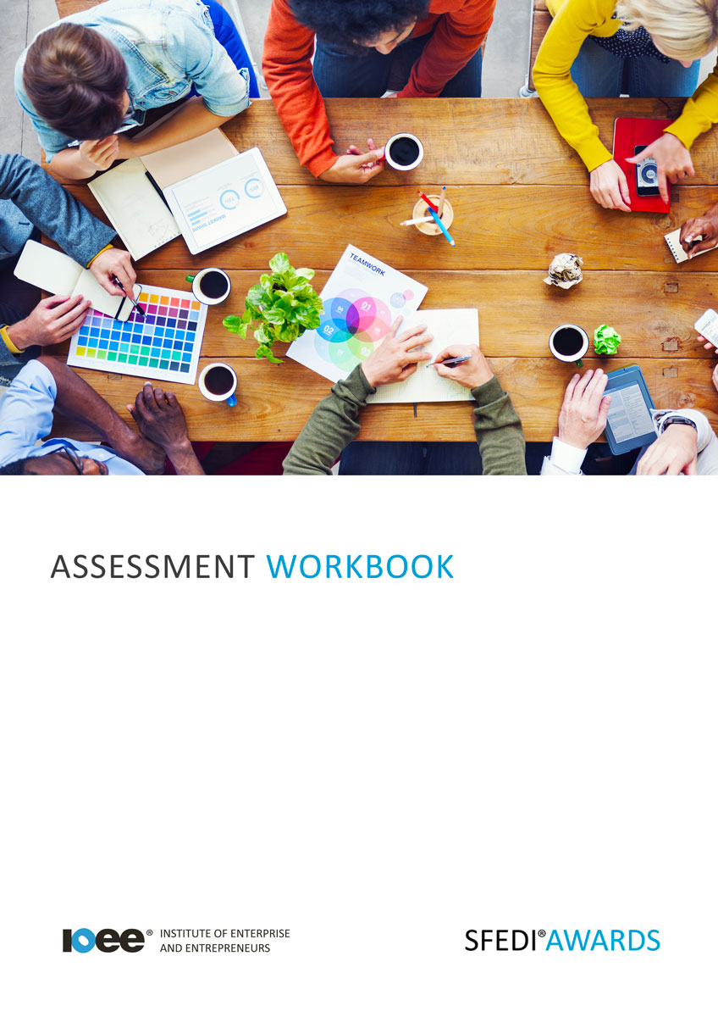

Personal Presentation and its impact
D/615/2249

Copyright © 2020 SFEDI Enterprises Ltd

All rights reserved. This book or any portion thereof may not be reproduced or used in any manner whatsoever without the express written permission of the publisher (address below).

Approved SFEDI Awards centres and learners undertaking a SFEDI Awards qualification may photocopy this document free of charge and/or include a PDF version on its intranet where it is only done so for the purposes of the approved delivery of this qualification.

SFEDI Enterprises Ltd t/a SFEDI Awards
19 Victoria Road
Darlington
DL1 5SF
www.sfedigroup.com

Every effort has been made to ensure that the information contained in this publication is true and accurate at the time of publication. However, SFEDI Enterprises t/a SFEDI Awards strives to continually develop and improve our qualifications and, as such, there may be occasions where changes are required. SFEDI Enterprises t/a SFEDI Awards does not accept liability for any loss or damage arising from the use of the information contained within this publication.

Introduction

This workbook has been developed so that you are able to collect and present evidence that demonstrates your knowledge and skills in relation to personal presentation and its impact.

There are different sections that make up this workbook in order to make sure you are able to complete all of the tasks necessary but you will be provided with support as you move along by your Assessor.

Further learning materials and support is available through your studying membership of the Institute of Enterprise and Entrepreneurs. If you haven’t yet received your login please speak to your Assessor who will be happy to sort this out for you.

This unit contains three learning outcomes and will support you to be able to:

- Understand what is meant by personal presentation
- Understand the importance of good personal presentation
- Understand ways of improving personal presentation
The evidence within this workbook will be assessed by,

Assessor Name:

and will be quality assured by,

Internal Quality Assurer Name:

Your Assessor will support you to plan how best to demonstrate your knowledge and skills which may be through the completion of the activities within this workbook or may include additional tasks best suited to you.

If any additional tasks are to be completed these will be listed in the table below with target dates for which you should try your best to complete each task listed.

Task | Target Date | Re-planned Target Date
Completion of the activities included within this workbook

By signing below, you agree to completing the work as detailed above and working with your Assessor to achieve this by the deadlines indicated.

Learner Name: | Signature: | Date:
Assessor Name: | Signature: | Date:

Activities

Activity 1

Whatever the situation, whether it is a job interview or having to attend a meeting, you need to make sure you present yourself appropriately through your personal presentation in the way that you dress, through verbal and non-verbal communication and even through displaying a positive attitude.
Using the following boxes explain what is meant by personal presentation and highlight some of the elements of personal presentation you should keep in mind when interacting with others.

Personal presentation is…

I should keep in mind the following about my personal presentation when interacting with others…

Using the table below, provide three examples of good and bad personal presentation in two different situations that you have experience of

Brief description of situation one
Good personal presentation examples | Bad personal presentation examples

Brief description of situation two
Good personal presentation examples | Bad personal presentation examples

Now you understand what personal presentation is, in the boxes below explain how good personal presentation can:

Effect people’s perceptions of you…
Effect the development of your character…
Help you achieve your goals…

Activity 4
Using the table below identify aspects of your own personal presentation that could be improved and ways in which you could develop them

Aspect of Personal Presentation to be Improved | How Could it be Improved?

Using the box below describe how your life could be changed if you were to follow through on these ideas to help improve your personal presentation

Activity Mapping
Now you have completed the activities to demonstrate your knowledge and skills it is time for your Assessor to map your work against the standards listed below.

By doing this they will be making sure that the work you have provided by completing the activities meets the requirements for you to gain your certificate.

Your Assessor will provide you with feedback on how you have done and whether any more work may be required.

Assessment Criterion - The learner can: | Activity Number or Reference Number of Additional Activities: | Assessor Signed Off ( / ):
Explain what is meant by personal presentation | 1
Provide three examples of good or bad personal presentation in different situations | 2
Describe how own personal presentation can affect perception by others | 3
Explain how good personal presentation can have an effect on own enterprising character development | 3
Identify and explain ways that good personal presentation can help to achieve goals | 3
Identify aspects of own personal presentation to be improved | 4
Describe ways to improve selected aspects of personal presentation | 4
Describe how own life could be changed if own personal presentation was improved | 4

Assessor Feedback

Authenticity Declarations

Learner Declaration

By signing this declaration, you agree that the evidence provided within this workbook has been produced by you and meets the requirements of being authentic, sufficient, valid and current to the standards required.

Learner Signature: Date:

Assessor Declaration

By signing this declaration, you agree that you have assessed all of the evidence produced within this workbook and have ensured that the work is that of the learner. You are also declaring that during the learning process you have ensured that the evidence is authentic, sufficient, valid and current to the standards required.

Assessor Signature: Date:

IQA Signature (if applicable): Date:

Additional Evidence Forms
Use these additional forms in order to record additional evidence for the activities within this workbook where additional space is required.

Ensure that each piece of evidence entered on these forms is clearly labelled with the corresponding activity number.

SFEDI Awards
19 Victoria Road
Darlington
DL1 5SF

customerservices@sfediawards.com 0845 224 5928
@sfediawards

