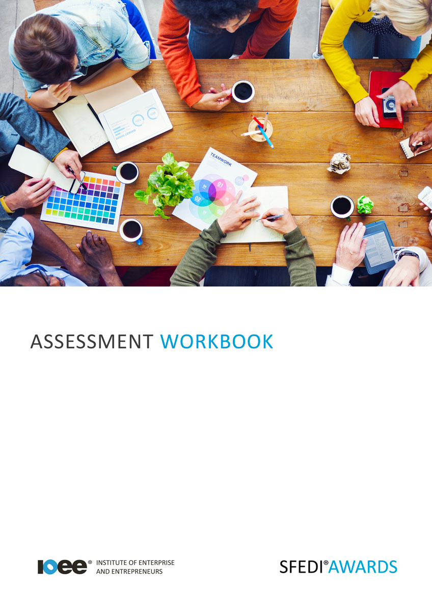

Personal Skills and Abilities to Start a Business
D/503/2960

Copyright © 2020 SFEDI Enterprises Ltd

All rights reserved. This book or any portion thereof may not be reproduced or used in any manner whatsoever without the express written permission of the publisher (address below).

Approved SFEDI Awards centres and learners undertaking a SFEDI Awards qualification may photocopy this document free of charge and/or include a PDF version on its intranet where it is only done so for the purposes of the approved delivery of this qualification.

SFEDI Enterprises Ltd t/a SFEDI Awards
19 Victoria Road
Darlington
DL1 5SF
www.sfedigroup.com

Every effort has been made to ensure that the information contained in this publication is true and accurate at the time of publication. However, SFEDI Enterprises t/a SFEDI Awards strives to continually develop and improve our qualifications and, as such, there may be occasions where changes are required. SFEDI Enterprises t/a SFEDI Awards does not accept liability for any loss or damage arising from the use of the information contained within this publication.

Introduction

This workbook has been developed so that you are able to collect and present evidence that demonstrates your knowledge and skills in relation to the personal skills and abilities to start a business.

There are different sections that make up this workbook in order to make sure you are able to complete all of the tasks necessary but you will be provided with support as you move along by your Assessor.

Further learning materials and support is available through your studying membership of the Institute of Enterprise and Entrepreneurs. If you haven’t yet received your login please speak to your Assessor who will be happy to sort this out for you.
This unit contains three learning outcomes and will support you to be able to:
- Reflect on own interest in starting a business
- Identify personal development needs in relation to running own business
- Reflect on the rewards and commitments of running own business
The evidence within this workbook will be assessed by,

Assessor Name:

and will be quality assured by,

Internal Quality Assurer Name:

Your Assessor will support you to plan how best to demonstrate your knowledge and skills which may be through the completion of the activities within this workbook or may include additional tasks best suited to you.

If any additional tasks are to be completed these will be listed in the table below with target dates for which you should try your best to complete each task listed.

Task | Target Date | Re-planned Target Date
Completion of the activities included within this workbook

By signing below you agree to completing the work as detailed above and working with your Assessor to achieve this by the deadlines indicated.

Learner Name: | Signature: | Date:
Assessor Name: | Signature: | Date:

Activities

Activity 1

Using the box below, explain what is important to you in running a business. This could be a range of things from planning to survive and grow the business, earning enough to pay your personal finances or even improving your standard of living. What is important to you and what order would you rate their importance?

Activity 2

Using the box below, identify the types of business and business activities that may be most appealing to you. Do you want to work on your own or with people? Do you want to work online or face to face? Do you see yourself carrying out physical activities? Do you see yourself providing products or services?

7

Activity 3

Use the table below to list a minimum of four forms of behaviours, knowlege and skills required to run a business

Behaviour, knowledge or skill | Behaviour (B) , Knowledge (K) or Skill (S) ? | How is it useful to running a business?
eg. problem solving | B, S | Problem solving means that you can overcome challenges in a productive and effective way in order to move forward and achieve mine and the goals of the business

8

Activity 4

Now look at your own behaviours, knowledge and skills. Use the table below to list your own current traits that you feel would help you to start and run a business and describe how you currently use them in your personal and/or working life

Character Trait | Behaviour (B) , Knowledge (K) or Skill (S) ? | How do I currently put it into practice?
eg. problem solving | B, S | I moved house and struggled to build a new circle of friends so I found out about all of the local clubs and groups and joined a couple to meet new people and make new friends

9

Activity 5

Use the table below to select aspects of your own current behaviours, knowledge and skills that you would like to develop further in order to help you to start and run a business and the reasons why you have selected those particular traits for development

Character Trait | Behaviour (B) , Knowledge (K) or Skill (S) ? | Why have you selected this trait for development?
eg. problem solving | B, S | When starting and running a business I will come across many challenges with finance, suppliers, etc. that will need me to be able to think through the problem properly to come to the best outcome to help me to start and run the business

10

Activity 6

Now use the table below to plan how you can develop the character traits you have identified. Think about the activities to be completed, the
timescales for the activities to take place and the method you can review how successful the activities are in helping you to develop

Character Trait | Activity to be Completed | Deadline for Completion | Method of Reviewing Success of the Outcome on Your Own Development
eg. problem solving | Read about ways of identifying and  thinking through problems | 1 month | Put into practice my problem solving technique and  see how I have done and further ways of improving

Starting and running a business is not the easy option, it involves commitment, financial contributions and often long and tiring hours. What are you prepared to give and possibly sacrifice for success?
Using the box below, estimate how much of your time, finances and personal commitment you are
willing to invest in starting and running your business

Using the personal survival budget below, estimate the amount of money you would need to earn
from your business to cover your personal financial needs

Estimated monthly expenditure | £
Mortgage and/or rent | £
Council tax | £
Utilities (gas, electricity, water, etc) | £
Personal and property insurance | £
General housekeeping expenses (food, etc) | £
Phone and internet | £
Car tax and insurance | £
Car running expenses | £
HP repayments | £
Hire charges | £
Subscriptions to journals, professional bodies, etc. | £
Savings plans and pension contributions | £
Contingencies | £
National insurance | £
Other (please specify) | £
Other (please specify) | £
Total personal expenditure | £
Estimated personal income (after tax)
Income from family/partner | £
Other income | £
Total personal income | £
Total survival income required from the business (after tax) (Total personal income - Total personal expenditure) | £

So you’ve considered the types of business you might want to run, why you want to run it, what you need to get from the business and what type of person you need to be and the skills required to start and run a business. But what about the rewards and benefits that running your own business can bring to you?
Running a business is more than just finance and convenience, there are other benefits that could be
experienced. What do you think they are? See how many you can list in the box below.

Activity Mapping

Now you have completed the activities to demonstrate your knowledge and skills it is time for your Assessor to map your work against the standards listed below.
By doing this they will be making sure that the work you have provided by completing the activities
meets the requirements for you to gain your certificate.

Your Assessor will provide you with feedback on how you have done and whether any more work may be required.

Assessment Criterion - The learner can: | Activity Number or Reference Number of Additional Activities: | Assessor Signed  Off (✓/✗):
Identify reasons why running a business may be in own interest | 1
Identify types of business and business activities that may be most appealing | 2
Identify types of knowledge, skills and qualities that are needed to run own business | 3 - 6
Identify any gaps in own knowledge, skills and qualities for running a business | 3 - 6
Explain the action that could be taken to develop own skills and abilities in order to run a business | 3 - 6
Estimate how much of own time, financial and personal commitment could be given to running a business | 7
Estimate the level of income from running a business that may be needed to cover own personal financial needs | 8
Identify the potential rewards and benefits that could  be experienced from running own business | 9

Assessor Feedback

Authenticity Declarations

Learner Declaration

By signing this declaration you agree that the evidence provided within this workbook has been produced by you and meets the requirements of being authentic, sufficient, valid and current to the standards required.

Learner Signature: Date:

Assessor Declaration

By signing this declaration you agree that you have assessed all of the evidence produced within this workbook and have ensured that the work is that of the learner. You are also declaring that during the learning process you have ensured that the evidence is authentic, sufficient, valid and current to the standards required.

Assessor Signature: Date:

IQA Signature (if applicable): Date:

Additional Evidence Forms

Use these additional forms in order to record additional evidence for the activities within this workbook where additional space is required.

Ensure that each piece of evidence entered on these forms is clearly labelled with the corresponding activity number.

SFEDI Awards
19 Victoria Road
Darlington
DL1 5SF

customerservices@sfediawards.com 0845 224 5928
@sfediawards

