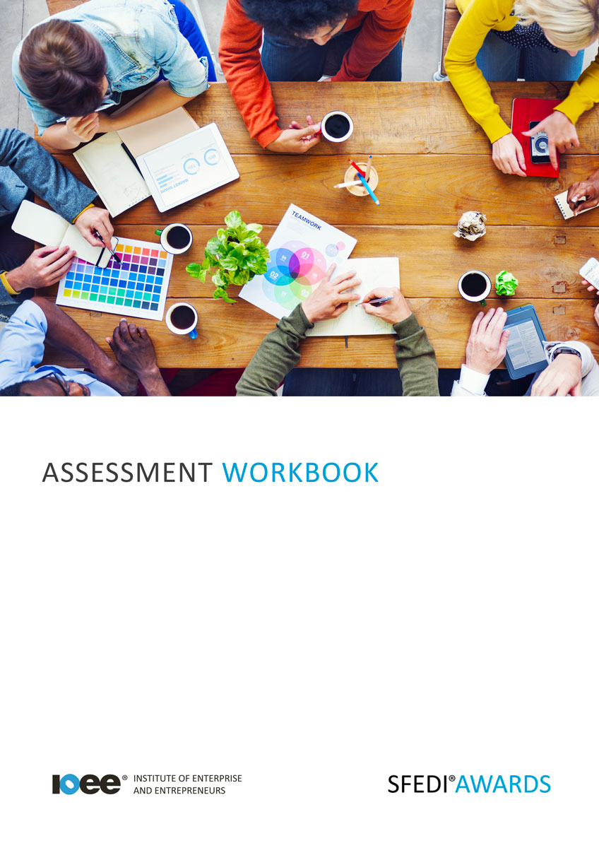

Presenting Yourself for Work Y/615/2279

Copyright © 2020 SFEDI Enterprises Ltd

All rights reserved. This book or any portion thereof may not be reproduced or used in any manner whatsoever without the express written permission of the publisher (address below).

Approved SFEDI Awards centres and learners undertaking a SFEDI Awards qualification may photocopy this document free of charge and/or include a PDF version on its intranet where it is only done so for the purposes of the approved delivery of this qualification.

SFEDI Enterprises Ltd t/a SFEDI Awards
19 Victoria Road
Darlington
DL1 5SF
www.sfedigroup.com

Every effort has been made to ensure that the information contained in this publication is true and accurate at the time of publication. However, SFEDI Enterprises t/a SFEDI Awards strives to continually develop and improve our qualifications and, as such, there may be occasions where changes are required. SFEDI Enterprises t/a SFEDI Awards does not accept liability for any loss or damage arising from the use of the information contained within this publication.

Introduction

This workbook has been developed so that you are able to collect and present evidence that demonstrates your knowledge and skills in relation to presenting yourself for work.

There are different sections that make up this workbook in order to make sure you are able to complete all of the tasks necessary but you will be provided with support as you move along by your Assessor.

Further learning materials and support is available through your studying membership of the Institute of Enterprise and Entrepreneurs. If you haven’t yet received your login please speak to your Assessor who will be happy to sort this out for you.
This unit contains three learning outcomes and will support you to be able to:
- Understand how to create a CV
- Understand and demonstrate how technology can be used for presenting yourself online
- Understand how to present yourself in person
The evidence within this workbook will be assessed by,

Assessor Name:

and will be quality assured by,

Internal Quality Assurer Name:

Your Assessor will support you to plan how best to demonstrate your knowledge and skills which may be through the completion of the activities within this workbook or may include additional tasks best suited to you.

If any additional tasks are to be completed these will be listed in the table below with target dates for which you should try your best to complete each task listed.

Task | Target Date | Re-planned Target Date
Completion of the activities included within this workbook

By signing below you agree to completing the work as detailed above and working with your Assessor to achieve this by the deadlines indicated.

Learner Name: | Signature: | Date:
Assessor Name: | Signature: | Date:

Activities

Activity 1

Using the boxes below, identify the different sections that should make up a CV and provide a
description of the types of information that should be within them

Section:

Description:

Section:

Description:

Section:

Description:

Section:

Description:

Section:

Description:

Section:

Description:

Section:

Description:

Based on the sections and descriptions you have provided, generate content that is personal to you and create your CV in a format that both presents you in the best light and is appropriate for distribution to potential employers.
Include copies of any drafts and the finalised CV with this workbook for assessment by your Assessor

Activity 3

CV’s are a traditional and widely used way of presenting your abilities, behaviours, knowledge and skills to potential employers but with the use of the internet employers often turn to online profiles to get an idea of who a person really is and what they are really like.

With the growth of Twitter, Facebook, Pinterest, LinkedIn and other social media platforms employers only need to put your name into a search engine and get the same, and more information, than you provide on your CV.

Using two different forms of technology, whether that be through social media or other online forums, create and provide two examples of how you present yourself appropriately online and explain what situation you might use them in.

You can either note down the web-links for where the information can be seen or include screen prints with this workbook for assessment by your Assessor.

Weblink:

When might you use this
profile?

Weblink:

When might you use this
profile?

So now you understand how to present yourself to others without seeing them face to face but what about when you get an interview or job or attend a meeting? Whatever the situation you need to make sure you present yourself appropriately through the way you dress, through verbal and non-verbal communication and even through displaying a positive attitude.
But what do we mean by appropriate presentation? Using the following boxes, highlight some of the
elements of personal presentation you should keep in mind when interacting with others.

Element of personal presentation:

What effect does it have?

Element of personal presentation:

What effect does it have?

Element of personal presentation:

What effect does it have?

Element of personal presentation:

What effect does it have?

Element of personal presentation:

What effect does it have?

Activity 5

Now it’s time to put what you’ve learnt into practice, it’s time to present yourself appropriately within a work related environment.
As the Assessor for I confirm that I have witnessed them present
themselves appropriately within a work environment on at least one occasion. This includes wearing appropriate clothing, using appropriate verbal and non-verbal communication techniques and demonstrating a positive and engaging attitude and behaviours.

Assessor Name: Signature: Date:

Activity Mapping

Now you have completed the activities to demonstrate your knowledge and skills it is time for your Assessor to map your work against the standards listed below.
By doing this they will be making sure that the work you have provided by completing the activities
meets the requirements for you to gain your certificate.

Your Assessor will provide you with feedback on how you have done and whether any more work may be required.

Assessment Criterion - The learner can: | Activity Number or Reference Number of Additional Activities: | Assessor Signed  Off (✓/✗):
Identify the main types of information shown in a Curriculum Vitae (CV) | 1
Generate content to use in creating a CV that covers the type of information needed in a straightforward CV | 2
Create a straightforward CV and present it in a suitable format | 2
Provide two examples of using technology for presenting themselves online and when they might use them | 3
Create the content needed to present themselves online, presenting it in a suitable format | 3
Describe three important things to consider when presenting themselves in person | 4
Present themselves appropriately in person in a work related situation | 5

Assessor Feedback

Authenticity Declarations

Learner Declaration

By signing this declaration you agree that the evidence provided within this workbook has been produced by you and meets the requirements of being authentic, sufficient, valid and current to the standards required.

Learner Signature: Date:

Assessor Declaration

By signing this declaration you agree that you have assessed all of the evidence produced within this workbook and have ensured that the work is that of the learner. You are also declaring that during the learning process you have ensured that the evidence is authentic, sufficient, valid and current to the standards required.

Assessor Signature: Date:

IQA Signature (if applicable): Date:

Additional Evidence Forms

Use these additional forms in order to record additional evidence for the activities within this workbook where additional space is required.

Ensure that each piece of evidence entered on these forms is clearly labelled with the corresponding activity number.

SFEDI Awards
19 Victoria Road
Darlington
DL1 5SF

customerservices@sfediawards.com 0845 224 5928
@sfediawards

