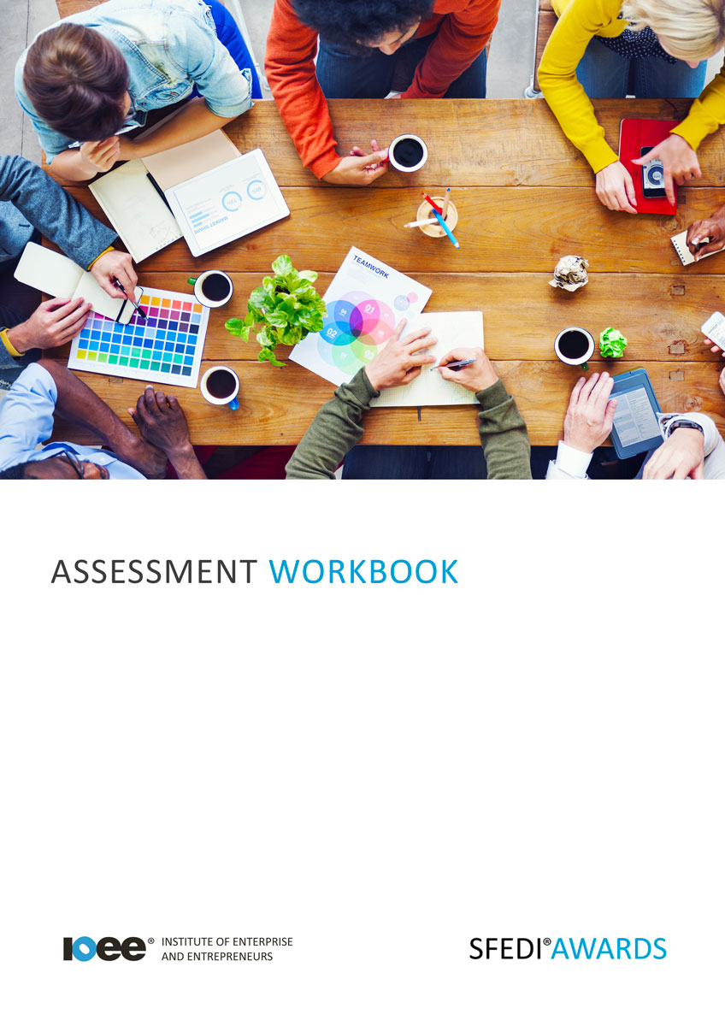

*Principles of Social Media for Business Use*

*R/505/0890*

Copyright © 2020 SFEDI Enterprises Ltd

All rights reserved. This book or any portion thereof may not be reproduced or used in any manner whatsoever without the express written permission of the publisher (address below).

Approved SFEDI Awards centres and learners undertaking a SFEDI Awards qualification may photocopy this document free of charge and/or include a PDF version on its intranet where it is only done so for the purposes of the approved delivery of this qualification.

SFEDI Enterprises Ltd t/a SFEDI Awards

19 Victoria Road

Darlington

DL1 5SF

[www.sfedigroup.com](http://www.sfedigroup.com/)

Every effort has been made to ensure that the information contained in this publication is true and accurate at the time of publication. However, SFEDI Enterprises t/a SFEDI Awards strives to continually develop and improve our qualifications and, as such, there may be occasions where changes are required. SFEDI Enterprises t/a SFEDI Awards does not accept liability for any loss or damage arising from the use of the information contained within this publication.

# Introduction

This workbook has been developed so that you are able to collect and present evidence that demonstrates your knowledge and skills in relation to the use of social media within a business.

There are different sections that make up this workbook in order to make sure you are able to complete all of the tasks necessary but you will be provided with support as you move along by your Assessor.

Further learning materials and support is available through your studying membership of the Institute of Enterprise and Entrepreneurs. If you haven’t yet received your login please speak to your Assessor who will be happy to sort this out for you.

This unit contains four learning outcomes and will support you to be able to:

* Understand the major social media channels
* Understand the specialist social media channels
* Understand how a business uses social media
* Understand the risks associated with using social media

The evidence within this workbook will be assessed by,

### Assessor Name:

and will be quality assured by,

### Internal Quality Assurer Name:

Your Assessor will support you to plan how best to demonstrate your knowledge and skills which may be through the completion of the activities within this workbook or may include additional tasks best suited to you.

If any additional tasks are to be completed these will be listed in the table below with target dates for which you should try your best to complete each task listed.

|  |  |  |
| --- | --- | --- |
| **Task** | **Target Date** | **Re-planned Target Date** |
| Completion of the activities included within this workbook |  |  |
|  |  |  |
|  |  |  |
|  |  |  |
|  |  |  |
|  |  |  |

By signing below you agree to completing the work as detailed above and working with your Assessor to achieve this by the deadlines indicated.

|  |  |  |
| --- | --- | --- |
| **Learner Name:** | **Signature:** | **Date:** |
| **Assessor Name:** | **Signature:** | **Date:** |

5

# Activities

## Activity 1

Using the table below, highlight the main social media channels that you think businesses use to engage with their customers and the wider

marketplace, the reason they use each of the channels and the main differences between the channels and the alternatives.

|  |  |  |
| --- | --- | --- |
| **Social media channel** | **Reasons a business would use this channel** | **Difference between this channel and its rivals** |
|  |  |  |
|  |  |  |
|  |  |  |
|  |  |  |

6

## Activity 2

Using the table below, highlight the main specialist social media channels, eg. CheckATrade, that you think businesses use to engage with their customers and the wider marketplace, the reason they use each of the channels and the main differences between the channels and the alternatives.

|  |  |  |
| --- | --- | --- |
| **Social media channel** | **Reasons a business would use this channel** | **Difference between this channel and its rivals** |
|  |  |  |
|  |  |  |
|  |  |  |
|  |  |  |

## Activity 3

Social media can be time consuming and expensive for a business to use as well as introducing other

challenges that need to be addressed so why bother? What difference does it make to a business?

Using the boxes below explain:

* why a business would use social media
* how social media supports a business to interact with those internal and external to the business
* how an online community can help with interaction with those internal and external to the business
* how a business can monitor how successful engagement has been using social media
* the challenges and risks to a business associated with using social media
* the ways they could overcome the challenges and risks associated with using social media
* the importance of a business being aware of when they are mentioned on social media
* why a business should have a social media policy

Why would a business use social media?

|  |
| --- |
|  |

How does using social media help a business to engage with those internal and external to the business?

|  |
| --- |
|  |

What is an online community **and** how can it help with engagement with those internal and external to the business?

|  |
| --- |
|  |

What tools can a business use to monitor how successful engagement has been using social media?

|  |
| --- |
|  |

What are the challenges or risks that a business may encounter through using social media and what methods could they use to overcome these?

|  |  |
| --- | --- |
| **Challenge or risk to a business of using social media** | **Methods of overcoming the challenge or risk** |
|  |  |
|  |  |
|  |  |
|  |  |
|  |  |

Why is it important for a business to be aware of when they have been mentioned on social media?

|  |
| --- |
|  |

What is a social media policy **and** what types of information would you normally find within one?

|  |
| --- |
|  |

Why is it important for a business to have a social media policy?

|  |
| --- |
|  |

Now you have completed the activities to demonstrate your knowledge and skills it is time for your Assessor to map your work against the standards listed below.

Activity Mapping

By doing this they will be making sure that the work you have provided by completing the activities

meets the requirements for you to gain your certificate.

Your Assessor will provide you with feedback on how you have done and whether any more work may be required.

|  |  |  |
| --- | --- | --- |
| **Assessment Criterion - The learner can:** | **Activity Number or Reference Number of Additional Activities:** | **Assessor Signed**  **Off (**✓**/**✗**):** |
| State the major social media channels | 1 |  |
| Identify reasons for using each of the major social media channels for business use | 1 |  |
| State the main differences between the major social  media channels | 1 |  |
| State the specialist social media channels | 2 |  |
| Identify reasons for using each of the specialist social media channels for business use | 2 |  |
| State the main differences between the specialist  social media channels | 2 |  |
| Identify why a business uses social media | 3 |  |
| Explain the advantages of a business building an online community | 3 |  |
| Describe why a business should be aware when they are mentioned in social media | 3 |  |
| State the benefits of a business using social media for  engagement | 3 |  |
| Identify ways of monitoring social media engagement | 3 |  |

|  |  |  |
| --- | --- | --- |
| **Assessment Criterion - The learner can:** | **Activity Number or Reference Number of Additional Activities:** | **Assessor Signed**  **Off (**✓**/**✗**):** |
| Identify risks associated with using social media for business use | 3 |  |
| Explain why a business should have a social media policy | 3 |  |

Activity Mapping

Assessor Feedback

|  |
| --- |
|  |

Authenticity Declarations

**Learner Declaration**

By signing this declaration you agree that the evidence provided within this workbook has been produced by you and meets the requirements of being authentic, sufficient, valid and current to the standards required.

### Learner Signature: Date:

**Assessor Declaration**

By signing this declaration you agree that you have assessed all of the evidence produced within this workbook and have ensured that the work is that of the learner. You are also declaring that during the learning process you have ensured that the evidence is authentic, sufficient, valid and current to the standards required.

### Assessor Signature: Date:

**IQA Signature (if applicable): Date:**

Additional Evidence Forms

Use these additional forms in order to record additional evidence for the activities within this workbook where additional space is required.

Ensure that each piece of evidence entered on these forms is clearly labelled with the corresponding activity number.

|  |
| --- |
|  |

|  |
| --- |
|  |

|  |
| --- |
|  |

|  |
| --- |
|  |

|  |
| --- |
|  |

|  |
| --- |
|  |

SFEDI Awards

19 Victoria Road

Darlington

DL1 5SF

[customerservices@sfediawards.com](mailto:customerservices@sfediawards.com) 0845 224 5928

@sfediawards