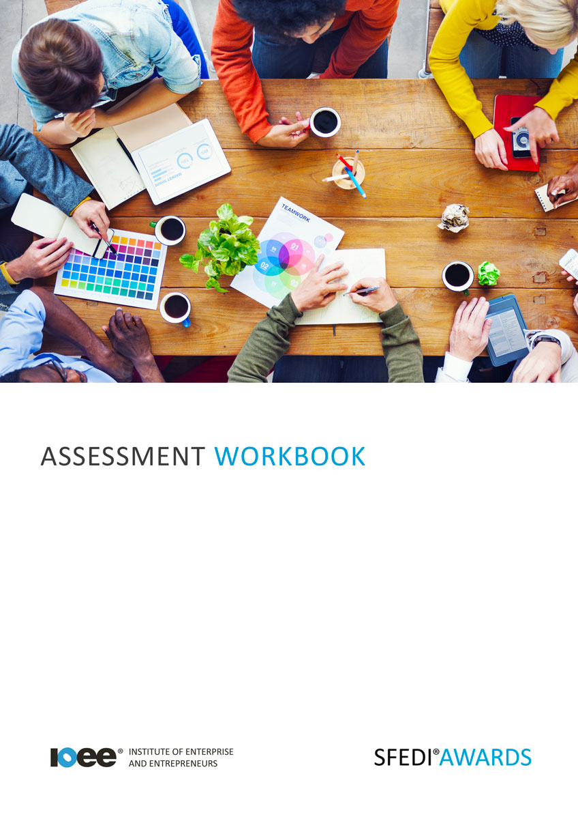

Run a Business from Home
M/601/4408

Copyright © 2020 SFEDI Enterprises Ltd

All rights reserved. This book or any portion thereof may not be reproduced or used in any manner whatsoever without the express written permission of the publisher (address below).

Approved SFEDI Awards centres and learners undertaking a SFEDI Awards qualification may photocopy this document free of charge and/or include a PDF version on its intranet where it is only done so for the purposes of the approved delivery of this qualification.

SFEDI Enterprises Ltd t/a SFEDI Awards
19 Victoria Road
Darlington
DL1 5SF
www.sfedigroup.com

Every effort has been made to ensure that the information contained in this publication is true and accurate at the time of publication. However, SFEDI Enterprises t/a SFEDI Awards strives to continually develop and improve our qualifications and, as such, there may be occasions where changes are required. SFEDI Enterprises t/a SFEDI Awards does not accept liability for any loss or damage arising from the use of the information contained within this publication.

Introduction

This workbook has been developed so that you are able to collect and present evidence that demonstrates your knowledge and skills in relation to running a business from home.

There are different sections that make up this workbook in order to make sure you are able to complete all of the tasks necessary but you will be provided with support as you move along by your Assessor.

Further learning materials and support is available through your studying membership of the Institute of Enterprise and Entrepreneurs. If you haven’t yet received your login please speak to your Assessor who will be happy to sort this out for you.
This unit contains four learning outcomes and will support you to be able to:
- Understand the benefits and challenges of running a business from home
- Know the facilities that may be needed for running a business from home
- Understand how to create a professional image when running a business from home
- Understand how to deal with the expectations of family, neighbours and clients

The evidence within this workbook will be assessed by,

Assessor Name:

and will be quality assured by,

Internal Quality Assurer Name:

Your Assessor will support you to plan how best to demonstrate your knowledge and skills which may be through the completion of the activities within this workbook or may include additional tasks best suited to you.

If any additional tasks are to be completed these will be listed in the table below with target dates for which you should try your best to complete each task listed.

Task | Target Date | Re-planned Target Date
Completion of the activities included within this workbook

By signing below you agree to completing the work as detailed above and working with your Assessor to achieve this by the deadlines indicated.

Learner Name: | Signature: | Date:
Assessor Name: | Signature: | Date:

Activities

Activity 1
Using the table below, describe the different issues that can arise when running a business from
home, eg. time commitment, work/home life balance

Issue | How can it impact badly on running a business from home and/or your personal life?

Using the table below, describe the different benefits when running a business from home, eg. cost-
savings or meeting family commitments

Benefit | How can it impact positively on running a business from home and/ or your personal life?

Running a business takes more planning than simply making a coffee, sitting down at your computer and starting to talk to your customers. There are different administrative and legal requirements that you need to go through first, eg. speaking to your mortgage provider or landlord or speaking with the local planning office.
Using the table below, identify the different administrative and legal requirements that need to be
completed prior to starting to operate a business from your home

Administrative or legal requirement | Best place to get advice or support from | Steps needed to complete this task

Working from home isn’t for everybody, you need to be motivated, be able to manage your workload and have methods to make sure you don’t feel cut off from the world. It takes a certain set of abilities, behaviours and skills to be able to do it and do it well.

Using the box below, identify ways that you could keep yourself motivated and focused whilst working at home

9

Activity 5
Using the table below, describe the types of storage, data back-up, computer systems, telephone systems and equipment needed to meet the needs
of your home business.

Equipment need | Requirement | Do you have this already? (Y/N) | How can you maximise your current resource level?
Storage
Data back-up
Computer systems
Telephone systems
Other equipment
Other equipment
Other equipment

Now thinking about your own home, where do you think would be the best place to set-up a work station? Think about lighting, access to power and ease of access to the equipment you listed within activity 5 when making your decision.

Using the box below, justify your reasoning for the position you have chosen to show why it is the most appropriate choice

It’s not just about whether you want to work at home and the benefits and potential downfalls it can bring, there is someone else in the relationship, the customer, and creating a positive impression with them is important whether you work at home or not.

Using the box below, explain why it is important to creative a positive impression with your customers in order to meet the needs of the business

Using the table below, provide examples of what might potentially give a negative impression of the business, why it would give a negative impression and ways in which you could overcome the situation

Example | Why would it give a bad impression? | How could you overcome the situation?

13

Activity 8
Although you may be working in the home alone, there are still sources of potential conflict whether that be with family, neighbours, customers,
suppliers. For example, think how your neighbours would react if there were work vans or constant deliveries every day.

Using the table below, identify potential sources of conflict as a result of running a business from home and the expectations of those people or groups of people that give rise to the conflict

Potential source of  conflict | What are their expectations that have led to the  conflict? | What agreements could you reach to overcome the potential  conflict?
eg. neighbours | Quiet surroundings without reduced access to both their drive way and on street parking immediately outside their house | Agree that work vans won’t be parked immediately outside their house and to ask permission if needed for a short period of time to check it won’t be in the way

14

Activity Mapping
Now you have completed the activities to demonstrate your knowledge and skills it is time for your Assessor to map your work against the standards listed below.
By doing this they will be making sure that the work you have provided by completing the activities
meets the requirements for you to gain your certificate.

Your Assessor will provide you with feedback on how you have done and whether any more work may be required.

Assessment Criterion - The learner can: | Activity Number or Reference Number of Additional Activities: | Assessor Signed Off (✓/✗):
Describe a range of issues affecting the choice of working from home (eg. time commitment, work/home life balance) | 1
Explain the benefits of working from home (eg. cost-  savings or meeting family commitments) | 2
Describe the administrative and legal requirements for running a business from home, such as registering change of property use | 3
Identify ways of keeping motivated and focused whilst working at home | 4
Describe the types of storage, data back-up and equipment needed to meet home business needs, including IT and telephone systems | 5
Explain how to maximise the use of what is already available at home, including current storage space, computer systems and telephone facilities | 5
Decide where the best place to set-up a work station in  the home is | 6
Identify sources of advice which would be helpful (eg. accountant, insurance broker, business advisor) | 3
Explain what is necessary to create a positive image to suit the business needs | 7
Provide examples of what might potentially give a negative professional image of the business and explain why | 7
Identify the sources of potential conflict that may arise  from running a business from home | 8
Describe the expectations of people affected by the  business (ie. family, neighbours and clients) | 8
Explain the kind of agreements that can be reached so that the business needs can be aligned with the  perceptions and needs of other people when appropriate | 8

Assessor Feedback

Authenticity Declarations

Learner Declaration

By signing this declaration you agree that the evidence provided within this workbook has been produced by you and meets the requirements of being authentic, sufficient, valid and current to the standards required.

Learner Signature: Date:

Assessor Declaration

By signing this declaration you agree that you have assessed all of the evidence produced within this workbook and have ensured that the work is that of the learner. You are also declaring that during the learning process you have ensured that the evidence is authentic, sufficient, valid and current to the standards required.

Assessor Signature: Date:

IQA Signature (if applicable): Date:

Additional Evidence Forms

Use these additional forms in order to record additional evidence for the activities within this workbook where additional space is required.

Ensure that each piece of evidence entered on these forms is clearly labelled with the corresponding activity number.

SFEDI Awards
19 Victoria Road
Darlington
DL1 5SF

customerservices@sfediawards.com 0845 224 5928
@sfediawards

