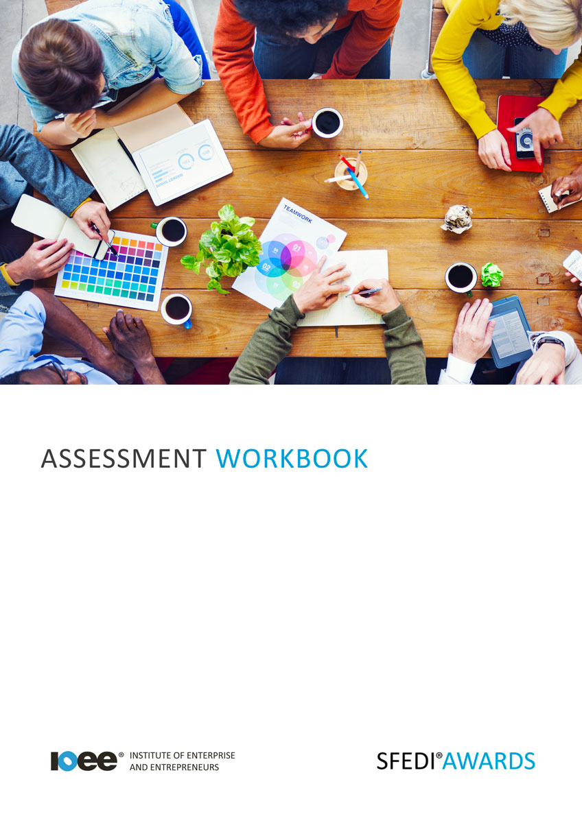

Safeguarding M/615/2272

Copyright © 2020 SFEDI Enterprises Ltd

All rights reserved. This book or any portion thereof may not be reproduced or used in any manner whatsoever without the express written permission of the publisher (address below).

Approved SFEDI Awards centres and learners undertaking a SFEDI Awards qualification may photocopy this document free of charge and/or include a PDF version on its intranet where it is only done so for the purposes of the approved delivery of this qualification.

SFEDI Enterprises Ltd t/a SFEDI Awards
19 Victoria Road
Darlington
DL1 5SF
www.sfedigroup.com

Every effort has been made to ensure that the information contained in this publication is true and accurate at the time of publication. However, SFEDI Enterprises t/a SFEDI Awards strives to continually develop and improve our qualifications and, as such, there may be occasions where changes are required. SFEDI Enterprises t/a SFEDI Awards does not accept liability for any loss or damage arising from the use of the information contained within this publication.

Introduction

This workbook has been developed so that you are able to collect and present evidence that demonstrates your knowledge and skills in relation to safeguarding.

There are different sections that make up this workbook in order to make sure you are able to complete all of the tasks necessary but you will be provided with support as you move along by your Assessor.

Further learning materials and support is available through your studying membership of the Institute of Enterprise and Entrepreneurs. If you haven’t yet received your login please speak to your Assessor who will be happy to sort this out for you.
This unit contains three learning outcomes and will support you to be able to:
- Understand safeguarding
- Understand how to identify safeguarding issues
- Understand how to report safeguarding issues
The evidence within this workbook will be assessed by,

Assessor Name:

and will be quality assured by,

Internal Quality Assurer Name:

Your Assessor will support you to plan how best to demonstrate your knowledge and skills which may be through the completion of the activities within this workbook or may include additional tasks best suited to you.

If any additional tasks are to be completed these will be listed in the table below with target dates for which you should try your best to complete each task listed.

Task | Target Date | Re-planned Target Date
Completion of the activities included within this workbook

By signing below you agree to completing the work as detailed above and working with your Assessor to achieve this by the deadlines indicated.

Learner Name: | Signature: | Date:
Assessor Name: | Signature: | Date:

Activities

Activity 1

Using the box below, provide a definition for the term ‘safeguarding’ that would help another person
to understand what it means

Safeguarding means…

Activity 2

Using the table below, identify the legislation that has an impact on safeguarding and also list the groups of people who are protected by each piece of legislation you identify

Name of legislation | Group the legislation protects

7

Activity 3

Using the table below, provide examples of potential safeguarding issues that individuals or groups of people may face and explain how they could legally protect themselves

Example safeguarding issue | Personal (P) or work (W) environment | How could an individual or group of people protect themselves legally from the safeguarding issue

Knowing who to talk to when you feel either yourself or you are aware that someone else could be at risk from a safeguarding issue is important. It not only helps to protect yourself but others around you and those who may be at risk in the future.

Using the box below, identify those who you could report potential safeguarding issues to in both a personal and a work setting

Using the box below, explain what you would/should do if someone disclosed a safeguarding issue to you

Using the box below, provide a definition for the term ‘risk assessment’ in the context of safeguarding that would help another person to understand what it means. Make sure you also identify the types of information that would be considered within a safeguarding risk assessment.

Risk assessment in the context of safeguarding is…

Activity Mapping

Now you have completed the activities to demonstrate your knowledge and skills it is time for your Assessor to map your work against the standards listed below.
By doing this they will be making sure that the work you have provided by completing the activities
meets the requirements for you to gain your certificate.

Your Assessor will provide you with feedback on how you have done and whether any more work may be required.

Assessment Criterion - The learner can: | Activity Number or Reference Number of Additional Activities: | Assessor Signed  Off (✓/✗):
Explain what is meant by the term safeguarding | 1
Identify the legislation that affects safeguarding | 2
Identify the types of people who are protected by safeguarding legislation | 2
Provide examples of safeguarding issues | 3
Explain how individuals can take steps to protect themselves in both their personal and work life | 3
Identify those who to report potential safeguarding issues to in a personal and work setting | 4
Explain what a risk assessment is in relation to safeguarding | 5
Explain what to do if someone was to disclose a safeguarding issue | 4

Assessor Feedback

Authenticity Declarations

Learner Declaration

By signing this declaration you agree that the evidence provided within this workbook has been produced by you and meets the requirements of being authentic, sufficient, valid and current to the standards required.

Learner Signature: Date:

Assessor Declaration

By signing this declaration you agree that you have assessed all of the evidence produced within this workbook and have ensured that the work is that of the learner. You are also declaring that during the learning process you have ensured that the evidence is authentic, sufficient, valid and current to the standards required.

Assessor Signature: Date:

IQA Signature (if applicable): Date:

Additional Evidence Forms

Use these additional forms in order to record additional evidence for the activities within this workbook where additional space is required.

Ensure that each piece of evidence entered on these forms is clearly labelled with the corresponding activity number.

SFEDI Awards
19 Victoria Road
Darlington
DL1 5SF

customerservices@sfediawards.com 0845 224 5928
@sfediawards

