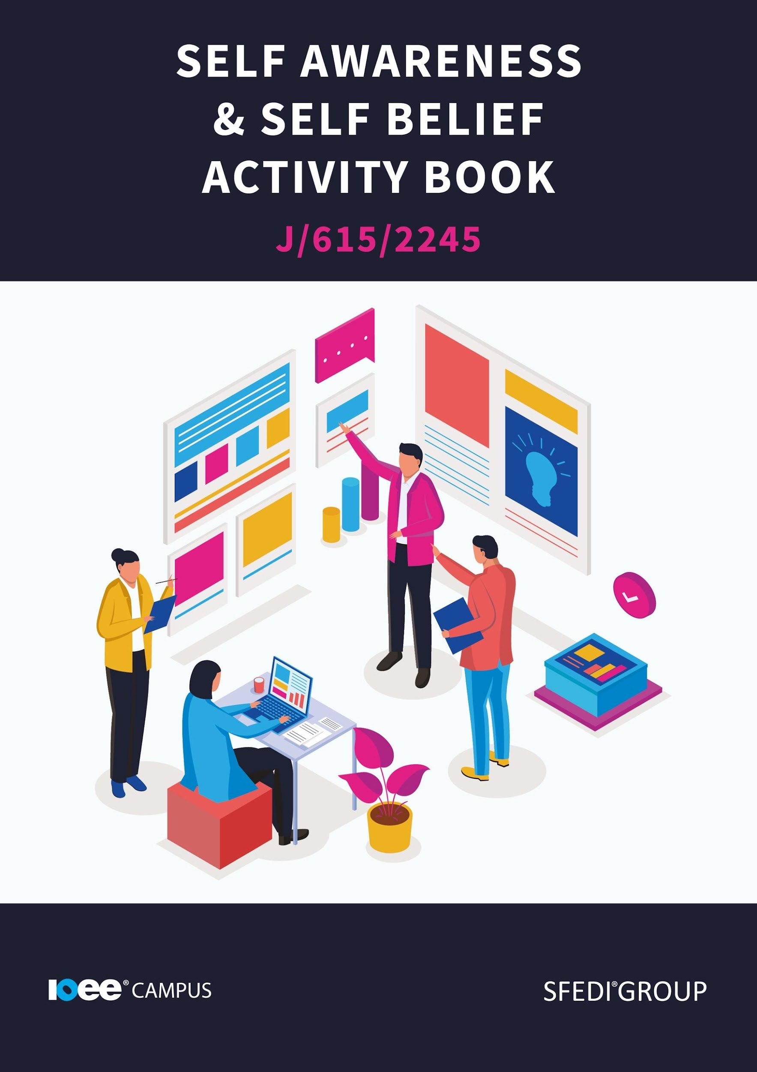

Introduction

This workbook has been developed so that you are able to collect and present evidence that demonstrates your knowledge and skills in relation to stress and stress management.

There are different sections that make up this workbook in order to make sure you are able to complete all of the tasks necessary, but you will be provided with support as you move along by your Assessor.

Further learning materials and support is available through your studying membership of the Institute of Enterprise and Entrepreneurs. If you haven’t yet received your login, please speak to your Assessor who will be happy to sort this out for you.

This unit contains two learning outcomes and will support you to be able to:

Be able to demonstrate self-belief through completing tasks

- Identify own needs, wants, interests and goals
- Identify own strengths and areas for improvement

Be able to demonstrate self-belief through completing tasks:

- Drive to contribute to something that is good for self or others
- Passion and willingness to achieve goals and face challenges
- Determination and not giving up when facing difficulties
- Recognition that resources are not unlimited
- Valuing of possessions and using them responsibly
- Time management
- Seeking the views and opinions of others
- Clear communication with others

The evidence within this workbook will be assessed by,

Assessor Name:

and will be quality assured by,

Internal Quality Assurer Name:

Copyright © 2020 SFEDI Enterprises Ltd

All rights reserved. This book or any portion thereof may not be reproduced or used in any manner whatsoever without the express written permission of the publisher (address below).

Approved SFEDI Awards centres and learners undertaking a SFEDI Awards qualification may photocopy this document free of charge and/or include a PDF version on its intranet where it is only done so for the purposes of the approved delivery of this qualification.

SFEDI Enterprises Ltd t/a SFEDI Awards
19 Victoria Rd
Darlington
DL1 5SF
www.sfedigroup.com

Every effort has been made to ensure that the information contained in this publication is true and accurate at the time of publication. However, SFEDI Enterprises t/a SFEDI Awards strives to continually develop and improve our qualifications and, as such, there may be occasions where changes are required. SFEDI Enterprises t/a SFEDI Awards does not accept liability for any loss or damage arising from the use of the information contained within this publication.
Introduction

Key Terms

Identify - Within this unit, you will have to identify situations, wants and needs. Identify means to highlight key points and give enough detail so that someone else can recognise your description.

Task - Within this unit, you will find small tasks to complete.

These tasks are designed to boost your self-discovery, test your knowledge and help you understand the information.

Reflection - Within this unit, you will be asked to reflect on moments in your life and decision making etc. These tasks are designed to allow you to connect to the material and apply the information to your own life.

Activity - This is the assessed piece of work that you must complete. When you come across an ‘Activity’ sign, head over to the sign posted page number in your activity workbook.

What is self-awareness?

Self-awareness is one of those skills that we often don't realise we are developing, as it seems to happen naturally. Throughout our lives, we may develop this skill by completing simple day to day tasks. Self-awareness is “understanding one's thoughts, feelings, values and background and how they impact the success of the interaction and relationship, or how they may influence one's work” (British Columbia Gov). Merriam Webster defines it as “an awareness of one's own personality or individuality”.

- Self-awareness comes about by identifying different elements of your life.
- What are your individual core needs?
- What do you want?
- What are you interested in?
- What are your long term, and short term, goals?

Identifying these areas is one of the first steps to self-awareness. To help you discover your own wants, needs and goals, it's important to know how different elements of your life affect your experiences.

Self-awareness, self-belief and reflecting on your actions can be the first step in many different paths. If you’re looking to start a new career, educational journey or relationship, being aware of yourself is important.

Needs and Wants

Do you NEED that?

Task: Before we start learning about wants, needs, goals and interests, try and make a list of what your wants and needs are. This can be generally or for a specific outcome. This list does not need to be too long, as long as it paints a basic picture of what your wants and needs are, this will work. Once you have made a list of what you want and what you need, set it aside and continue with the rest of the unit.

During your self-awareness journey, you will find yourself identifying your wants and needs. They may be short term, or they may be long term. Sometimes your wants and needs may seem to overlap. But, when you begin to consider their role in your life, they are quite different.

Definition: To recognise the difference between a need and a want, let’s look at a definition of the two words. Here are our definitions.

Need - A need is something thought to be a necessity or essential item required for life.

Want - A want is something that you would like and which increases the quality of life.

We may find ourselves saying we need to have something, perhaps in the form of chocolate bars, collectables, shoes or that fancy new games console. But do we need these items? The short answer is, no. These items are things we may want, but they aren’t essential or required for life. They make our lives more comfortable, and more glamorous. A list of things we need could be food, water, a safe place to sleep and warmth. When we look at a list of our wants and needs, we can see how different these two things are from each other.

Task - Go through your list of needs and see what you can move over to the ‘want’ section. Do you have things on that list that you can live without?

Reflection - How are your definitions different to the ones provided in this booklet? Do you think you have a clear idea of what want and need are? Did you think the two words meant the same thing?

Your Assessor will support you to plan how best to demonstrate your knowledge and skills which may be through the completion of the activities within this workbook or may include additional tasks best suited to you.

If any additional tasks are to be completed these will be listed in the table below with target dates for which you should try your best to complete each task listed.

Task | Target Date | Re-planned Target Date
Completion of the activities included within this workbook

By signing below, you agree to completing the work as detailed above and working with your Assessor to achieve this by the deadlines indicated.

Learner Name:

Signature:

Date:

Assessor Name:

Signature:

Date:

Activity One

The Hierarchy of Needs

One theorist, Abraham Maslow, developed a theory called ‘the hierarchy of needs’. A hierarchy is a way to organise things, in order of priority. This could be in order or importance, need or value to you. This theory puts the needs of a person in order, based on their place and function in life. For example, a stage one need would be food. A stage five need would be self-actualisation (becoming the best version of yourself). This is because food is something that we do need to survive. We do not need to develop as people in order to exist on the planet. Becoming a better version of ourselves is what Maslow calls a growth need. A growth need is a need for people who feel a need to develop. These people have already achieved the other needs in their life and are able to focus on self-development.

You must achieve the other needs on the lower levels before climbing up the pyramid to the growth needs. The higher up the pyramid, the less a person needs that element. If we try to achieve a stage five need before we have our stage one needs, we may struggle or even fail.

A summary of the theory is as follows:

Human beings have different needs. These needs all have a different level of importance, and these fall into a hierarchy. The most important needs form the base of the pyramid. The further up the pyramid we go, the less we need that thing.

We must have the basic stage needs before we try to fulfil other stage needs.

The needs are not set into certain levels (Security and safety may be a stage one need for some people and it may be stage two for others). This is due to external factors that may affect a person’s life experience.

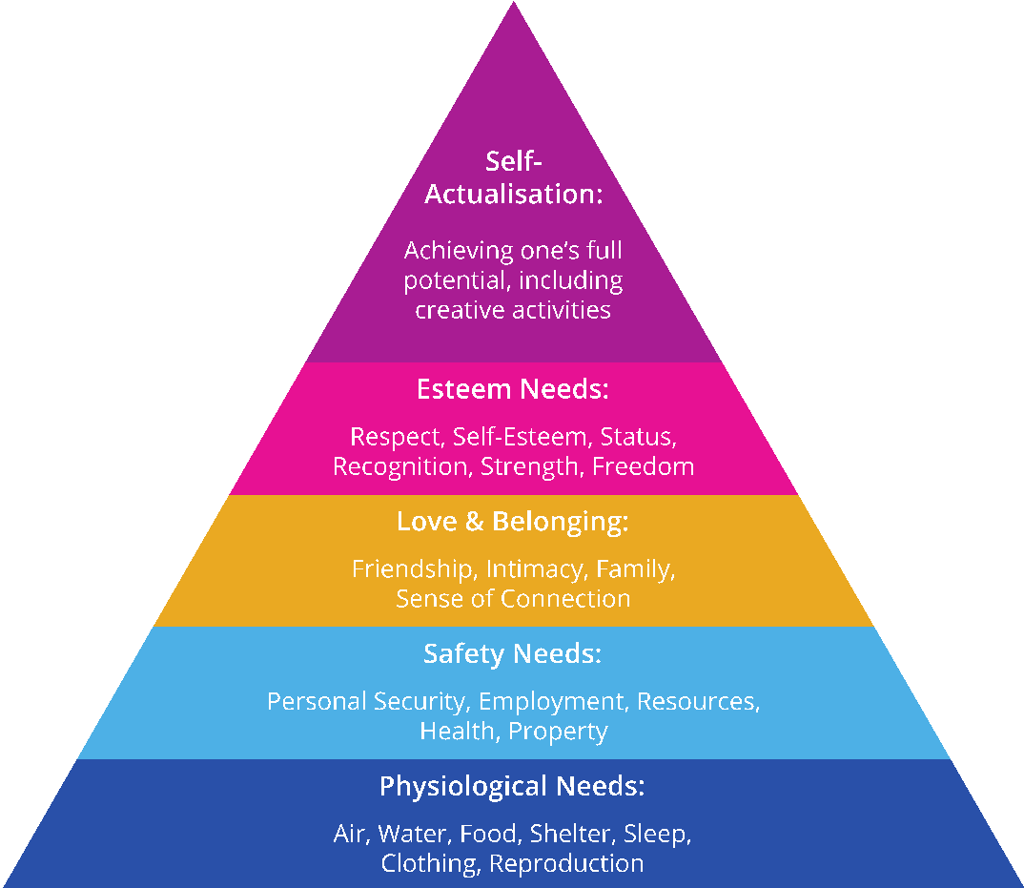

Hobbies and interests

Each person must have hobbies, interests and things they find enjoyable in life. We all have certain activities that we enjoy doing more than others. Perhaps you enjoy visiting galleries, or maybe you enjoy a bit of retail therapy. You may enjoy the challenge of a demanding job or the freedom of being your own boss. Interests, hobbies and enjoyment are important in our lives and personal development.

One part of being self-aware is being able to identify what brings happiness and enjoyment into your life. Of course, life can't all be fun and games, and so we do need to find a balance between what we enjoy in our personal lives and what we enjoy in our careers. There may be some crossover, such as enjoying challenging situations which could occur in your personal life and your career. But it is important to find a healthy balance between career interests and personal interests.

Reflection and Task: Take a moment to think about your life. What do you enjoy doing? Do you have a list of interests? Is there anything you want to get involved in? Make a list of your interests and hobbies and reflect on how much enjoyment they bring to your life.

Another step in self-awareness is being able to identify your own goals or targets. These targets may be long term or short term. These goals may also fit into your list of needs, or they may be more of a pass time and something you want.

Are your targets smarter than a ten-year-old?

Almost everyone will have set themselves targets at some point or another. Big or little, setting ourselves these goals can allow us to check in with our progress. These goals also allow us to set ourselves an amount of work to complete in a certain amount of time. These goals could be for day to day tasks. It could be that we want to get the ironing done by 7 pm at the latest, or we will have all our work done by 5 pm on a Friday. Sometimes, though, these targets aren't achievable. That could be because your targets aren’t smart enough.

SMART, which means Specific, Measurable, Achievable, Relevant and Time-bound, targets are one way to keep everything on track and be able to see where you are progressing, as well as the areas that need a little more development.

So, what makes a SMART target?

To set a SMART target, you will need to pick a specific goal that you want to achieve. This can be anything but you must be as specific as possible. This way, you can see if you have met that specific criterion.

Saying you want to finish a course is not a specific enough target. A specific target could be that you want to finish the Self Awareness and Self Belief unit of your course. This gives you more clarity and allows you to reflect on whether you have achieved that specific goal.

Your target must be measurable too, so what do you want to complete? Saying you want to finish a course is not specific enough. Set yourself a grade goal, or say that you want a certain amount of marks. This will allow you to measure your success and help you develop your skills and learning further down the line, which could lead to better grades.

Make sure your target is achievable. There is little, to no point, in setting yourself unrealistic targets. If your targets are too hard to achieve, you could end up with no tasks completed. You may feel defeated, because you never seem to achieve what you have set for yourself. If you miss one deadline, because a task wasn't achievable, you could start a domino rally of tasks that you don't get around to. So try setting yourself ambitious but realistic targets.

What is a realistic goal and what is an unrealistic goal?

It is important, when setting yourself goals, to make sure that they are realistic and achievable. Ambition and drive is always good, but make sure that what you are aiming for can happen.

Recognising what is realistic versus what is an unrealistic goal will help you to make choices in the future.

To set achievable goals, consider what you have to put into the goal. How much time will it take to achieve it and do you have the resources to get to the end? There is no shame in admitting that things may take a little longer than you first expected, or admitting that you aren't quite ready at the moment to achieve your goal.

Your target has to be relevant too. If you try to complete all of the tasks that are available (such as cleaning the house and finishing your painting) you will run out of time to focus on the important tasks (such as your self-development, or that business idea you wanted to try out). Making your target relevant to the goal you want to achieve is important to the success of your plan. Think of the relevance of your target as your motivation or reason to complete the target. Where will it lead you? Is this task important? Does this task aid your journey or is it a decoration (again thinking back to the wants and needs)?

Time is important when it comes to setting SMART targets, so set yourself a time limit. Not setting a time limit could lead you to miss a deadline or put extra pressure on yourself later on. Setting a time limit will allow you to know when to have a job finished and when to move on to the next task. By having a final deadline, you can also prepare smaller check-ins to enable you to keep pushing forward and stay on track.

Reflection - Would you say that your target setting is realistic or unrealistic? Have you ever set yourself a target that you have been unable to achieve? How would you make that target a SMART target?

At this point, we must think, is the goal long term or short term? But what is the difference?

Long-term and short-term goals

The difference between a long term and short-term goal may seem pretty obvious, but when we are making lists of goals, we may lose track of which is which. Having a definition to think back to makes the task easier.

A long-term goal is an aim that may take some time to achieve. These goals usually take some time to plan. This could be moving into your first home, going to University or College, getting work experience or working your way up the career ladder.

A short-term goal is something that can be achieved in a short amount of time. These goals usually do not need that much planning, if they require any at all. This goal could be saving up for a one-off purchase or taking a short class.

When setting yourself goals and listing your wants and needs, it is important to separate your work life and your personal life. By doing this you will be able to see where you aim to be in each aspect of your life without feeling overwhelmed.

Let’s look at some examples, and compare the long-term goals and the short-term goals:

Long term goal:

Setting up a new business would be a long-term goal. This would take at least a few months, some level of planning as well as plenty of resources to achieve this goal. A long-term goal would be something that you would need to consider before any action.

Short term goal:

Saving money to buy a new computer may take a few months to save the funds for, but it should be achievable within a year (depending on your financial situation). Once the purchase has been made, the goal has been achieved.

Note the difference in the amount of time it takes to complete each goal, as well as the number of resources needed to reach it.

Separating our wants, needs, goals and interests is an important task that we all must do to be aware of ourselves.

Reflection - Would you know what your long-term goals are, and what your short-term goals are? Do you have any long-term goals? It may be useful to list them and keep track of your

Reflection - What do you think your hierarchy of needs are? Do you know the priority of your needs?

Using the table below, identify your goals, interests, needs or wants in your personal, family and/or work life. These should be personal to you as this will best help you to identify what you need and how to achieve them in the future

Outcome | Goal (G)  Interest (I)  Need (N)  or Want (W) | Family (F)  Personal (P)  Or Work (W) | Timeframe for achievement | How it will be achieved?

Activity Two

Strengths and weaknesses

Each individual possesses their own strengths and weaknesses. The term weakness is sometimes seen negatively. Identifying a weakness is understanding that there are areas of yourself that need to grow to complete the task at hand. When thinking of our own strengths and weaknesses, it is important to remain truthful. If you are honest with yourself during this section, you will get the most out of it. By pretending that we have no strengths or weaknesses, we stop ourselves from developing. By not allowing ourselves to develop, we stop ourselves from becoming better people. So when listing strengths and weaknesses try to be as honest as possible. If you are good at something, note it down. If you feel like you could do better in one element of your life, note it down. This is the start of your upswing. You must be honest with yourself. This applies to what you want to achieve and whether you are or aren’t good at something.

You can use a device known as a SWOT analysis to identify your areas of strength, weakness, threat and opportunities.

Threats and Opportunities are different to strengths and weaknesses. When listing what may be a threat (or an external threat), think about what obstacles you may face. This does not include being less skilled in that area, as that would come under weakness.

For example, a threat could be not having enough resources and having to apply for a loan. This would be a threat as you are unable to say for definite whether you can get approved for the loan. At this point, you are unable to state whether the plan will work as expected.

An opportunity is your goal or the little goals that you have before achieving the final task. So in this section of your SWOT analysis, you would list off things that you will be able to do along the way. For example, hiring people into your business. This is a step that you will take to reach your end target, whatever that may be.

Below is an example of what a SWOT analysis may look like.

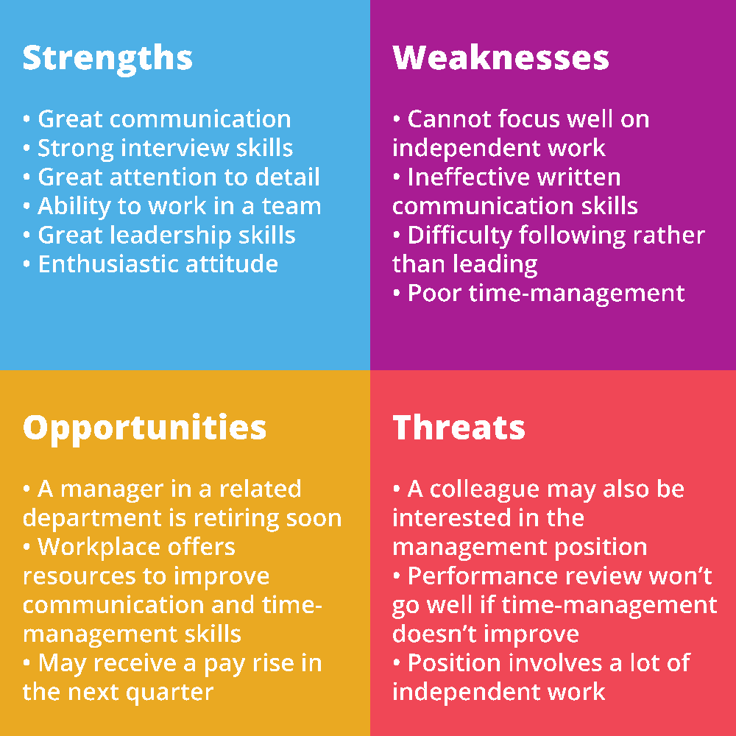
(Scribendi, 2021)

For each of the outcomes you have identified, think of your current strengths and areas for development. What do you currently have that will help you to achieve the outcome and what do you need to develop before being able to achieve it. This could be an ability, a behaviour, knowledge or a skill.

Outcome | What current strengths do you have that will help you achieve this? | What do you need to develop further to help you to achieve this?

Now use the table below to plan how you can develop the abilities, behaviours, knowledge or skills that you have identified as needing development to help you to achieve your desired outcomes.

Ability, behaviour, knowledge or skill to be developed | Activity to be completed | Deadline for completion | Method of reviewing success of the outcome on your own development
eg. problem solving | Read about ways of identifying and thinking through problems | 1 month | Put into practice my problem-solving technique and see how I have done and further ways of improving

Activity Three

Self-belief

Your goals, wants, needs and interests can all stem from your personality, past experiences and the version of yourself you want to create. This could be a different personality in a certain situation (like a work persona), or it could be a developed version of your current self.

Personality tests, such as the Myers Briggs test, allow you to see your personality type. These tests ask a few 'agree or disagree' questions before showing you your results. (I am INFJ, which is an Intuitive Introvert of Feeling and Judgement). This may seem unrelated, but your personality will say a lot about what you are aiming for. It can also tell you what you feel you need to succeed and what is not that important to you.

Task: Personality test

Why not take a personality test, and see how your decisions stem from your personality? You can then use these results to see how your personality affects other areas of your life. You may like to consider all aspects of a decision, or you're able to understand subjects without needing a background in that area. This all comes from your level of intuition.

Reflection - Once you have your results, take a moment to reflect on how your personality comes across.

Research shows that human beings often find it hard to identify our own strengths (and sometimes weaknesses), so your SWOT analysis may have more weaknesses than positives or more positives than weaknesses (Boyes, 2018).

Try to find a level playing field for you to base your list on. Every individual has things they excel with and things they can improve, it is what makes us human.

Even by commenting on your strengths and weaknesses, you have added to your list of strengths. Emotional intelligence is a strength in its own way. Being able to understand your own emotions, as well as the emotions of those that are around us, is a skill that shows growth and maturity.

Self-belief is the ability to understand where you fit into situations. It is also knowing how your actions affect situations and being able to explain the difference your presence has made. Small decisions, such as holding a door open for someone, can have larger effects later on. These decisions change the way people understand you as a person, colleague, friend or family member. Reflecting on these small actions could allow you to work more effectively.

You will find that on your self-awareness journey, you may have to look back on situations in which you were setting targets. You may have to think back to your wants or needs. When you have been reflecting, you will have been practising self-belief. Noting the changes you make and the ability to control your own path is all part of self-belief. Being able to compare your wants and needs is also part of self-belief.

Another part of self-belief and awareness is being able to note the challenges and problems you have faced. It is important to be able to comment on the reason why they happened as well as how you could avoid them next time.

Some challenges may occur at work, some may occur through day-to-day life. We must identify these challenges. We should then reflect on how they occurred and how they can be solved.

Some tasks, or situations, need us to use some of our skills to complete the job or solve an issue. These skills include drive to contribute to something that is good for self or others, passion and willingness to achieve goals and face challenges, determination and not giving up when facing difficulties, recognition that resources are not unlimited, valuing of possessions and using them responsibly, time management, seeking the views and opinions of others and clear communication with others.

Some examples of using those skills are as follows:

- Drive to contribute to something that is good for self or others. This means working on a task that has an impact on yourself or other people. As well as continuing to do so even when you face challenges.
- Passion and willingness. This is showing that you are working and interested in the task that you are working on. You must show that you are willing to put effort into the task.
- Determination and not giving up. Continuing to work on your task even when you face a difficult decision or an issue with the work. Not giving up on the task and ensuring to complete it.
- Recognition of resources. Understanding that resources (time, money or expertise) have a cut-off and are not unlimited. Efficiently make use of the resources.
- Valuing of possessions. Understanding the value of items and objects. Making sure you use them responsibly. This could increase your productivity.
- Time management. Setting yourself deadlines, and check-ins along the way to make sure you complete the task on time.
- Seeking the views of others. Checking in with your colleagues or peers to get their view on things you are doing or ideas you have. This makes the task more of a team effort.
- Clear communication. Talking or engaging with other people in a clear, concise and accessible way.

Task: Take a look at the following case studies. As you read through the case studies, highlight the skills Keith and Steph have used. It may be worth noting how the skills helped complete the task.

A day in the life of: Keith

Keith has been working in sales for roughly three years now. He has worked for the same company, TreeTop Timber LTD for just over two years. He enjoys his job, even on difficult days. His job requires him to work as part of a team, as well as working independently, and Keith enjoys both aspects. Last week, in his meeting with his manager, Keith had to present his sales record. This included a list of sales enquiries, a list of new clients and how that would affect the business. Before this meeting, Keith prepared an electronic script of what he wanted to say. He made sure this document was drafted well in advance of the meeting and kept adding to it as the week went on. This way he knew he wouldn’t miss any important clients off. By preparing the document, he would also be able to ask the questions he needed to. In the script, he spoke about the number of sales enquiries he had responded to. He then focused on one example and explained the plan for the product. Keith mentioned the resources he would need to complete the job, such as the use of factory equipment and the number of hours of labour it would take. His manager had brought up some potential issues with the order. Keith noted these down, to contact the customer later. Keith knew his manager was usually busy, so he tried to get all of the information he needed to contact the customer. Keith also asked for some pointers on how to handle the situation as he valued his manager's opinion. Later in the day, Keith spoke to the customer. He contacted them by telephone. The customer was slightly annoyed that their original plan could not go ahead and let their frustrations out towards Keith. He calmly told the customer what they could do and continued to explain the plan, so the customer knew what the next steps were. He apologised to the customer for the inconvenience and was able to calm them down. The customer agreed to the proposed plan of action and the call ended. Keith then reported this to his manager, made a note of this in his diary. He was to report back to his customer once the items had been prepared for shipping. When the time came, and he received word that the product was ready for shipping, Keith called his customer. He explained the shipping process and gave them an expected delivery date. When the product had been delivered, Keith crossed their order number off the list and moved on to the next task.

A day in the life of: Steph

Steph, a mother of 2 children, had planned to take the children out for the day. She had planned to take them swimming, which would require a bus journey. She had the bus fare ready and their swimming bags were packed. She asked her husband to supervise the children for a moment as she walked to the end of the road. She checked the bus timetable and realised that the bus service she would have used was not operating on that day. She returned to the house and told her husband that the buses would not be operating. Steph had forgotten that there were planned road closures in her area. As soon as she remembered she let out a sigh. Steph explained to the children that there had been a change of plan. She thought the children would be upset and cry, but she explained calmly that there was nothing she could do about it. So Steph quickly began planning something new to do. She offered them the choice of a day at the park or a day of playing with their toys in the house. The children chose to go to the park for the day. When the family got to the park, Steph wanted to make sure the children followed some rules. She told them to stay where she could see them, and make sure they stayed together. Steph played with the children for a little bit, as she loved spending time with her children. After a while, she went to sit on a nearby bench. She made sure the children knew where she was going to be sat and reminded them to stay where she could see them. After a few hours, the children were tired, and Steph decided to take them home. On the way home, Steph received a text message from her sister asking how swimming was. When Steph got home, she called her sister on the phone. She told her sister that they did not go swimming and that they went for a day out at the park instead. She asked if she had done the right thing by offering them an alternative day out. She wanted to get the opinion of her sister as her sister is also the mother of a child. After a long day the children went to bed, and Steph sat at the dining table feeling like she had succeeded.

Reflection - When faced with a challenge, do you try to think of ways to avoid it in the future? Do you put strategies in place to try to minimise the frequency of these occurring?

It’s great having plans for the future and understanding your strengths and areas for development but to really succeed you need to believe in yourself and your ability to complete tasks effectively to support yourself and others.

Think of a situation where you have successfully completed a task and use the boxes below to explain what you did successfully and how you managed to work towards the outcome.

Describe the task you were completing and the reasons why you needed to complete the task including how it would benefit you and/or others.

What milestone(s) or goal(s) did you have to meet in completing the task?

Was there a timeframe for completing the task and, if so, what was it? How did you make sure you stuck to your timeframe by managing your time appropriately?

Describe the steps you followed and actions you took in order to complete the task

What resources, both physical and non-physical, did you need in order to complete the task and how did you make sure that you didn’t run out? How you protected the resources from damage or misuse?

Did you seek help from anyone else to complete the task or to get feedback from anyone else on how you were progressing? How did they help you to complete the task? What skills did you use to communicate with them?

Using the table below, explain any challenges that you had to overcome and the methods you used to overcome them

Description of the challenge | Method used to overcome the challenge

Use the box below to explain any of the activities you had to re-plan as a result of the challenges you faced and the impact this had on the overall completion of the task

What did you learn about your abilities, behaviours, knowledge and skills by completing the tasks? Is there anything you would have done differently?

Activity Mapping

Now you have completed the activities to demonstrate your knowledge and skills it is time for your Assessor to map your work against the standards listed below.

By doing this they will be making sure that the work you have provided by completing the activities meets the requirements for you to gain your certificate.

Your Assessor will provide you with feedback on how you have done and whether any more work may be required.

Assessment Criterion – The Leaner can: | Activity Number or Reference Number of Additional Activities: | Assessor Signed Off (✓/✗):
Identify own needs, wants, interests and goals | 1
Identify own strengths and areas for improvement | 2
Identify a situation where a task has been completed successfully demonstrating the following:  - Drive to contribute to something that is good for self or others  - Passion and willingness to achieve goals and face challenges  - Determination and not giving up when facing difficulties  - Recognition that resources are not unlimited  - Valuing of possessions and using them responsibly  - Time management  - Seeking the views and opinions of others  - Clear communication with others | 3

Assessor Feedback

Authenticity Declarations

Learner Declaration

By signing this declaration, you agree that the evidence provided within this workbook has been produced by you and meets the requirements of being authentic, sufficient, valid and current to the standards required.

Learner Signature:

Date:

Assessor Declaration

By signing this declaration, you agree that you have assessed all of the evidence produced within this workbook and have ensured that the work is that of the learner. You are also declaring that during the learning process you have ensured that the evidence is authentic, sufficient, valid and current to the standards required.

Assessor Signature:

Date:

IQA Signature (if applicable):

Date:

Additional Evidence Forms

Use these additional forms in order to record additional evidence for the activities within this workbook where additional space is required.

Ensure that each piece of evidence entered on these forms is clearly labelled with the corresponding activity number.

Helpful Resources & References

Helpful resources:

SWOT analysis - Personal SWOT Analysis - Career Planning from MindTools.com

Emotional Intelligence - Test your emotional intelligence

Self-belief activities - Activity: build your self-belief - Self-belief: thinking positively about yourself and your abilities - LibGuides at Teesside University

Self-esteem tools - 7 Most Effective Self-Esteem Tools and Activities (positivepsychology.com)

TEDx Talk - A guide to believing in yourself (But for real this time).

Myers Briggs Personality Test - Personality Type Indicator (my-personality-test.com)

References:

Barron, K., 2021. Why Self-Awareness Is Important: Benefits, Tips, and Examples - TCK Publishing. [online] TCK Publishing. Available at: <https://www.tckpublishing.com/self-awareness/> [Accessed 25 June 2021].

Boyes, A., 2018. 6 Reasons It's Hard to See Your Own Strengths. [online] Psychology Today. Available at: <https://www.psychologytoday.com/gb/blog/in-practice/201809/6-reasons-its-hard-see-your-own-strengths> [Accessed 23 June 2021].

Eurich, T., 2017. Increase your self-awareness with one simple fix | Tasha Eurich | TEDxMileHigh. [image] Available at: <https://www.youtube.com/watch?v=tGdsOXZpyWE> [Accessed 25 June 2021].

McLeod, S., 2020. Maslow's Hierarchy of Needs. [online] Simplypsychology.org. Available at: <https://www.simplypsychology.org/maslow.html> [Accessed 23 June 2021].

Merriam Webster – definition: Self-awareness | Definition of Self-awareness by Merriam-Webster

Scribendi. 2021. Scribendi. [ONLINE] Available at: https://www.scribendi.com/academy/articles/how_to_write_a_swot_analysis.en.html. [Accessed 6 September 2021].

Www2.gov.bc.ca. n.d. Self-discovery & Awareness - Province of British Columbia. [online] Available at: <https://www2.gov.bc.ca/gov/content/careers-myhr/job-seekers/about-competencies/indigenous-relations/self-discovery-awareness> [Accessed 23 June 2021].

SFEDI Enterprises Ltd t/a SFEDI Awards
19 Victoria Rd
Darlington
DL1 5SF
www.sfedigroup.com

customerservices@sfediawards.com
0845 224 5928
@sfediawards

