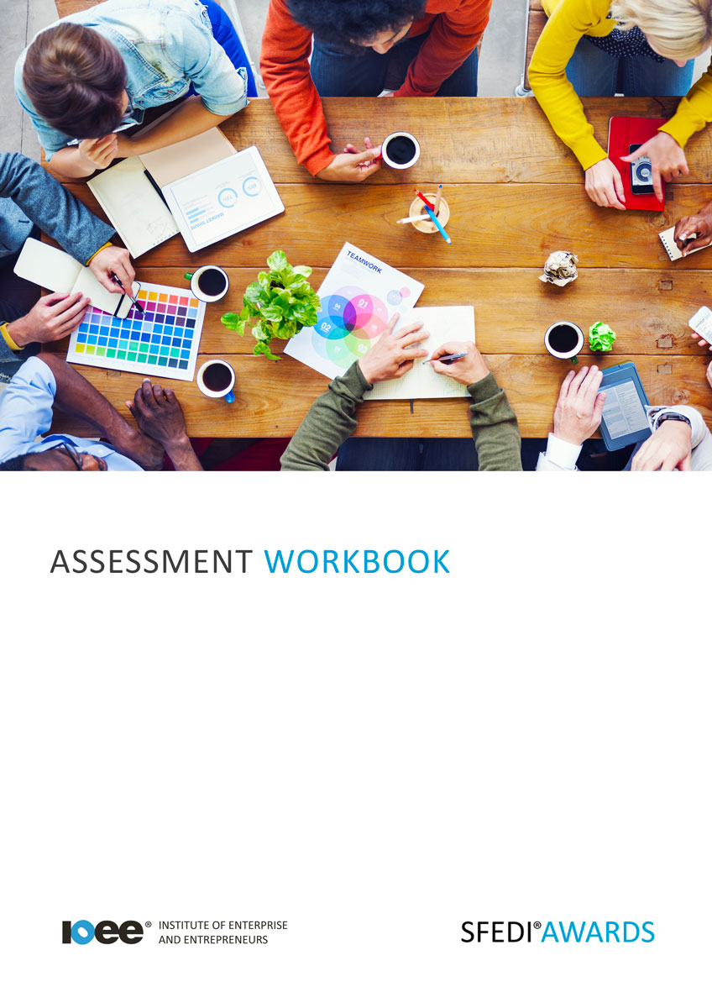

*Self-Awareness and Self-Belief J/615/2245*

Copyright © 2020 SFEDI Enterprises Ltd

All rights reserved. This book or any portion thereof may not be reproduced or used in any manner whatsoever without the express written permission of the publisher (address below).

Approved SFEDI Awards centres and learners undertaking a SFEDI Awards qualification may photocopy this document free of charge and/or include a PDF version on its intranet where it is only done so for the purposes of the approved delivery of this qualification.

SFEDI Enterprises Ltd t/a SFEDI Awards

19 Victoria Road

Darlington

DL1 5SF

[www.sfedigroup.com](http://www.sfedigroup.com/)

Every effort has been made to ensure that the information contained in this publication is true and accurate at the time of publication. However, SFEDI Enterprises t/a SFEDI Awards strives to continually develop and improve our qualifications and, as such, there may be occasions where changes are required. SFEDI Enterprises t/a SFEDI Awards does not accept liability for any loss or damage arising from the use of the information contained within this publication.

# Introduction

This workbook has been developed so that you are able to collect and present evidence that demonstrates your knowledge and skills in relation to the development of self-awareness and self- belief.

There are different sections that make up this workbook in order to make sure you are able to complete all of the tasks necessary but you will be provided with support as you move along by your Assessor.

Further learning materials and support is available through your studying membership of the Institute of Enterprise and Entrepreneurs. If you haven’t yet received your login please speak to your Assessor who will be happy to sort this out for you.

This unit contains two learning outcomes and will support you to be able to:

* Demonstrate self-awareness
* Demonstrate self-belief through completing tasks

The evidence within this workbook will be assessed by,

#### Assessor Name:

and will be quality assured by,

#### Internal Quality Assurer Name:

Your Assessor will support you to plan how best to demonstrate your knowledge and skills which may be through the completion of the activities within this workbook or may include additional tasks best suited to you.

If any additional tasks are to be completed these will be listed in the table below with target dates for which you should try your best to complete each task listed.

|  |  |  |
| --- | --- | --- |
| **Task** | **Target Date** | **Re-planned Target Date** |
| Completion of the activities included within this workbook |  |  |
|  |  |  |
|  |  |  |
|  |  |  |
|  |  |  |
|  |  |  |

By signing below you agree to completing the work as detailed above and working with your Assessor to achieve this by the deadlines indicated.

|  |  |  |
| --- | --- | --- |
| **Learner Name:** | **Signature:** | **Date:** |
| **Assessor Name:** | **Signature:** | **Date:** |

Activities

5

**Activity 1**

Using the table below, identify your goals, interests, needs or wants in your personal, family and/or work life. These should be personal to you as this will best help you to identify what you need and how to achieve them in the future

|  |  |  |  |  |
| --- | --- | --- | --- | --- |
| **Outcome** | **Goal (G), Interest (I), Need (N) or Want (W)** | **Family (F) Personal**  **(P) or Work**  **(W)** | **Timeframe for achievement** | **How it will be achieved?** |
|  |  |  |  |  |
|  |  |  |  |  |
|  |  |  |  |  |
|  |  |  |  |  |
|  |  |  |  |  |
|  |  |  |  |  |
|  |  |  |  |  |

6

### Activity 2

For each of the outcomes you have identified, think of your current strengths and areas for development. What do you currently have that will help you to achieve the outcome and what do you need to develop before being able to achieve it. This could be an ability, a behaviour, knowledge or a skill.

|  |  |  |
| --- | --- | --- |
| **Outcome** | **What current strengths do you have that will help you achieve this?** | **What do you need to develop further to help you to achieve this?** |
|  |  |  |
|  |  |  |
|  |  |  |
|  |  |  |
|  |  |  |
|  |  |  |
|  |  |  |

7

Now use the table below to plan how you can develop the abilities, behaviours, knowledge or skills that you have identified as needing

development to help you to achieve your desired outcomes.

|  |  |  |  |
| --- | --- | --- | --- |
| **Ability, behaviour, knowledge or skill to be developed** | **Activity to be completed** | **Deadline for completion** | **Method of reviewing success of the outcome on your own development** |
| *eg. problem solving* | *Read about ways of identifying and thinking through problems* | *1 month* | *Put into practice my problem solving technique and see how I have done and further ways of improving* |
|  |  |  |  |
|  |  |  |  |
|  |  |  |  |
|  |  |  |  |
|  |  |  |  |
|  |  |  |  |

### Activity 3

It’s great having plans for the future and understanding your strengths and areas for development but to really succeed you need to believe in yourself and your ability to complete tasks effectively to support yourself and others.

Think of a situation where you have successfully completed a task and use the boxes below to explain what you did successfully and how you managed to work towards the outcome

Describe the task you were completing and the reasons why you needed to complete the task

including how it would benefit you and/or others

|  |
| --- |
|  |

What milestone(s) or goal(s) did you have to meet in completing the task?

|  |
| --- |
|  |

Was there a timeframe for completing the task and, if so, what was it? How did you make sure you stuck to your timeframe by managing your time appropriately?

|  |
| --- |
|  |

Describe the steps you followed and actions you took in order to complete the task

|  |
| --- |
|  |

What resources, both physical and non-physical, did you need in order to complete the task and how did you make sure that you didn’t run out? How you protected the resources from damage or misuse?

|  |
| --- |
|  |

Did you seek help from anyone else to complete the task or to get feedback from anyone else on how you were progressing? How did they help you to complete the task? What skills did you use to communicate with them?

|  |
| --- |
|  |

Using the table below, explain any challenges that you had to overcome and the methods you used to overcome them

|  |  |
| --- | --- |
| **Description of the challenge** | **Method used to overcome the challenge** |
|  |  |
|  |  |
|  |  |
|  |  |
|  |  |

Use the box below to explain any of the activities you had to re-plan as a result of the challenges you faced and the impact this had on the overall completion of the task

|  |
| --- |
|  |

What did you learn about your abilities, behaviours, knowledge and skills by completing the tasks? Is there anything you would have done differently?

|  |
| --- |
|  |

# Activity Mapping

Now you have completed the activities to demonstrate your knowledge and skills it is time for your Assessor to map your work against the standards listed below.

By doing this they will be making sure that the work you have provided by completing the activities

meets the requirements for you to gain your certificate.

Your Assessor will provide you with feedback on how you have done and whether any more work may be required.

|  |  |  |
| --- | --- | --- |
| **Assessment Criterion - The learner can:** | **Activity Number or Reference Number of Additional Activities:** | **Assessor Signed**  **Off (**✓**/**✗**):** |
| Identify own needs, wants, interests and goals | 1 |  |
| Identify own strengths and areas for improvement | 2 |  |
| Identify a situation where a task has been completed successfully demonstrating the following:   * Drive to contribute to something that is good for self or others * Passion and willingness to achieve goals and face challenges * Determination and not giving up when facing   difficulties   * Recognition that resources are not unlimited * Valuing of possessions and using them responsibly * Time management * Seeking the views and opinions of others * Clear communication with others | 3 |  |

# Assessor Feedback

|  |
| --- |
|  |

Authenticity Declarations

## Learner Declaration

By signing this declaration you agree that the evidence provided within this workbook has been produced by you and meets the requirements of being authentic, sufficient, valid and current to the standards required.

#### Learner Signature: Date:

**Assessor Declaration**

By signing this declaration you agree that you have assessed all of the evidence produced within this workbook and have ensured that the work is that of the learner. You are also declaring that during the learning process you have ensured that the evidence is authentic, sufficient, valid and current to the standards required.

#### Assessor Signature: Date:

**IQA Signature (if applicable): Date:**

Additional Evidence Forms

Use these additional forms in order to record additional evidence for the activities within this workbook where additional space is required.

Ensure that each piece of evidence entered on these forms is clearly labelled with the corresponding activity number.

|  |
| --- |
|  |

|  |
| --- |
|  |

|  |
| --- |
|  |

|  |
| --- |
|  |

|  |
| --- |
|  |

|  |
| --- |
|  |

SFEDI Awards

19 Victoria Road

Darlington

DL1 5SF

[customerservices@sfediawards.com](mailto:customerservices@sfediawards.com) 0845 224 5928

@sfediawards