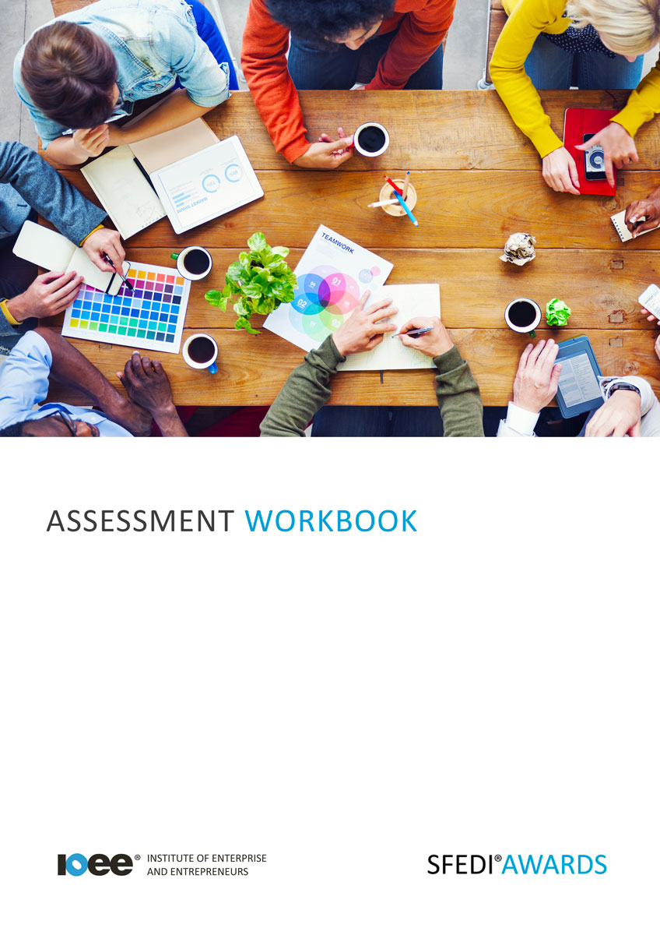

Stress and Stress Management
A/615/2744
A/615/2744

Copyright © 2020 SFEDI Enterprises Ltd

All rights reserved. This book or any portion thereof may not be reproduced or used in any manner whatsoever without the express written permission of the publisher (address below).

Approved SFEDI Awards centres and learners undertaking a SFEDI Awards qualification may photocopy this document free of charge and/or include a PDF version on its intranet where it is only done so for the purposes of the approved delivery of this qualification.

SFEDI Enterprises Ltd t/a SFEDI Awards
19 Victoria Road
Darlington
DL1 5SF
www.sfedigroup.com

Every effort has been made to ensure that the information contained in this publication is true and accurate at the time of publication. However, SFEDI Enterprises t/a SFEDI Awards strives to continually develop and improve our qualifications and, as such, there may be occasions where changes are required. SFEDI Enterprises t/a SFEDI Awards does not accept liability for any loss or damage arising from the use of the information contained within this publication.

Introduction

This workbook has been developed so that you are able to collect and present evidence that demonstrates your knowledge and skills in relation stress and stress management.

There are different sections that make up this workbook in order to make sure you are able to complete all of the tasks necessary but you will be provided with support as you move along by your Assessor.

Further learning materials and support is available through your studying membership of the Institute of Enterprise and Entrepreneurs. If you haven’t yet received your login please speak to your Assessor who will be happy to sort this out for you.
This unit contains three learning outcomes and will support you to be able to:
- Understand what is meant by stress
- Understand the effects of stress
- Understand the causes and coping mechanisms for stress
The evidence within this workbook will be assessed by,

Assessor Name:

and will be quality assured by,

Internal Quality Assurer Name:

Your Assessor will support you to plan how best to demonstrate your knowledge and skills which may be through the completion of the activities within this workbook or may include additional tasks best suited to you.

If any additional tasks are to be completed these will be listed in the table below with target dates for which you should try your best to complete each task listed.

Task | Target Date | Re-planned Target Date
Completion of the activities included within this workbook

By signing below you agree to completing the work as detailed above and working with your Assessor to achieve this by the deadlines indicated.

Learner Name: | Signature: | Date:
Assessor Name: | Signature: | Date:

Activities

Activity 1

Using the box below, provide a definition for the term ‘stress’ that would help another person to
understand what it means

Stress Means…

Activity 2

Understanding the different types of stress that you may experience and the effects it can have is important. Using the boxes below provide a definition for the terms ‘acute stress’, ‘episodic acute stress’ and ‘chronic stress’ that would help another person to understand what they mean

Acute Stress Means…

Acute Stress can be caused by…

Episodic Stress means…

Episodic Stress can be caused by…

Chronic Stress means…

Chronic Stress can be caused by…

Stress has many different impacts both short and long term on people, their family and the wider
community, some of these impacts might be bad and some might even be good.

Using the table below, identify a minimum of one short term and one long term impact stress can have on you, your family and the wider community.

Impact on | Short term/long term | Description of the impact
You | Short term
You | Long term
Your family | Short term
Your family | Long term
Wider community | Short term
Wider community | Long term

Using what you have learnt so far, use the table below to explain situations where stress could be useful or harmful and why this is the case

Useful/harmful impact | Environment, eg. work, sport, etc. | Why is stress useful or harmful?
Useful |  | Stress in this situation is useful because.....
Harmful |  | Stress in this situation is harmful because.....

10

Activity 5
So now you understand the bigger picture and where stress can occur and the uses and harm it can bring but what about you? What causes you to feel stress?
This activity provides you with the opportunity to explore what may cause you to become stressed and ways in which you may be able to deal with the
situation you find yourself in.
Your Assessor is there to support you through this exercise so if you need help or want to talk through your ideas with your Assessor please do so as
they can often help out with difficult subjects.

Environment, eg. work, sport, etc. | What happens that causes you to feel stressed? | Who does you being stressed impact (you, family, community) | What are the impacts of the stress?

Now thinking of the situations you have identified, use the box below to identify methods you could
use to manage and deal with the stress in a healthy way.

This might not be to remove the stress completely, it may simply be to minimise the impact it has on you, your family or the community and make it more manageable so that you are still able to live a healthy and productive life.

So you now have coping mechanisms you can use to deal with stress but there is nothing wrong with speaking out and getting help as sometimes we can’t do it alone and need the support of others to help us work through a situation and reach the best outcome.

Using the table below, identify those you can speak with whether individuals, organisations or groups and how you can access them

Name of individual, organisation or group | Contact details | How can they support you to overcome stress?

Activity Mapping

Now you have completed the activities to demonstrate your knowledge and skills it is time for your Assessor to map your work against the standards listed below.
By doing this they will be making sure that the work you have provided by completing the activities
meets the requirements for you to gain your certificate.

Your Assessor will provide you with feedback on how you have done and whether any more work may be required.

Assessment Criterion - The learner can: | Activity Number or Reference Number of Additional Activities: | Assessor Signed  Off (✓/✗):
Explain what is meant by stress | 1
Identify the different types of stress | 2
Identify the short and long term effects of stress on  an individual, a family unit and the wider society | 3
Explain why stress can be both useful and harmful | 4
Identify a range of possible causes of stress | 2/5
Identify situations that trigger own stress | 5
Identify methods of managing and dealing with stress and stressful situations in a healthy way | 5
Identify the people and organisations that are available to support an individual to deal with stress and how to access them | 5

Assessor Feedback

Authenticity Declarations

Learner Declaration

By signing this declaration you agree that the evidence provided within this workbook has been produced by you and meets the requirements of being authentic, sufficient, valid and current to the standards required.

Learner Signature: Date:

Assessor Declaration

By signing this declaration you agree that you have assessed all of the evidence produced within this workbook and have ensured that the work is that of the learner. You are also declaring that during the learning process you have ensured that the evidence is authentic, sufficient, valid and current to the standards required.

Assessor Signature: Date:

IQA Signature (if applicable): Date:

Additional Evidence Forms

Use these additional forms in order to record additional evidence for the activities within this workbook where additional space is required.

Ensure that each piece of evidence entered on these forms is clearly labelled with the corresponding activity number.

SFEDI Awards
19 Victoria Road
Darlington
DL1 5SF

customerservices@sfediawards.com 0845 224 5928
@sfediawards

