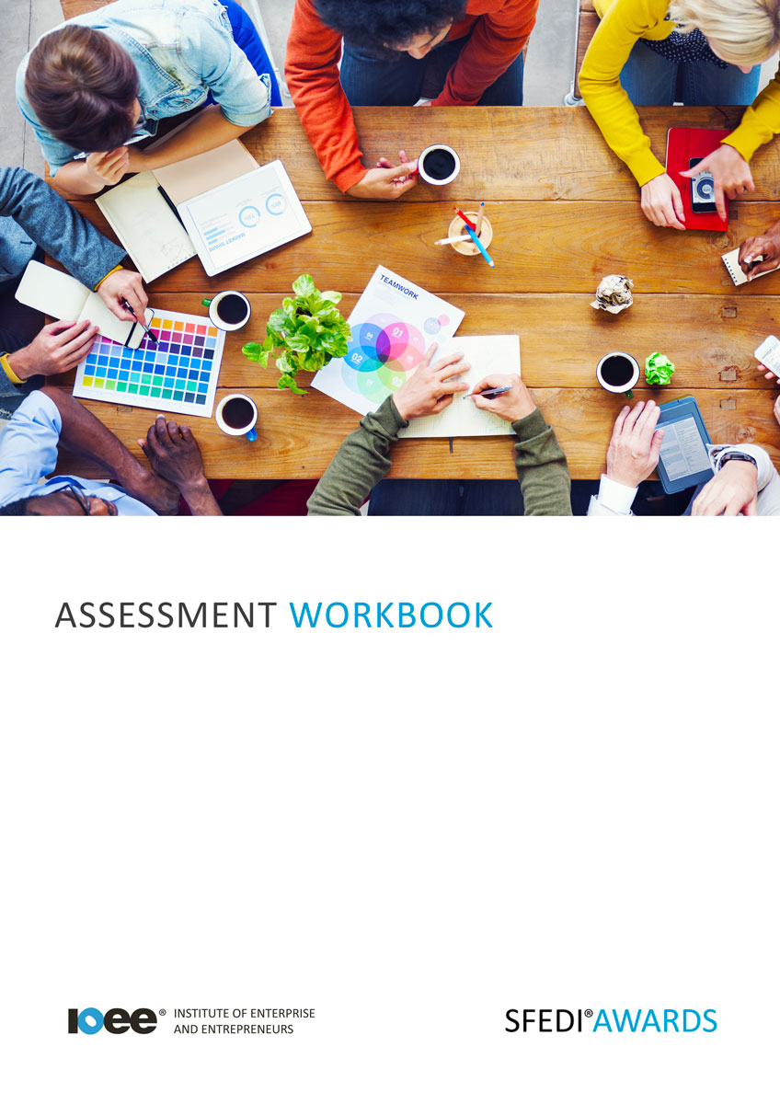

The Importance of Managing Personal Finance
L/615/2277

Copyright © 2020 SFEDI Enterprises Ltd

All rights reserved. This book or any portion thereof may not be reproduced or used in any manner whatsoever without the express written permission of the publisher (address below).

Approved SFEDI Awards centres and learners undertaking a SFEDI Awards qualification may photocopy this document free of charge and/or include a PDF version on its intranet where it is only done so for the purposes of the approved delivery of this qualification.

SFEDI Enterprises Ltd t/a SFEDI Awards
19 Victoria Road
Darlington
DL1 5SF
www.sfedigroup.com

Every effort has been made to ensure that the information contained in this publication is true and accurate at the time of publication. However, SFEDI Enterprises t/a SFEDI Awards strives to continually develop and improve our qualifications and, as such, there may be occasions where changes are required. SFEDI Enterprises t/a SFEDI Awards does not accept liability for any loss or damage arising from the use of the information contained within this publication.

Introduction

This workbook has been developed so that you are able to collect and present evidence that
demonstrates your knowledge and skills in relation to managing personal finance.

There are different sections that make up this workbook in order to make sure you are able to complete all of the tasks necessary but you will be provided with support as you move along by your Assessor.

Further learning materials and support is available through your studying membership of the Institute of Enterprise and Entrepreneurs. If you haven’t yet received your login please speak to your Assessor who will be happy to sort this out for you.
This unit contains two learning outcomes and will support you to be able to:
- Understand why personal money management is important
- Understand ways of managing own money effectively
The evidence within this workbook will be assessed by,

Assessor Name:

and will be quality assured by,

Internal Quality Assurer Name:

Your Assessor will support you to plan how best to demonstrate your knowledge and skills which may be through the completion of the activities within this workbook or may include additional tasks best suited to you.
If any additional tasks are to be completed these will be listed in the table below with target dates for
which you should try your best to complete each task listed.

Task | Target Date | Re-planned Target Date
Completion of the activities included within this workbook

By signing below you agree to completing the work as detailed above and working with your Assessor
to achieve this by the deadlines indicated.

Learner Name: | Signature: | Date:
Assessor Name: | Signature: | Date:

Activities

Activity 1

Using the box below, explain why it is important that you manage your money properly. What are the
consequences of not doing so?

Activity 2

Managing your money properly can have many different benefits and not just for you. Using the
boxes below, explain how managing your own money properly can help:
- you to achieve your personal goals
- others within your immediate family and/or circle of friends
- wider society Personal goals

Others within your immediate family and/or circle of friends

Wider society

Activity 3
Now you understand the importance of managing your money properly it’s time to look at your own finances. Using the table below, list your sources of income and see how much you have

Source of income | Is it one off (O), weekly (W), monthly  (M) or annual (A)? | Amount (£)
 |  | £
 |  | £
 |  | £
 |  | £
 |  | £
Total |  | £

Now you’ve looked at your sources of income, what ways could you possibly increase it? This could be either through developing one of your current sources of income or by looking for additional or replacement sources. Use the box below to describe the ways which you could increase your income

Using the personal survival budget below, estimate the amount of money you spend on a monthly basis and whether the expenses are essential, nice to have but not essential or luxuries

Estimated monthly expenditure | Essential (E), not essential (NE), luxury (L) | £
Mortgage and/or rent |  | £
Council tax |  | £
Utilities (gas, electricity, water, etc) |  | £
Personal and property insurance |  | £
General housekeeping expenses (food, etc) |  | £
Phone and internet |  | £
Car tax and insurance |  | £
Car running expenses |  | £
HP repayments |  | £
Hire charges |  | £
Subscriptions to journals, professional bodies, etc. |  | £
Savings plans and pension contributions |  | £
Contingencies |  | £
National insurance |  | £
Other (please specify) |  | £
Other (please specify) |  | £
Other (please specify) |  | £
Other (please specify) |  | £
Total personal expenditure |  | £
Estimated personal income (after tax)
Income |  | £
Surplus/Deficit |  | £

Whether at the end of looking at both your income and expenditure you have a surplus or deficit of cash at the end of every month, striving to control your expenditure is a constant and important principle.

Use the box below to describe methods you could use to control your expenditure more effectively and help increase the surplus you have or minimise or overcome the deficit in your monthly cash levels

Activity Mapping
Now you have completed the activities to demonstrate your knowledge and skills it is time for your
Assessor to map your work against the standards listed below.
By doing this they will be making sure that the work you have provided by completing the activities
meets the requirements for you to gain your certificate.
Your Assessor will provide you with feedback on how you have done and whether any more work may
be required.

Assessment Criterion - The learner can: | Activity Number or Reference Number of Additional Activities: | Assessor Signed  Off (✓/✗):
Explain why it is important to manage money  effectively | 1
Explain why managing own money effectively can  help:  - achieve personal goals  - others within immediate family and/or circle of friends  - wider society | 2
Describe sources of own income and identify amount received | 3
Identify own expenditure in terms of:  - essential for living  - nice to have but not essential  - luxuries | 3
Describe ways of:  - increasing own income  - reducing own expenditure | 3

Assessor Feedback

Authenticity Declarations

Learner Declaration

By signing this declaration you agree that the evidence provided within this workbook has been produced by you and meets the requirements of being authentic, sufficient, valid and current to the standards required.

Learner Signature: Date:

Assessor Declaration

By signing this declaration you agree that you have assessed all of the evidence produced within this workbook and have ensured that the work is that of the learner. You are also declaring that during the learning process you have ensured that the evidence is authentic, sufficient, valid and current to the standards required.

Assessor Signature: Date:

IQA Signature (if applicable): Date:

Additional Evidence Forms

Use these additional forms in order to record additional evidence for the activities within this
workbook where additional space is required.
Ensure that each piece of evidence entered on these forms is clearly labelled with the corresponding
activity number.

SFEDI Awards
19 Victoria Road
Darlington
DL1 5SF

customerservices@sfediawards.com 0845 224 5928
@sfediawards

