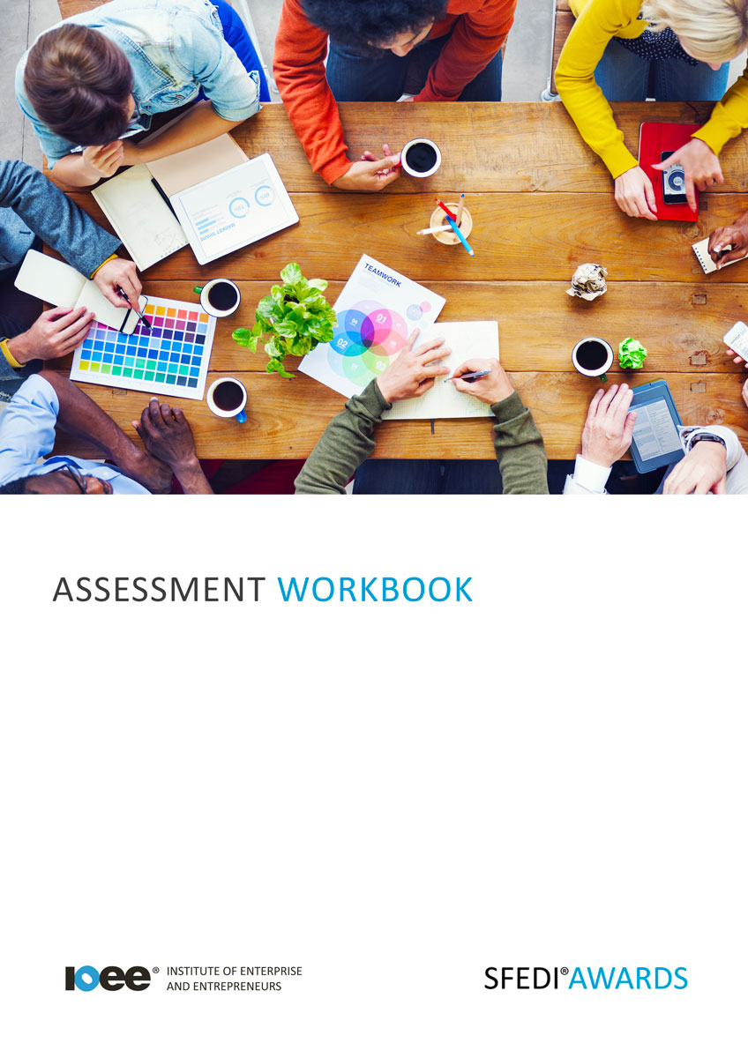

Understand Enterprising Skills T/505/2129

Copyright © 2020 SFEDI Enterprises Ltd

All rights reserved. This book or any portion thereof may not be reproduced or used in any manner whatsoever without the express written permission of the publisher (address below).

Approved SFEDI Awards centres and learners undertaking a SFEDI Awards qualification may photocopy this document free of charge and/or include a PDF version on its intranet where it is only done so for the purposes of the approved delivery of this qualification.

SFEDI Enterprises Ltd t/a SFEDI Awards
19 Victoria Road
Darlington
DL1 5SF
www.sfedigroup.com

Every effort has been made to ensure that the information contained in this publication is true and accurate at the time of publication. However, SFEDI Enterprises t/a SFEDI Awards strives to continually develop and improve our qualifications and, as such, there may be occasions where changes are required. SFEDI Enterprises t/a SFEDI Awards does not accept liability for any loss or damage arising from the use of the information contained within this publication.

Introduction

This workbook has been developed so that you are able to collect and present evidence that demonstrates your knowledge and skills in relation to enterprise skills.

There are different sections that make up this workbook in order to make sure you are able to complete all of the tasks necessary but you will be provided with support as you move along by your Assessor.

Further learning materials and support is available through your studying membership of the Institute of Enterprise and Entrepreneurs. If you haven’t yet received your login please speak to your Assessor who will be happy to sort this out for you.
This unit contains three learning outcomes and will support you to be able to:
- Understand what an enterprise is
- Understand what enterprising skills and behaviours are
- Understand the benefits of having enterprising skills and behaviours in different settings
The evidence within this workbook will be assessed by,

Assessor Name:

and will be quality assured by,

Internal Quality Assurer Name:

Your Assessor will support you to plan how best to demonstrate your knowledge and skills which may be through the completion of the activities within this workbook or may include additional tasks best suited to you.

If any additional tasks are to be completed these will be listed in the table below with target dates for which you should try your best to complete each task listed.

Task | Target Date | Re-planned Target Date
Completion of the activities included within this workbook

By signing below you agree to completing the work as detailed above and working with your Assessor to achieve this by the deadlines indicated.

Learner Name: | Signature: | Date:
Assessor Name: | Signature: | Date:

Activities

Activity 1

Using the box below, provide a definition for the term ‘enterprise’ that would help another person to
understand what it means

An enterprise is…

Using the boxes below, describe three characteristics of an owner-managed enterprise

Characteristic 1

Characteristic 2

Characteristic 3

Using the boxes below, describe three legal structures that could be used to set up a new enterprise

Legal Structure 1

Legal Structure 2

Legal Structure 3

Using the box below, explain how being enterprising is different to being an entrepreneur

Being enterprising is different from being an entrepreneur because…

9

Activity 5

Use the table below to list a minimum of four forms of knowledge, behaviours and skills that are normally considered to be enterprising skills

Knowledge, behaviour or skill | Knowledge (K),  Behaviour  (B) or Skill (S) | How is it useful in everyday life?
eg. problem solving | S, B | Problem solving means that you can overcome challenges in a productive and effective way in order to move forward and achieve your goals

10

Activity 6

Now look at your own knowledge, behaviours and skills. Use the table below to list your own current enterprising traits and describe how you currently use them in your personal and/or working life

Knowledge, behaviour or skill | Knowledge (K),  Behaviour  (B) or Skill (S) | How do I currently put it into practice?
eg. problem solving | S, B | I moved house and struggled to build a new circle of friends so I found out about all of the local clubs and groups and joined a couple to meet new people and make new friends

11

Activity 7

Now use the table below to plan how you can develop the character traits you have identified. Think about the activities to be completed, the
timescales for the activities to take place and the method you can review how successful the activities are in helping you to develop

Knowledge, behaviour or  skill | Activity to be completed | Deadline for  completion | Method of reviewing success of the outcome on  your own development
eg. problem solving | Read about ways of identifying and  thinking through problems | 1 month | Put into practice my problem solving technique and see  how I have done and further ways of improving

Activity 8

Now you have looked into what types of behaviours, attitudes and skills are considered to be enterprising and the ways in which you can develop your own enterprising traits but how easy do you think it is to develop enterprising skills? Is it something you’re born with or something that can be learnt?

Using the box below, explain the extent to which you think enterprising traits can be developed in individuals. Use your own experience where possible to provide examples to back up your thoughts

Activity Mapping

Now you have completed the activities to demonstrate your knowledge and skills it is time for your Assessor to map your work against the standards listed below.
By doing this they will be making sure that the work you have provided by completing the activities
meets the requirements for you to gain your certificate.

Your Assessor will provide you with feedback on how you have done and whether any more work may be required.

Assessment Criterion - The learner can: | Activity Number or Reference Number of Additional Activities: | Assessor Signed  Off (✓/✗):
Describe what is meant by an enterprise | 1
Explain the key characteristics of an owner-managed enterprise | 2 - 3
Describe what is meant by being enterprising | 4
Describe the skills that are associated with being enterprising | 5
Describe the behaviours that are associated with being enterprising | 5
Identify own strengths in terms of enterprising skills and behaviours | 6 - 7
Explain the extent to which enterprising skills and behaviours can be developed in individuals | 8
Describe where and when enterprising skills are useful | 5 - 6
Explain the advantages of being able to use enterprising skills | 5 - 6

Assessor Feedback

Authenticity Declarations

Learner Declaration

By signing this declaration you agree that the evidence provided within this workbook has been produced by you and meets the requirements of being authentic, sufficient, valid and current to the standards required.

Learner Signature: Date:

Assessor Declaration

By signing this declaration you agree that you have assessed all of the evidence produced within this workbook and have ensured that the work is that of the learner. You are also declaring that during the learning process you have ensured that the evidence is authentic, sufficient, valid and current to the standards required.

Assessor Signature: Date:

IQA Signature (if applicable): Date:

Additional Evidence Forms

Use these additional forms in order to record additional evidence for the activities within this workbook where additional space is required.

Ensure that each piece of evidence entered on these forms is clearly labelled with the corresponding activity number.

SFEDI Awards
19 Victoria Road
Darlington
DL1 5SF

customerservices@sfediawards.com 0845 224 5928
@sfediawards

