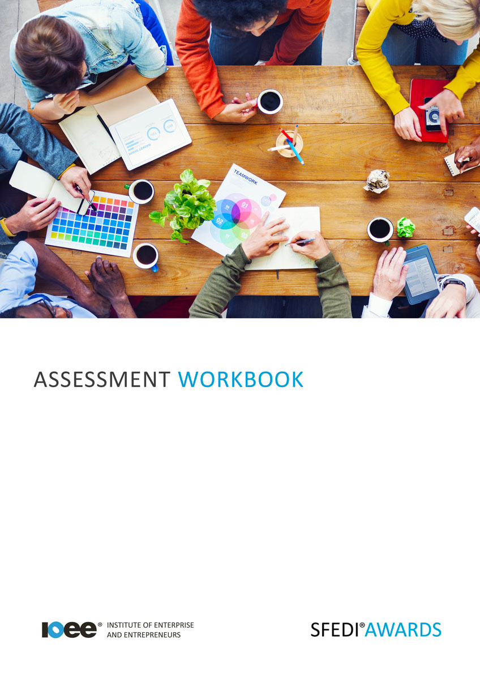

Understand How to Access Help and Support in Business
J/506/6083

Copyright © 2020 SFEDI Enterprises Ltd

All rights reserved. This book or any portion thereof may not be reproduced or used in any manner whatsoever without the express written permission of the publisher (address below).

Approved SFEDI Awards centres and learners undertaking a SFEDI Awards qualification may photocopy this document free of charge and/or include a PDF version on its intranet where it is only done so for the purposes of the approved delivery of this qualification.

SFEDI Enterprises Ltd t/a SFEDI Awards
19 Victoria Road
Darlington
DL1 5SF
www.sfedigroup.com

Every effort has been made to ensure that the information contained in this publication is true and accurate at the time of publication. However, SFEDI Enterprises t/a SFEDI Awards strives to continually develop and improve our qualifications and, as such, there may be occasions where changes are required. SFEDI Enterprises t/a SFEDI Awards does not accept liability for any loss or damage arising from the use of the information contained within this publication.

Introduction

This workbook has been developed so that you are able to collect and present evidence that demonstrates your knowledge and skills in relation to how to access help and support in business.

There are different sections that make up this workbook in order to make sure you are able to complete all of the tasks necessary but you will be provided with support as you move along by your Assessor.

Further learning materials and support is available through your studying membership of the Institute of Enterprise and Entrepreneurs. If you haven’t yet received your login please speak to your Assessor who will be happy to sort this out for you.
This unit contains two learning outcomes and will support you to be able to:
- Understand the help and support that is available to businesses
- Understand the value of business networks and how they work

The evidence within this workbook will be assessed by,

Assessor Name:

and will be quality assured by,

Internal Quality Assurer Name:

Your Assessor will support you to plan how best to demonstrate your knowledge and skills which may be through the completion of the activities within this workbook or may include additional tasks best suited to you.

If any additional tasks are to be completed these will be listed in the table below with target dates for which you should try your best to complete each task listed.

Task | Target Date | Re-planned Target Date
Completion of the activities included within this workbook

By signing below you agree to completing the work as detailed above and working with your Assessor to achieve this by the deadlines indicated.

Learner Name: | Signature: | Date:
Assessor Name: | Signature: | Date:

Activities
5

Activity 1

Using the table below, identify the different types of informal support that are available to a business

Type of informal support | What are the benefits of this form of support? | What are the negatives of this type of support?
eg. family | It is often free and available on demand so support can be accessed as and when needed | Parents don’t want to hurt your feelings and so may not always tell you what you need to hear

6

Activity 2

Using the table below, identify the different types of formal support that are available to a business

Type of formal support | What are the benefits of this form of support? | What are the negatives of this type of support?
eg. mentor | They can help you to develop your own thinking skills and analyse your business | Concentrates on getting you to come up with your own answers but sometimes you just need advice or practical support

Use the table below to explain how you can find out where you can access different forms of business support. You should think about not just internet searches but individuals, groups or organisations you can talk to in order to access methods of support

Type of support | How to find out where you can  access the type of support | What process needs to be  followed to access the support?
eg. mentor | Speak to the local enterprise partnership | Contact the mentor organisation and outline what type of support I am after and agree how they can help. Agree how the support will be delivered and organise first meeting

Using the box below, provide a definition for the term ‘business network’ that would help another
person to understand what it means

A business network is…

9

Activity 5

Using the table below, identify the different types of business networks that are available and how they can support you in running a business

Type of business network | How are they run? | What benefits can they bring to running a business?
eg. business breakfast group | Usually organised by a local business group, eg. the LEP on an informal basis | Allows business owners to talk through challenges they are facing to share experiences and possible solutions in a relaxed environment

Activity 6

Using the box below, explain how a business network can help to identify potential business opportunities

A business network can help identify opportunities by…

Activity Mapping

Now you have completed the activities to demonstrate your knowledge and skills it is time for your Assessor to map your work against the standards listed below.
By doing this they will be making sure that the work you have provided by completing the activities meets the requirements for you to gain your certificate.

Your Assessor will provide you with feedback on how you have done and whether any more work may be required.

Assessment Criterion - The learner can: | Activity Number or Reference Number of Additional Activities: | Assessor Signed  Off (✓/✗):
Analyse the informal sources of help and support available for a business | 1
Analyse the formal sources of help and support available for a business | 2
Explain how to find out where help and support for a  business can be obtained | 3
Explain how to access help and support available to a business | 3
Explain what a business network is | 4
Evaluate the different types of networks that exist  that can help a business | 5
Explain the benefits that networks can bring to a  business | 5
Explain how to use networks to identify potential business opportunities | 6

Assessor Feedback

Authenticity Declarations

Learner Declaration

By signing this declaration you agree that the evidence provided within this workbook has been produced by you and meets the requirements of being authentic, sufficient, valid and current to the standards required.

Learner Signature: Date:

Assessor Declaration

By signing this declaration you agree that you have assessed all of the evidence produced within this workbook and have ensured that the work is that of the learner. You are also declaring that during the learning process you have ensured that the evidence is authentic, sufficient, valid and current to the standards required.

Assessor Signature: Date:

IQA Signature (if applicable): Date:

Additional Evidence Forms

Use these additional forms in order to record additional evidence for the activities within this workbook where additional space is required.

Ensure that each piece of evidence entered on these forms is clearly labelled with the corresponding activity number.

SFEDI Awards
19 Victoria Road
Darlington
DL1 5SF

customerservices@sfediawards.com 0845 224 5928
@sfediawards

