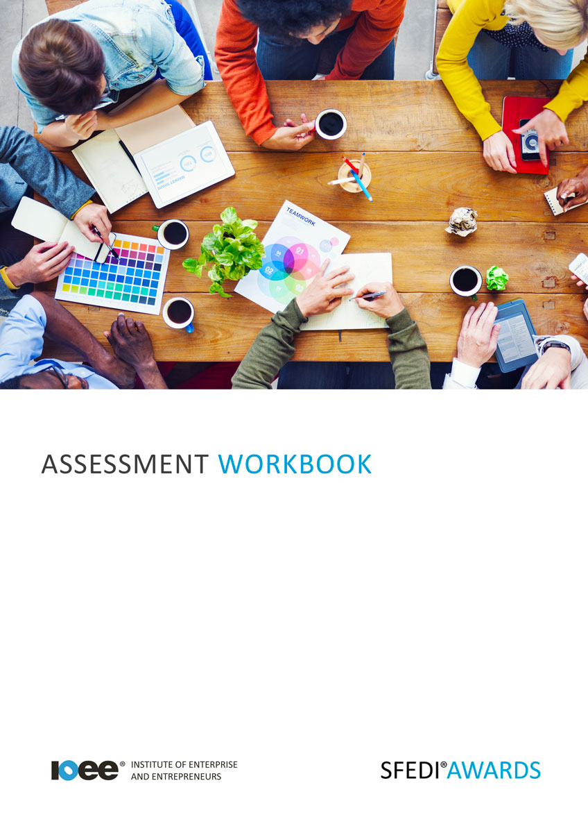

Understand How to Manage Money in a Business
T/505/2146

Copyright © 2020 SFEDI Enterprises Ltd

All rights reserved. This book or any portion thereof may not be reproduced or used in any manner whatsoever without the express written permission of the publisher (address below).

Approved SFEDI Awards centres and learners undertaking a SFEDI Awards qualification may photocopy this document free of charge and/or include a PDF version on its intranet where it is only done so for the purposes of the approved delivery of this qualification.

SFEDI Enterprises Ltd t/a SFEDI Awards
19 Victoria Road
Darlington
DL1 5SF
www.sfedigroup.com

Every effort has been made to ensure that the information contained in this publication is true and accurate at the time of publication. However, SFEDI Enterprises t/a SFEDI Awards strives to continually develop and improve our qualifications and, as such, there may be occasions where changes are required. SFEDI Enterprises t/a SFEDI Awards does not accept liability for any loss or damage arising from the use of the information contained within this publication.

Introduction

This workbook has been developed so that you are able to collect and present evidence that demonstrates your knowledge and skills in relation to managing money in a business.

There are different sections that make up this workbook in order to make sure you are able to complete all of the tasks necessary but you will be provided with support as you move along by your Assessor.

Further learning materials and support is available through your studying membership of the Institute of Enterprise and Entrepreneurs. If you haven’t yet received your login please speak to your Assessor who will be happy to sort this out for you.
This unit contains two learning outcomes and will support you to be able to:
- Understand the importance of money when running a business
- Understand how to plan the money that is needed when running a business
The evidence within this workbook will be assessed by,

Assessor Name:

and will be quality assured by,

Internal Quality Assurer Name:

Your Assessor will support you to plan how best to demonstrate your knowledge and skills which may be through the completion of the activities within this workbook or may include additional tasks best suited to you.

If any additional tasks are to be completed these will be listed in the table below with target dates for which you should try your best to complete each task listed.

Task | Target Date | Re-planned Target Date
Completion of the activities included within this workbook

By signing below you agree to completing the work as detailed above and working with your Assessor to achieve this by the deadlines indicated.

Learner Name: | Signature: | Date:
Assessor Name: | Signature: | Date:

Activities

Activity 1

Using the box below, explain why it is important to manage money appropriately within a business and what impact there is on business and people by not doing so

It is important to manage money because…

Not doing so can impact on business by…

Not doing so can impact on people by…

Using the table below, identify the different documents or records a business can use to track income and expenditure. Also think about how these documents can be used to support budgeting money appropriately

Document or record | How can this document or record support budgeting money appropriately?

Using the box below, explain the different methods a business could use to demonstrate they are meeting their plans for money, eg. profit levels, sales forecasts, cashflow, etc.

Using the box below, explain the importance for a business to keep clear records of money transactions, eg. sales, returns, transfers, etc.

Using the box below, explain what personal requirements you would need to include when planning money for a business. This could be a range of things from planning to survive and grow the business, earning enough to pay your personal finances or even increasing your standard of living. What are your requirements and what order would you rate their importance?

Activity Mapping

Now you have completed the activities to demonstrate your knowledge and skills it is time for your Assessor to map your work against the standards listed below.
By doing this they will be making sure that the work you have provided by completing the activities meets the requirements for you to gain your certificate.

Your Assessor will provide you with feedback on how you have done and whether any more work may be required.

Assessment Criterion - The learner can: | Activity Number or Reference Number of Additional Activities: | Assessor Signed  Off (✓/✗):
Explain why it is important to manage money when running a business | 1
Explain what can happen if money in a business is not managed appropriately | 1
Explain who can be affected if money in the business  is not managed appropriately | 1
List a range of documents or records that can be used to track income and expenditure in the business | 2
Explain how these documents support budgeting within the business | 2
Explain the different ways of showing that plans for  money in a business are being met | 3
Explain the need to keep clear records of money transactions in the business | 4
Explain own personal requirements that need to be included when planning money for a business | 5

Assessor Feedback

Authenticity Declarations

Learner Declaration

By signing this declaration you agree that the evidence provided within this workbook has been produced by you and meets the requirements of being authentic, sufficient, valid and current to the standards required.

Learner Signature: Date:

Assessor Declaration

By signing this declaration you agree that you have assessed all of the evidence produced within this workbook and have ensured that the work is that of the learner. You are also declaring that during the learning process you have ensured that the evidence is authentic, sufficient, valid and current to the standards required.

Assessor Signature: Date:

IQA Signature (if applicable): Date:

Additional Evidence Forms

Use these additional forms in order to record additional evidence for the activities within this workbook where additional space is required.

Ensure that each piece of evidence entered on these forms is clearly labelled with the corresponding activity number.

SFEDI Awards
19 Victoria Road
Darlington
DL1 5SF

customerservices@sfediawards.com 0845 224 5928
@sfediawards

