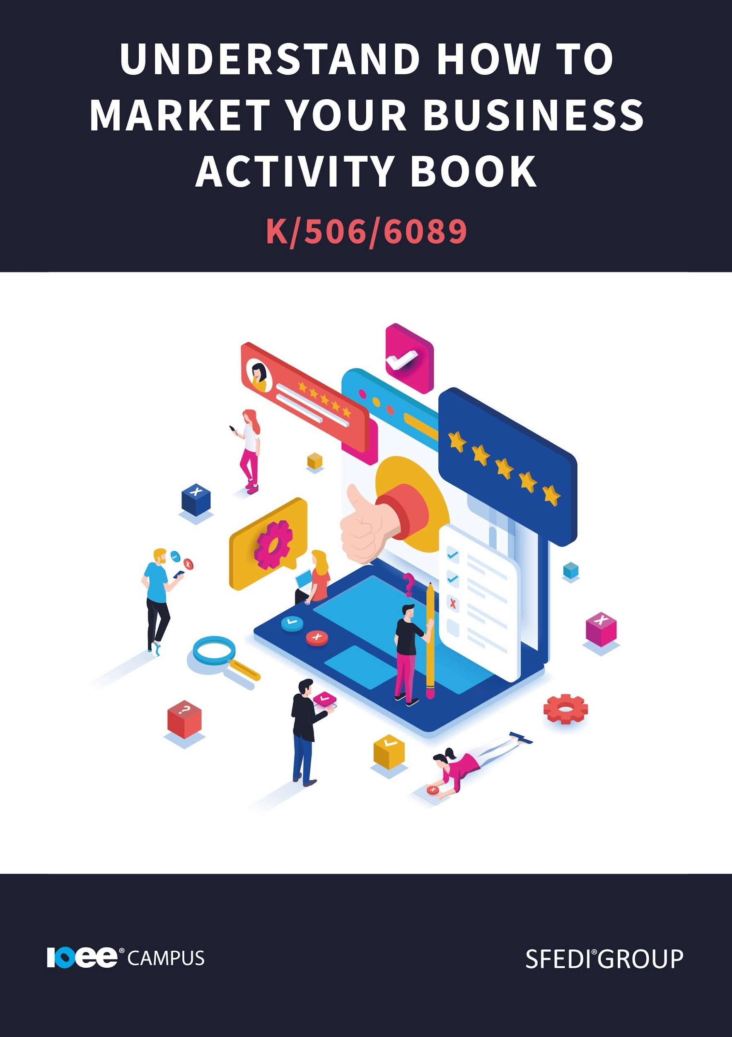

Introduction

Unit Overview and Main Outcomes:

This unit contains 3 learning outcomes which will support the learner to be able to:
✓ Understand the need to research the market for a business
✓ Understand how a business can reach the customers
✓ Understand how to assess customer satisfaction

Assessment and Grading of This Unit:

This unit is graded on a pass or fail basis and the learner must demonstrate evidence against all of the listed assessment criteria in order to achieve this unit. The following provides examples of assessment methods that could be used to generate evidence for this unit. This list is not an exhaustive list and other methods can be used by the centre.

✓ Product evidence
✓ Learner statement/case study
✓ Pre-approved worksheets
✓ Professional discussion
✓ Recognition of prior achievement
✓ Recognition of prior learning
✓ Witness testimony

The evidence within this workbook will be assessed by,

Assessor Name:

and will be quality assured by,

Internal Quality Assurer Name:
Copyright © 2020 SFEDI Enterprises Ltd

All rights reserved. This book or any portion thereof may not be reproduced or used in any manner whatsoever without the express written permission of the publisher (address below).

Approved SFEDI Awards centres and learners undertaking a SFEDI Awards qualification may photocopy this document free of charge and/or include a PDF version on its intranet where it is only done so for the purposes of the approved delivery of this qualification.

SFEDI Enterprises Ltd t/a SFEDI Awards
19 Victoria Rd
Darlington
DL1 5SF
www.sfedigroup.com

Every effort has been made to ensure that the information contained in this publication is true and accurate at the time of publication. However, SFEDI Enterprises t/a SFEDI Awards strives to continually develop and improve our qualifications and, as such, there may be occasions where changes are required. SFEDI Enterprises t/a SFEDI Awards does not accept liability for any loss or damage arising from the use of the information contained within this publication.

Introduction

Every business in the world has a marketing strategy. Whether it’s social media promotion, word of mouth or even exceptional customer service. Marketing your business is an important step in its survival.

Making sure the right people see your business, posts and content is one of the most important aspects of business development. But just who do you need to share your content with?

Market research can involve researching competition and how they operate, your audience and how they will access your content and the effect of your price on the market.

Your Assessor will support you to plan how best to demonstrate your knowledge and skills which may be through the completion of the activities within this workbook or may include additional tasks best suited to you.

If any additional tasks are to be completed these will be listed in the table below with target dates for which you should try your best to complete each task listed.

Task | Target Date | Re-planned Target Date
Completion of the activities included within this workbook

By signing below, you agree to completing the work as detailed above and working with your Assessor to achieve this by the deadlines indicated.

Learner Name:

Signature:

Date:

Assessor Name:

Signature:

Date:

Activity One

Let's take a look at how some of these areas affect how your business will run, and why you should research them.

Audience demographics:

Forming one of the biggest chunks of your market research, your audience and customer base will be a rather large focus. When we look at this section of your market research, we need to look at a few key areas. Who are your customers going to be? To answer this, it would be good to ask some of the following questions:

How old are your customers? Where do they usually shop? What do they usually buy? Do they have families? Do they have friends? How much do they earn (a tricky question to answer)? How much do they spend? Do they use social media? Do they have an email address? Do they use mobile phones? Do they have a landline phone?

It may seem like an excessive list of questions for you to ask, but these questions will allow you to have a really good insight into your customers spending habits and the habits of people in their age, gender or location brackets.

All, or most of, these questions will allow you to shape your customer's experience. They will allow you to shift your business into different directions, based on your customer base and their purchasing habits.

Reflection: Who do you think your audience are? Ask yourself the above questions and make note of your responses.

Your competition:

Although you don't want to copy your competition or ‘steal’ their strategies, researching your competition may give you some ideas, or push you away from certain ideas. A competitor may have tried to advertise in a certain way, or may have sold a certain product that damaged their reputation or made their company lose some of their customer base.

Alternatively, they could have tried another way of advertising that really helped their business. Either way it is important that you keep an eye on the competition, keep up to date with what they are doing on social media and in their stores, and see what works. By doing this, you could use some of the same strategies, increase your customer reach and develop your business.

Reflection: Who is your competition? Do they use any marketing techniques that really work for them? Do they sell any special items that make them stand out?
Prices in the market:

Prices on the market may not be one of the first things you consider when researching the market, but the price of a product or service is actually really important. Especially during your start up phase, your prices and fees should be a priority.

Maybe you already have an idea of how much you are wanting to charge for a product. Maybe you feel like a certain figure would be a fair price. Have a look to see what other companies are charging for similar products to yours. If their products are cheaper or more expensive, maybe rethink your prices. You want to be competitive but not too cheap.

Using the box below, describe why researching the market for a business idea is important

It is important to research the market for a business because:

Activity Two

Promotion and advertisements

In order to spread the word about the products and the services you can offer, you will need to look into the different ways you can advertise your business. There are various ways of doing this, depending on your customer target audience. There are ALOT of different ways to market your business. Let's take a look at the most popular and effective ways.

Social Media

Some of your customers may be younger people/ people who use technology regularly. These customers may find your services and products on sites such as Facebook, Twitter or LinkedIn. To reach these customers, try focusing on your social media channels, increase the quality of your posts and look at posting more frequently. It is important to know what channels your customers use and try to focus on those sites.

If your customer spends a lot of their time on Twitter, you should post content and information there. Of course, spreading the word across multiple platforms is a good strategy, but if you know your customers use a certain social media app, focus on that first.

Examples of social media marketing include: social media advertisement, regular content posting, video or text content and interactive posts (such as polls, Q+A’s etc).

Word of mouth promotion

Word of mouth promotion is a fancier term for getting your customers talking. When you focus on word of mouth, you are really hoping that your customers will talk to other people about your business. To get your customers talking you may need to provide them with extra customer service, some good deals or build up a really strong relationship with them. This is a really good way to spread the word about your business, as their friends and families may have similar interests or needs, and you will be able to reach those people without having to invest in paid advertisements or spending hours on social media.

Examples of word of mouth promotion include: Customers talking to their family and friends about your business, an employee talking to people in the business, an employee attending events to advertise the business.

Traditional Marketing

Traditional marketing is one of the simplest and most straightforward methods of marketing. Working on fliers, business cards, newspaper adverts and radio slots, traditional marketing should bring in some customers with a very straight forward process. Although a lot of advertisement is done through technology or over the internet, these forms of marketing are still effective today. Especially for those who may not use technology, or who may prefer the personal approach to their business.

Examples of traditional marketing include: newspaper adverts, radio adverts, fliers, business cards and posters.

Video Marketing:

“According to a 2021 study, 87% of marketers say using video in their marketing strategy has a positive ROI” (hubspot, 2021). An ROI is a return on investment. A positive return on investment means the company hasn't lost any money investing in this strategy, and has instead made more money. This means that 87% of people made an equal return or made a profit based on using video marketing. In 2021 we are people who like to absorb information through images, videos and sounds. Using video is a great way to combine all of these methods and deliver the information in an easy to view way.

Examples of video marketing include: interactive videos, online screenings of new content, virtual tours of businesses or introduction videos for your employees.

Influencer Marketing

It may suit your business to follow the influencer marketing route. This involves reaching out to someone who has a large, active, following. Arranging a deal for them to include you in social media posts, or blog posts, for a fee. This individual’s viewers are then presented with the opportunity to buy your product or service. These people often have thousands of content viewers who engage and are influenced by their content. Not the newest of ideas out there, but this method does tend to bring in some good results. Influencers don't come cheap though. According to DigitalMarketing.org, travel influencers can charge around $220 (that's around £150) per social media post.

Examples of influencer Marketing would be sponsored YouTube videos, paid social media posts and inviting influencers to events, to name a few.

These are just a few ways you can advertise your business, but there are many more to choose from. Of course, not all of these will work for your business, the strategy you choose will depend on your audience and the way your business provides their goods or services.

Using the table below, identify the different ways the products or services of a business can be promoted.

Method of promoting a product or service | Benefits of using the method | Disadvantages of using the method
eg. ads on social media | Can reach a large amount of people through one advertising campaign with limited time and effort | People often see adverts on social media as spam and so could damage image of business and can’t target specific customers as the adverts have to be generic to reach as many people as possible in one go

Activity Three

Delivering your service

Now you know some ways of advertising your business, will run. You have already identified your customer base and know what products or services you will be selling, now you need to think about how to sell them. Are you an online retailer? Will you be selling items out of a retail space? Will you be a blogger / influencer and create income by advertising products to your following?

Online retailer

An online retailer, such as Amazon, ETSY sellers or BooHoo, operates in a rather simple way. Once a business has decided what they are wanting to sell, they now have to sell it. Condensing the process down, an online retailer posts images and descriptions of their items or services on to a website. A customer chooses the item or service they would like to buy, the customer or the business pays for delivery and the business arranges the delivery to the customer's chosen address. The online retailer doesn't have to pay for a shop, and the bills that come with running a shop, or sales staff. The online retailer then has more income than someone who owns a shop, and is able to still reach customers. However, sometimes being an online retailer doesn’t run smoothly. Issues such as website errors, internet outages or electricity shortages makes the process a lot harder, and sometimes impossible to complete.

Selling from a retail space

When selling from a retail space, the business owner sells their goods or their services from a registered building. This building is registered as the retail space for the company. Customers are able to visit the space, browse the goods or services available and purchase them there and then. Most of the time, they are able to walk away with the goods immediately. The business owner is able to gain customer attention, simply by having the retail space. Some customers may walk past and be drawn into the shop based on its appearance or presence in the area. Online retailers rely on advertisements or people searching for their business intentionally. Having a retail space comes with more responsibility though, as there are often more expenses and the amount of money made by the company may be less, due to these expenses. Some people prefer the convenience of buying items from an online retailer, and prefer the anonymous and easy to access service.

Blogger / influencer

You may not actually own any goods to sell, and you may be providing a service. As mentioned above, influencers are able to make a large sum of money simply by posting on their social media or by attending events. In this scenario, the seller has no products to offer and instead offers the service of advertising. This seller has few expenses and is able to bring in money by being active on social media or their own blog. If the influencer runs their own blog, they may hire people to maintain the page, produce images or even content for the blog. This will cost the influencer money and could add to their expenses. They also are responsible, as the identifiable influencer, to complete the task to a high standard and produce results.

Franchise Outlet retailer

If you are a Franchisee, you will have certain terms and conditions with the company you represent. Normally a franchisee would sell from a retail space. They are sometimes given certain criteria they are required to meet such as customer service levels, hygiene standards and behavioural policies. A franchisee has the benefits of selling goods from a known brand. This will bring in business and allow the franchisee the opportunity to make some good money. But the business owner (above the franchise) will take a fee and royalties based on the sales of the goods and the performance of the store. So whilst a franchisee makes money based on the brand's reputation and name, the brand will also take some money from this, simply by existing.

Using the table below, identify the different ways the products or services of a business can be delivered.

Method of delivering a product or service | Benefits of using the method | Disadvantages of using the method
eg. selling from a retail space | Fixed location so people know where to find you at all times and can interact with people face to face | Can be costly on rent and overheads and can be troublesome as lots of people want the convenience of shopping online

Activity Four

Customer experience and satisfaction:

All of the above examples all had one marketing strategy in common. Word of mouth. Almost all businesses can use word of mouth marketing to drive traffic to their business. Word of mouth marketing works in two ways. Either a customer has a bad experience and tells their friends and family to put them off, or they had a good experience and recommends the business to their friends and family. That is why it is so important that your customer leaves your business / ends the interaction feeling satisfied and wanting to return. If they want to return, chances are their friends and family will want to see what you have to offer too.

If your customer leaves feeling dissatisfied or like they could get better service or quality from somewhere else, you may lose their business and be short of customers. They could also put other customers off trying your products and you could lose future possible sales too. Making sure your customer feels like their needs have been met, they have had good customer service and they have been looked after is vital to make sure you have customers return.

Using the box below, describe why it is important to satisfy the needs of customers.

It is important to satisfy customers because:

Activity Five

To satisfy your customer you will need to know your customer’s needs. What are they asking for? How can you help them? Is there anything extra you can do for them?

Let's have a look at some examples of businesses, products and how they may meet their customer needs.

Spotify - Music streaming provider.

Customer needs: music streaming, good quality sound and easy to access songs they want to hear.

How do they meet the customer’s needs: they provide a free accessible platform for their customers to listen to music. They are able to hear music from thousands of artists. They also offer a paid version that removes advertisements from the streaming site.

Amazon Prime - Music, Video and book streaming

Customer needs: To listen to music, to watch films and to read books on their electronic devices linked with Amazon.

How do they meet the customer’s needs: The service provides customers with video, music and books as part of a subscription. For a fee, customers have access to music, films, tv shows and books. The service also includes free next day delivery on items as well as discounts for products.

Asda – Supermarket

Customer needs: Grocery shopping, clothing and financial services provider.

How do they meet the customer’s needs: This supermarket provides their customers with an ample choice of food, drinks, clothing, household items and sometimes even furniture. The supermarket also offers short term emergency loans, travel money exchange and insurance policies. The customer is free to browse products and select which items they want before paying for them.

Using the table below, identify how different products or services of your choice manage to meet the requirements of the intended customer.

Product or service | What are the needs of the customer? | How does it meet the needs of the customer?
eg. Spotify | Easily accessible music selection on the move with wide choice of possible songs and artists available | People can stream music on phones, computers and other forms of technology and there are a lot of different types of music available both free and for a monthly fee

Activity Six

There are several ways to check if your customer is satisfied with their goods or services that you have provided. Some of them are pretty simple and can be done by being aware of your surroundings. Other methods may require some conversation and a bit more planning. A simple survey may be useful for your customers. Whether online or in store, you may be able to get your customers to fill in a customer satisfaction survey. Most shops offer some form of reward or chance of winning a prize in return for the feedback. Perhaps you could offer a discount as an incentive for them to fill in a survey. Another way to check the customer satisfaction rate is just by asking them, as and when they are in the store. By checking in with your customers, you can immediately see if you are satisfying them and are able to implement changes to make them feel more satisfied. You could check your customer satisfaction by just seeing if your customers are returning. Do you recognise anyone in your store? Are you getting the same email asking for orders?

Using the box below, explain a minimum of two ways a business can measure the satisfaction levels of their customers in relation to its products and services.

A business can measure satisfaction levels by:

Activity Mapping

Now you have completed the activities to demonstrate your knowledge and skills it is time for your Assessor to map your work against the standards listed below.

By doing this they will be making sure that the work you have provided by completing the activities meets the requirements for you to gain your certificate.

Your Assessor will provide you with feedback on how you have done and whether any more work may be required.

Assessment Criterion – The Leaner can: | Activity Number or Reference Number of Additional Activities: | Assessor Signed Off (✓/✗):
Understand the need to research the market for a business | 1
Describe why researching the market for a business idea if important | 1
Explain the different ways in which the product or services of a business can be promoted | 2
Explain the different ways of delivering the products  or services of a business | 3
Explain how aspects of products and services could match customer requirements | 5
Describe why it is important to satisfy customers | 4
Explain the different ways of measuring the level of satisfaction of customers with the products and services of a business | 6

Assessor Feedback

Authenticity Declarations

Learner Declaration

By signing this declaration, you agree that the evidence provided within this workbook has been produced by you and meets the requirements of being authentic, sufficient, valid and current to the standards required.

Learner Signature:

Date:

Assessor Declaration

By signing this declaration, you agree that you have assessed all of the evidence produced within this workbook and have ensured that the work is that of the learner. You are also declaring that during the learning process you have ensured that the evidence is authentic, sufficient, valid and current to the standards required.

Assessor Signature:

Date:

IQA Signature (if applicable):

Date:

Additional Evidence Forms

Use these additional forms in order to record additional evidence for the activities within this workbook where additional space is required.

Ensure that each piece of evidence entered on these forms is clearly labelled with the corresponding activity number.

Useful Resources & References

References:

41 types of marketing your brand can invest in. https://blog.hubspot.com/marketing/marketing-types

What is market research? - Market research - GCSE Business Revision - Other - BBC Bitesize

Useful resources:

How to make money using social media - https://www.youtube.com/watch?v=8do_STCBuqQ

Marketing tips that will change your business - https://www.youtube.com/watch?v=bDdDt6Z-Ojo

8 steps to marketing your business | Small Business

How to Market a Small Business Online and In-Person (ecwid.com)

13 Simple Ways to Market Your Business Offline (entrepreneur.com)

Essentials to Creating a Powerful Marketing Plan (thebalancesmb.com)

4 Ways to Build a Stronger Brand-Consumer Relationship Using Social Media (entrepreneur.com)

SFEDI Enterprises Ltd t/a SFEDI Awards
19 Victoria Rd
Darlington
DL1 5SF
www.sfedigroup.com

customerservices@sfediawards.com
0845 224 5928
@sfediawards

