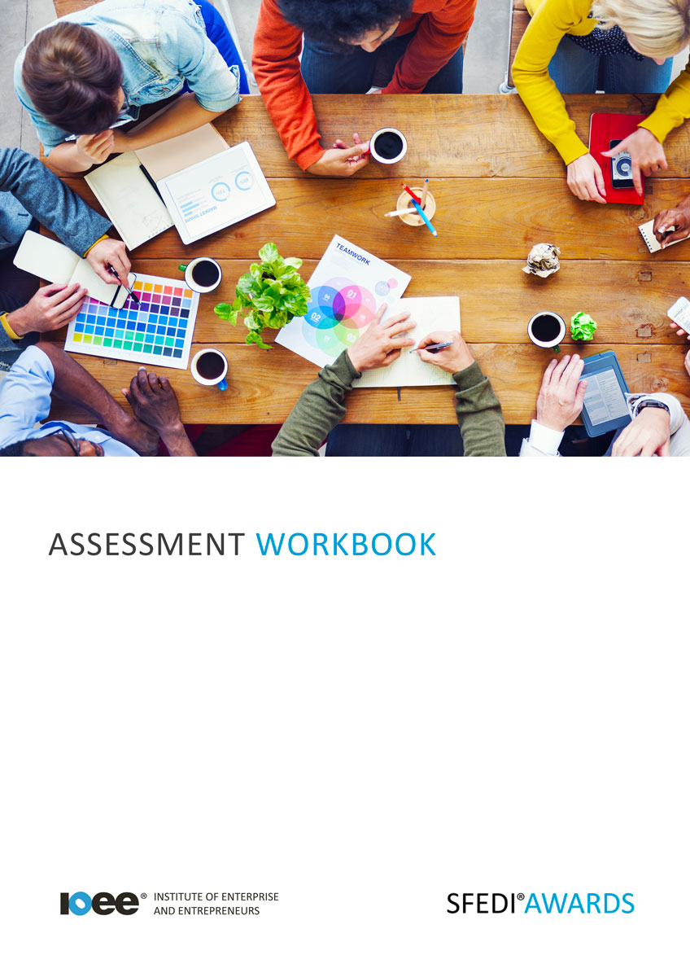

Understand How to Market Your Business
K/506/6089

Copyright © 2020 SFEDI Enterprises Ltd

All rights reserved. This book or any portion thereof may not be reproduced or used in any manner whatsoever without the express written permission of the publisher (address below).

Approved SFEDI Awards centres and learners undertaking a SFEDI Awards qualification may photocopy this document free of charge and/or include a PDF version on its intranet where it is only done so for the purposes of the approved delivery of this qualification.

SFEDI Enterprises Ltd t/a SFEDI Awards
19 Victoria Road
Darlington
DL1 5SF
www.sfedigroup.com

Every effort has been made to ensure that the information contained in this publication is true and accurate at the time of publication. However, SFEDI Enterprises t/a SFEDI Awards strives to continually develop and improve our qualifications and, as such, there may be occasions where changes are required. SFEDI Enterprises t/a SFEDI Awards does not accept liability for any loss or damage arising from the use of the information contained within this publication.

Introduction

This workbook has been developed so that you are able to collect and present evidence that demonstrates your knowledge and skills in relation to how to market your business.

There are different sections that make up this workbook in order to make sure you are able to complete all of the tasks necessary but you will be provided with support as you move along by your Assessor.

Further learning materials and support is available through your studying membership of the Institute of Enterprise and Entrepreneurs. If you haven’t yet received your login please speak to your Assessor who will be happy to sort this out for you.
This unit contains three learning outcomes and will support you to be able to:
- Understand the need to research the market for a business
- Understand how a business can reach the customers
- Understand how to assess customer satisfaction

The evidence within this workbook will be assessed by,

Assessor Name:

and will be quality assured by,

Internal Quality Assurer Name:

Your Assessor will support you to plan how best to demonstrate your knowledge and skills which may be through the completion of the activities within this workbook or may include additional tasks best suited to you.

If any additional tasks are to be completed these will be listed in the table below with target dates for which you should try your best to complete each task listed.

Task | Target Date | Re-planned Target Date
Completion of the activities included within this workbook

By signing below you agree to completing the work as detailed above and working with your Assessor to achieve this by the deadlines indicated.

Learner Name: | Signature: | Date:
Assessor Name: | Signature: | Date:

Activities

Activity 1

Using the box below, describe why researching the market for a business idea is important

It is important to research the market for a business because…

6

Activity 2

Using the table below, identify the different ways the products or services of a business can be promoted

Method of promoting a product or service | Benefits of using the method | Disadvantages of using the method
eg. ads on social media | Can reach a large amount of people through one  advertising campaign with limited time and effort | People often see adverts on social media as spam and so could damage image of business and can’t target specific customers as the adverts have to be generic to reach as many people as possible in one go

7

Activity 3

Using the table below, identify the different ways the products or services of a business can be delivered

Method of delivering a product or service | Benefits of using the method | Disadvantages of using the method
eg. selling from a retail space | Fixed location so people know where to find you at all  times and can interact with people face to face | Can be costly on rent and overheads and can be troublesome as lots of people want the convenience of shopping online

Activity 4

Using the box below, describe why it is important to satisfy the needs of customers

It is important to satisfy customers because…

8

9

Activity 5

Using the table below, identify how different products or services of your choice manage to meet the requirements of the intended customer

Product or service | What are the needs of the customer? | How does it meet the needs of the customer?
eg. Spotify | Easily accessible music selection on the move with wide choice of possible songs and artists available | People can stream music on phones, computers and other forms of technology and there are a lot of different types of music available both free and for a monthly fee

Activity 6

Using the box below, explain a minimum of two ways a business can measure the satisfaction levels of their customers in relation to its products and services

A business can measure satisfaction levels by…

Activity Mapping

Now you have completed the activities to demonstrate your knowledge and skills it is time for your Assessor to map your work against the standards listed below.
By doing this they will be making sure that the work you have provided by completing the activities meets the requirements for you to gain your certificate.

Your Assessor will provide you with feedback on how you have done and whether any more work may be required.

Assessment Criterion - The learner can: | Activity Number or Reference Number of Additional Activities: | Assessor Signed  Off (✓/✗):
Understand the need to research the market for a business | 1
Describe why researching the market for a business idea if important | 1
Explain the different ways in which the product or  services of a business can be promoted | 2
Explain the different ways of delivering the products  or services of a business | 3
Explain how aspects of products and services could match customer requirements | 5
Describe why it is important to satisfy customers | 4
Explain the different ways of measuring the level of satisfaction of customers with the products and services of a business | 6

Assessor Feedback

Authenticity Declarations

Learner Declaration

By signing this declaration you agree that the evidence provided within this workbook has been produced by you and meets the requirements of being authentic, sufficient, valid and current to the standards required.

Learner Signature: Date:

Assessor Declaration

By signing this declaration you agree that you have assessed all of the evidence produced within this workbook and have ensured that the work is that of the learner. You are also declaring that during the learning process you have ensured that the evidence is authentic, sufficient, valid and current to the standards required.

Assessor Signature: Date:

IQA Signature (if applicable): Date:

Additional Evidence Forms

Use these additional forms in order to record additional evidence for the activities within this workbook where additional space is required.

Ensure that each piece of evidence entered on these forms is clearly labelled with the corresponding activity number.

SFEDI Awards
19 Victoria Road
Darlington
DL1 5SF

customerservices@sfediawards.com 0845 224 5928
@sfediawards

