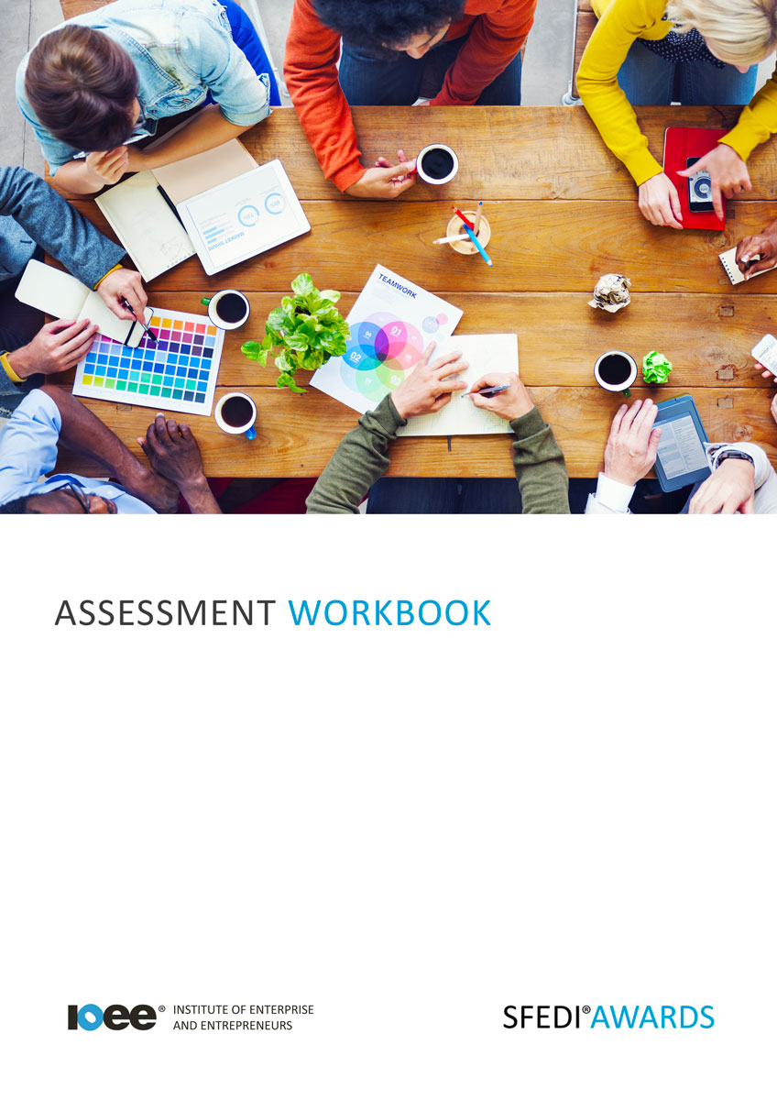

Understand How to Plan for a New Business
K/503/2962

Copyright © 2020 SFEDI Enterprises Ltd

All rights reserved. This book or any portion thereof may not be reproduced or used in any manner whatsoever without the express written permission of the publisher (address below).

Approved SFEDI Awards centres and learners undertaking a SFEDI Awards qualification may photocopy this document free of charge and/or include a PDF version on its intranet where it is only done so for the purposes of the approved delivery of this qualification.

SFEDI Enterprises Ltd t/a SFEDI Awards
19 Victoria Road
Darlington
DL1 5SF
www.sfedigroup.com

Every effort has been made to ensure that the information contained in this publication is true and accurate at the time of publication. However, SFEDI Enterprises t/a SFEDI Awards strives to continually develop and improve our qualifications and, as such, there may be occasions where changes are required. SFEDI Enterprises t/a SFEDI Awards does not accept liability for any loss or damage arising from the use of the information contained within this publication.

Introduction

This workbook has been developed so that you are able to collect and present evidence that demonstrates your knowledge and skills in relation to how to plan for a new business.

There are different sections that make up this workbook in order to make sure you are able to complete all of the tasks necessary but you will be provided with support as you move along by your Assessor.

Further learning materials and support is available through your studying membership of the Institute of Enterprise and Entrepreneurs. If you haven’t yet received your login please speak to your Assessor who will be happy to sort this out for you.
This unit contains three learning outcomes and will support you to be able to:
- Understand the factors to be considered when planning to start a business
- Understand the layout and purpose of a business plan
- Understand how to get information, help and advice when planning a business

The evidence within this workbook will be assessed by,

Assessor Name:

and will be quality assured by,

Internal Quality Assurer Name:

Your Assessor will support you to plan how best to demonstrate your knowledge and skills which may be through the completion of the activities within this workbook or may include additional tasks best suited to you.

If any additional tasks are to be completed these will be listed in the table below with target dates for which you should try your best to complete each task listed.

Task | Target Date | Re-planned Target Date
Completion of the activities included within this workbook

By signing below you agree to completing the work as detailed above and working with your Assessor to achieve this by the deadlines indicated.

Learner Name: | Signature: | Date:
Assessor Name: | Signature: | Date:

Activities

Activity 1

So you want to start your business, you’ve got that great new idea but who are you selling to and how can that impact on the type of business you start or the way you operate?
Using the box below, explain why a business should identify the intended market they want to sell to

In an increasingly brand and image conscious economy and society, its never been more important for a business to have an image that they promote to the marketplace and customers but why?

Using the box below, explain why a new business should spend time, and often money, investing in an image

A new, or even existing business, needs to be aware of the environment in which it wants to operate as many things can impact on its success meaning a business needs to be adaptable to change and both internal and external pressures.
For a business of your choice, identify the internal factors that can affect the success or failure of that
business and the reasons why

Business type:

Internal factor | How can it affect the success or failure of the business?
eg., unreliable staff | Due to unreliable staff the business is continually short staffed meaning that customer service levels drop and they lose customers to competitors as a result

Now, completing a PESTLE analysis, consider the external factors that could affect the success or
failure of that business

Political | Economic
Social | Technological
Legal | Environmental

Activity 4

Using the table below, identify the different sections that would make up a standard business plan
and provide a short explanation of what should be included in that section

Section | Description of information to include
eg. executive summary | A short overview of the aims and objectives of the business including a description of the product or service, an idea of the size and type of  market, how the business is viable and potential growth potential for the business. It should be short and to the point and is usually the last thing written in the business plan

10

Activity 5

Using the table below, identify a minimum of two goals that a business could work towards and explain how working towards a business plan can help a business to achieve them

Business goal | Benefit of a business plan to achieving the goal
eg. achieve 12-month sales figures | The business plan helps a business to plan the resources needed in order to set up the business ready for trading and to make sure that enough products are available to meet planned demand. It also helps by setting out how the product will be marketed to customers to make sure they know where to buy from and how the business will deliver it to them

11

Activity 6

Using the table below, identify a minimum of two laws that can affect the starting and running of a business. Think of where you could find further information about the law and what impact it would have on a business. Try and think of laws that are most relevant to the type of business you are most interested in

Type of law | Where can I find out more information? | Impact on business
eg. copyright law for music | Further information could be found on the gov.uk or PRS websites | Businesses with customers, including staff members, who want to play music so that people can hear it need a licence otherwise they may be breaking copyright law and could be fined

12

Activity 7

Starting and running a business can be lonely and sometimes you need the support of others to make sure you are on the right track.
Using the table below, identify the different types of informal support that are available to a business

Type of informal support | What are the benefits of this form of support? | What are the negatives of this type of support?
eg. family | It is often free and available on demand so support can be accessed as and when needed | Parents don’t want to hurt your feelings and so may not always tell you what you want to hear

13

Activity 8

Using the table below, identify the different types of formal support that are available to a business

Type of formal support | What are the benefits of this form of support? | What are the negatives of this type of support?
eg. mentor | They can help you to develop your own thinking skills and analyse your business | Concentrates on getting you to come up with your own answers but sometimes you just need advice or practical support

14

Activity 9

Using the table below, identify the different types of business networks that are available and how they can support you in running a business

Type of business  network | How are they run? | What benefits can they bring to running a business?
eg. business breakfast group | Usually organised by a local business group, eg. the LEP  on an informal basis | Allows business owners to talk through challenges they are facing to share experiences and possible solutions in a relaxed environment

Activity 10

Use the table below to explain how you can find out where you can access different forms of business support. You should think about not just internet searches but individuals, groups or organisations you can talk to in order to access methods of support

Type of support | How to find out where to find out about the support available | What process needs to be followed to access the support?
eg. mentor | Speak to the local enterprise partnership | Contact the mentor organisation and outline what type of support I am after and agree how they can help. Agree how the support will be delivered and organise first meeting

Activity Mapping

Now you have completed the activities to demonstrate your knowledge and skills it is time for your Assessor to map your work against the standards listed below.
By doing this they will be making sure that the work you have provided by completing the activities
meets the requirements for you to gain your certificate.

Your Assessor will provide you with feedback on how you have done and whether any more work may be required.

Assessment Criterion - The learner can: | Activity Number or Reference Number of Additional Activities: | Assessor Signed  Off (✓/✗):
Explain why it is important to identify the intended market for a new business | 1
Explain why it is important to identify an image for a new business | 2
Identify the different internal and external factors that can affect the success or failure of a new business | 3
Describe the goals that could be set for different  parts of a business in order to help it succeed | 5
Identify the content and format that might be used in a business plan | 4
Describe how the business plan can be used to help a business achieve its goals | 5
Identify the different types of laws and regulations that can affect a new business | 6
Explain how to access different types of information, help and advice that are relevant to planning a business | 7 - 10
Describe the types of support that are available for people when planning a new business | 7 - 10

Assessor Feedback

Authenticity Declarations

Learner Declaration

By signing this declaration you agree that the evidence provided within this workbook has been produced by you and meets the requirements of being authentic, sufficient, valid and current to the standards required.

Learner Signature: Date:

Assessor Declaration

By signing this declaration you agree that you have assessed all of the evidence produced within this workbook and have ensured that the work is that of the learner. You are also declaring that during the learning process you have ensured that the evidence is authentic, sufficient, valid and current to the standards required.

Assessor Signature: Date:

IQA Signature (if applicable): Date:

Additional Evidence Forms

Use these additional forms in order to record additional evidence for the activities within this workbook where additional space is required.

Ensure that each piece of evidence entered on these forms is clearly labelled with the corresponding activity number.

SFEDI Awards
19 Victoria Road
Darlington
DL1 5SF

customerservices@sfediawards.com 0845 224 5928
@sfediawards

