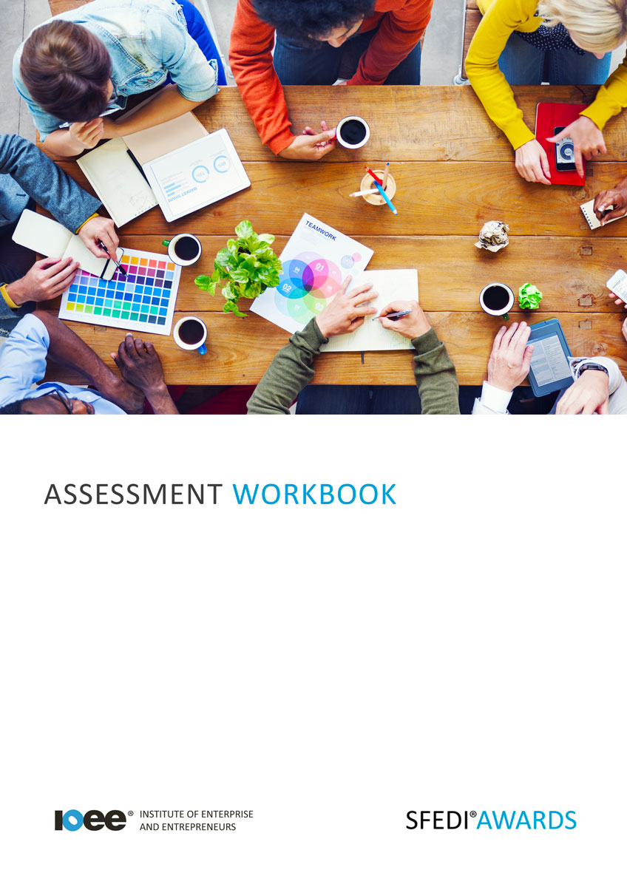

Understand the Challenges and Risks of Starting a New Business
F/503/2966

Copyright © 2020 SFEDI Enterprises Ltd

All rights reserved. This book or any portion thereof may not be reproduced or used in any manner whatsoever without the express written permission of the publisher (address below).

Approved SFEDI Awards centres and learners undertaking a SFEDI Awards qualification may photocopy this document free of charge and/or include a PDF version on its intranet where it is only done so for the purposes of the approved delivery of this qualification.

SFEDI Enterprises Ltd t/a SFEDI Awards
19 Victoria Road
Darlington
DL1 5SF
www.sfedigroup.com

Every effort has been made to ensure that the information contained in this publication is true and accurate at the time of publication. However, SFEDI Enterprises t/a SFEDI Awards strives to continually develop and improve our qualifications and, as such, there may be occasions where changes are required. SFEDI Enterprises t/a SFEDI Awards does not accept liability for any loss or damage arising from the use of the information contained within this publication.

Introduction

This workbook has been developed so that you are able to collect and present evidence that demonstrates your knowledge and skills in relation to the challenges and risks of starting a new business.

There are different sections that make up this workbook in order to make sure you are able to complete all of the tasks necessary but you will be provided with support as you move along by your Assessor.

Further learning materials and support is available through your studying membership of the Institute of Enterprise and Entrepreneurs. If you haven’t yet received your login please speak to your Assessor who will be happy to sort this out for you.
This unit contains two learning outcomes and will support you to be able to:
- Understand why vision and values are important to a new business
- Understand the potential opportunities and risks in a new business

The evidence within this workbook will be assessed by,

Assessor Name:

and will be quality assured by,

Internal Quality Assurer Name:

Your Assessor will support you to plan how best to demonstrate your knowledge and skills which may be through the completion of the activities within this workbook or may include additional tasks best suited to you.

If any additional tasks are to be completed these will be listed in the table below with target dates for which you should try your best to complete each task listed.

Task | Target Date | Re-planned Target Date
Completion of the activities included within this workbook

By signing below you agree to completing the work as detailed above and working with your Assessor to achieve this by the deadlines indicated.

Learner Name: | Signature: | Date:
Assessor Name: | Signature: | Date:

Activities

Activity 1

Using the box below, explain what success for a potential business might look like. Where possible think of some examples from existing businesses or even your own experience to justify your answer

Using the box below, explain what is important to you in running a business. This could be a range of things from planning to survive and grow the business, earning enough to pay your personal finances or even improving your standard of living. What is important to you and what order would you rate their importance?

Using the boxes below, plan an outline for a new product or service that could offer you a business opportunity. Where possible try and use an idea you have had for a product or service you would like to sell but don’t worry, even if you haven’t yet had that great idea, this process can often help you to identify one that you could take forward.

Product or service name

Description of the product or service

Who is the intended customer for the product or service?

What are the unique selling points (UPS) of the product or service?

Is there any competition already in the marketplace and how will you stand out from the crowd?

£
What is the price being charged for this product or service or one that is
similar to your idea?

Thinking about your idea and the existing competition in the marketplace, how likely do you think success will be in starting a business based on this idea? Make sure you justify your answer

Using the table below, identify the activities you need to take in order to take advantage of the idea

Development step | How would you carry out/complete this step?

Like any new business there are risks in taking that first step. Using the table below, identify the risks that you could encounter in taking forward your business idea and explain the methods you could use to overcome those risks.

Potential risk | What actions could I take to overcome the risk?

Activity 4

So now you’ve considered how you can identify a potential business opportunity and the steps you would take in order to take advantage of the opportunity. But identifying an opportunity and planning these steps is not the end of it, it’s just the beginning.

What kind of business are you starting? How do you want it to be seen by people? How do you want it to operate? Being able to answer these questions are just as important as it will help to shape the success you have in the future.

Like with people planning their future, businesses should have a vision and a set of values to help them operate. But what do we mean by these terms.
Using the boxes below, provide a definition for the terms ‘vision’ and ‘values’ in a business context that
would help another person to understand what they mean

Vision means…

Values means…

So now we know what is meant by ‘vision’ and ‘values’ to a business but why are they important? How
can they help a business to succeed?

Using the box below explain why having a vision and values is important to the success of a business. Use at least one example from a business you know well to help to justify your answer.

Having a vision and values is important because…

Activity Mapping

Now you have completed the activities to demonstrate your knowledge and skills it is time for your Assessor to map your work against the standards listed below.
By doing this they will be making sure that the work you have provided by completing the activities
meets the requirements for you to gain your certificate.

Your Assessor will provide you with feedback on how you have done and whether any more work may be required.

Assessment Criterion - The learner can: | Activity Number or Reference Number of Additional Activities: | Assessor Signed  Off (✓/✗):
Describe what success for a potential business might look like | 1
Identify what might be important and of personal value when running a business | 2
Explain why having a vision and values are important to the success of a business | 4
Explain how to identify new business opportunities | 3
Describe how to take advantage of a potential new business opportunity | 3
Identify the potential risks associated with a new business opportunity | 3

Assessor Feedback

Authenticity Declarations

Learner Declaration

By signing this declaration you agree that the evidence provided within this workbook has been produced by you and meets the requirements of being authentic, sufficient, valid and current to the standards required.

Learner Signature: Date:

Assessor Declaration

By signing this declaration you agree that you have assessed all of the evidence produced within this workbook and have ensured that the work is that of the learner. You are also declaring that during the learning process you have ensured that the evidence is authentic, sufficient, valid and current to the standards required.

Assessor Signature: Date:

IQA Signature (if applicable): Date:

Additional Evidence Forms

Use these additional forms in order to record additional evidence for the activities within this workbook where additional space is required.

Ensure that each piece of evidence entered on these forms is clearly labelled with the corresponding activity number.

SFEDI Awards
19 Victoria Road
Darlington
DL1 5SF

customerservices@sfediawards.com 0845 224 5928
@sfediawards

