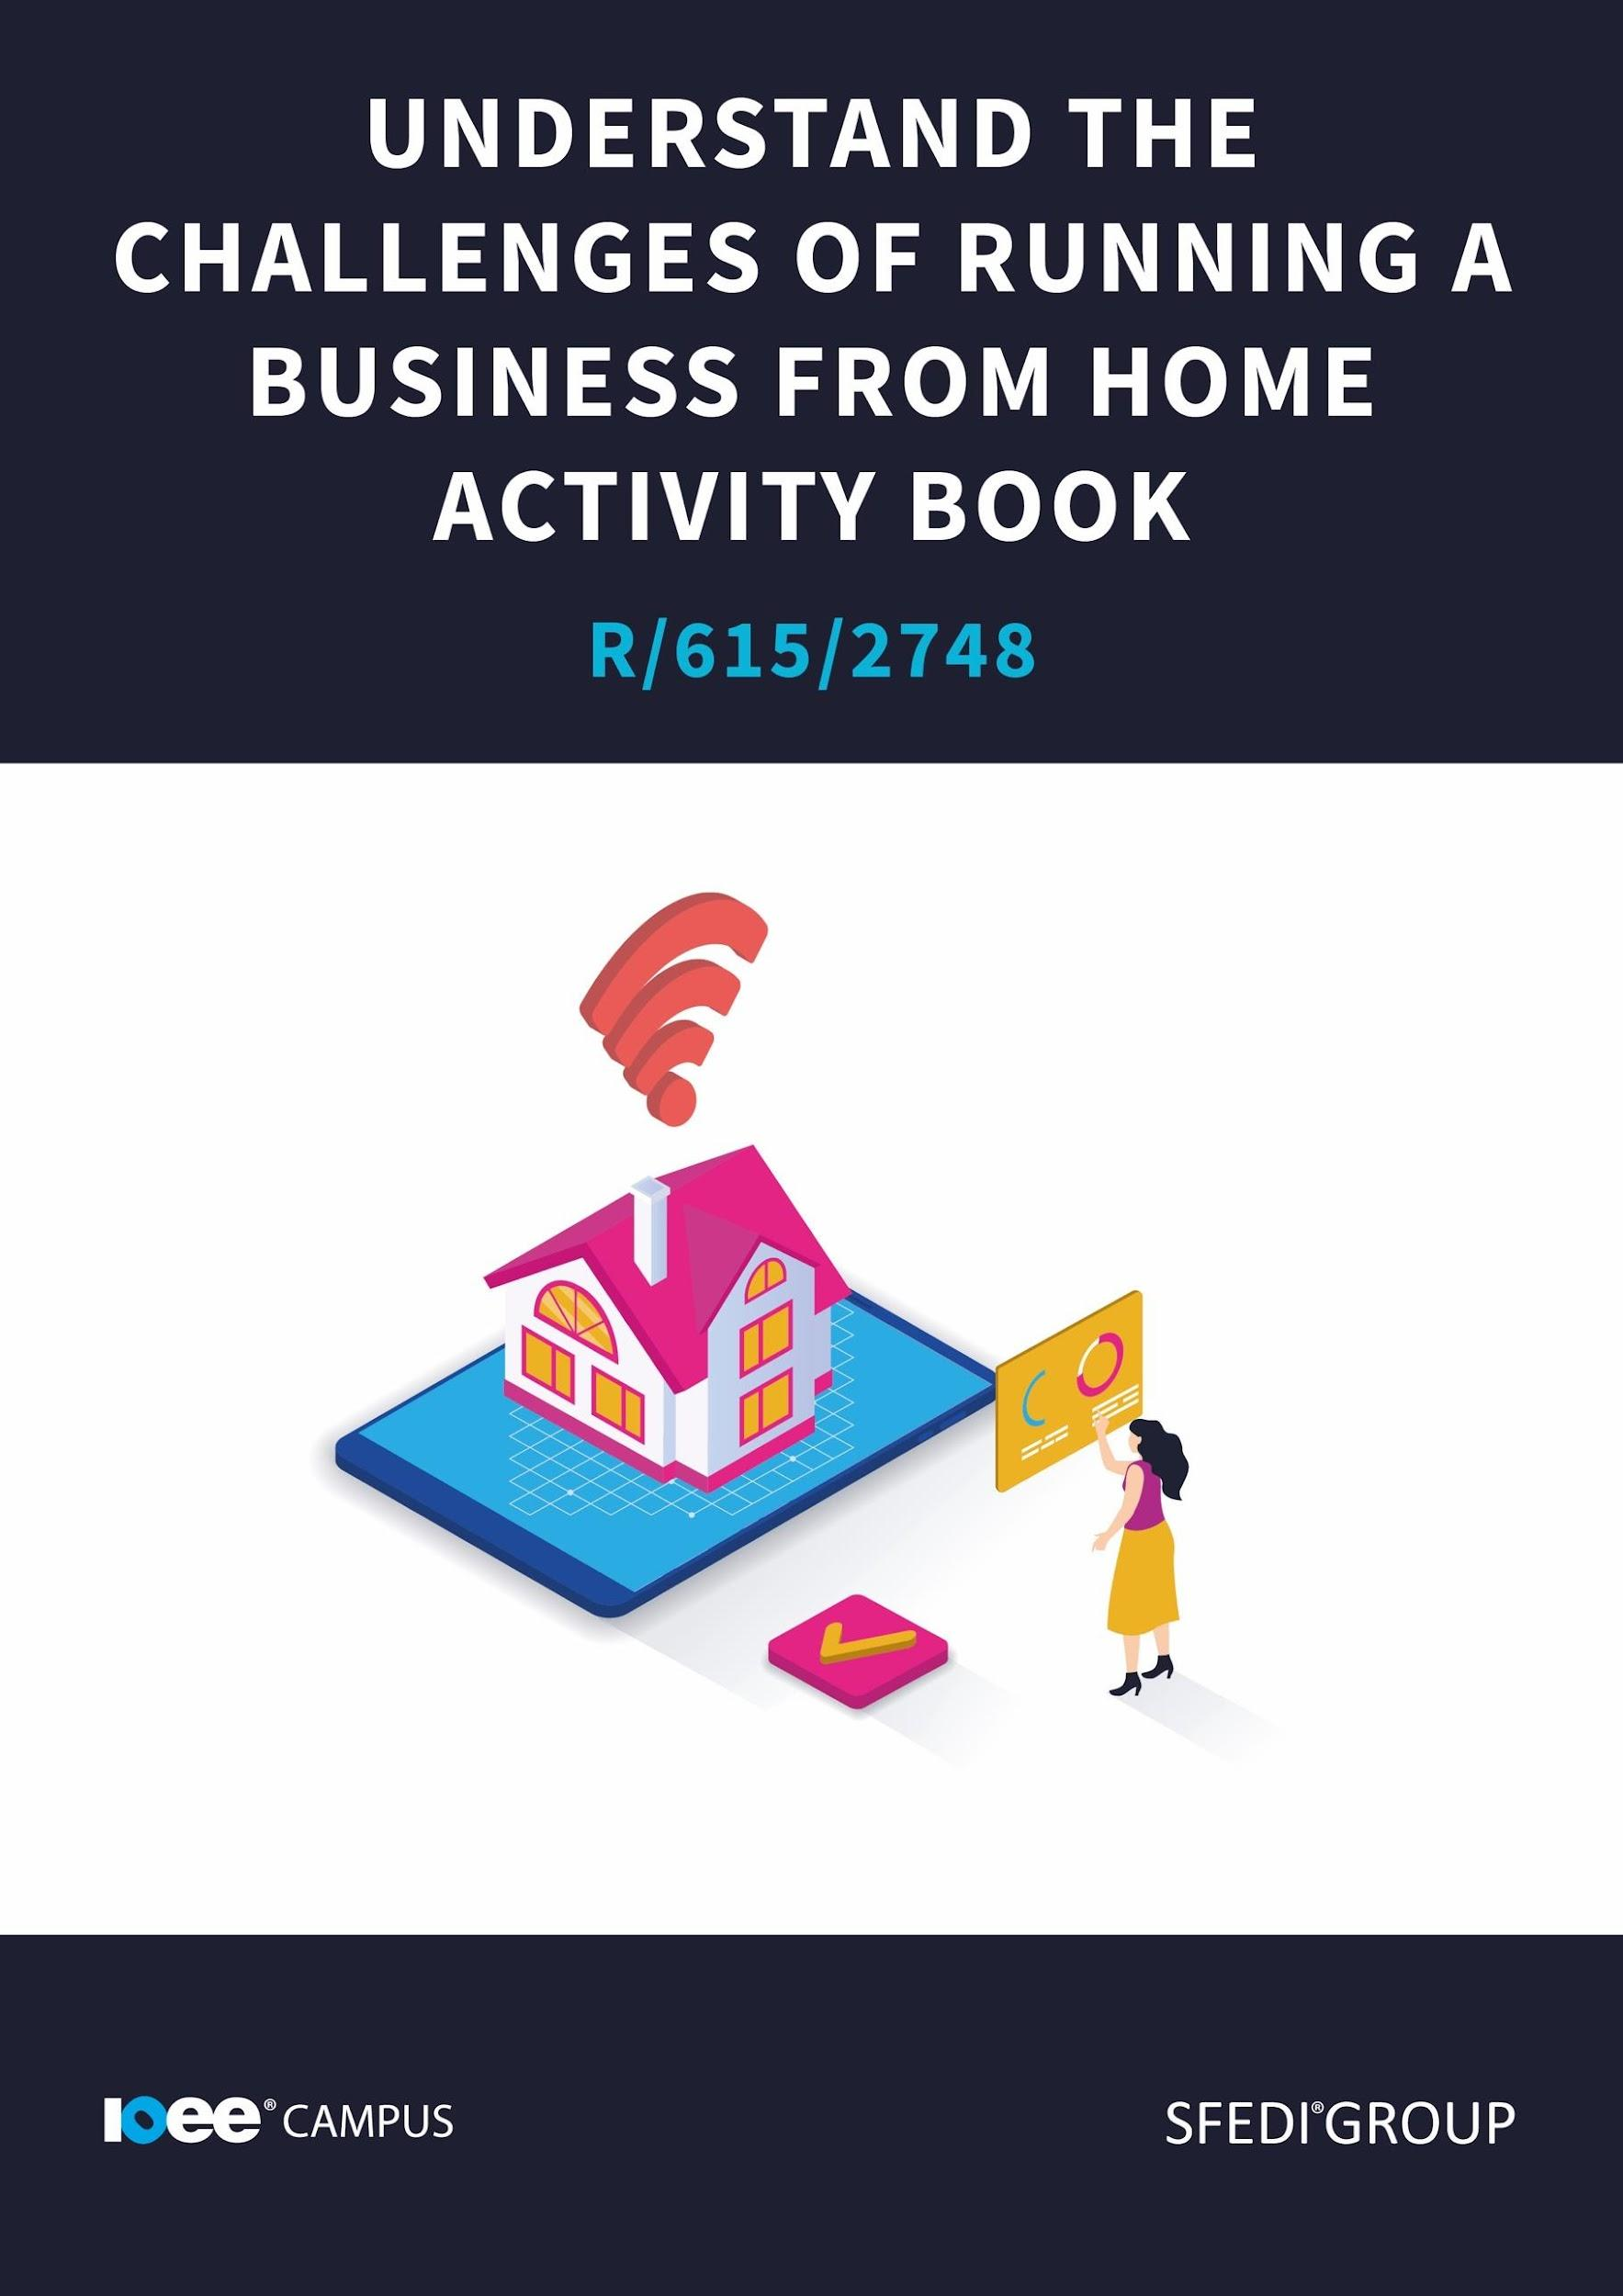

Introduction

This unit contains 2 learning outcomes which will support the learner to be able to:

✓ Understand the benefits and challenges of running a business from home
✓ Understand how to create a professional image when running a business from home

This unit is graded on a pass or fail basis and the learner must demonstrate evidence against all of the listed assessment criteria in order to achieve this unit.

The following provides examples of assessment methods that could be used to generate evidence for this unit. This list is not an exhaustive list and other methods can be used by the centre.

✓ Product evidence
✓ Learner statement/case study
✓ Pre-approved worksheets
✓ Professional discussion
✓ Recognition of prior achievement
✓ Recognition of prior learning
✓ Witness testimony

The evidence within this workbook will be assessed by,

Assessor Name:

and will be quality assured by,

Internal Quality Assurer Name:
Copyright © 2020 SFEDI Enterprises Ltd

All rights reserved. This book or any portion thereof may not be reproduced or used in any manner whatsoever without the express written permission of the publisher (address below).

Approved SFEDI Awards centres and learners undertaking a SFEDI Awards qualification may photocopy this document free of charge and/or include a PDF version on its intranet where it is only done so for the purposes of the approved delivery of this qualification.

SFEDI Enterprises Ltd t/a SFEDI Awards
19 Victoria Rd
Darlington
DL1 5SF
www.sfedigroup.com

Every effort has been made to ensure that the information contained in this publication is true and accurate at the time of publication. However, SFEDI Enterprises t/a SFEDI Awards strives to continually develop and improve our qualifications and, as such, there may be occasions where changes are required. SFEDI Enterprises t/a SFEDI Awards does not accept liability for any loss or damage arising from the use of the information contained within this publication.

Introduction

How many of us have thought about running a business from home? The flexible hours, the comfortable environment, the income with less travel expenses. Running a business from home may sound like a dream. Following your dream and doing something you're actually passionate about, what more could you ask for? It is important to remember that running a business from home is not free of its challenges. While we do tend to look at those rather impressive rewards, it is important to keep these challenges in the back of our minds.

Your Assessor will support you to plan how best to demonstrate your knowledge and skills which may be through the completion of the activities within this workbook or may include additional tasks best suited to you.

If any additional tasks are to be completed these will be listed in the table below with target dates for which you should try your best to complete each task listed.

Task | Target Date | Re-planned Target Date
Completion of the activities included within this workbook

By signing below, you agree to completing the work as detailed above and working with your Assessor to achieve this by the deadlines indicated.

Learner Name:

Signature:

Date:

Assessor Name:

Signature:

Date:

Activity One

Task:

Before we start looking at the challenges we will have to face when running a business from home, take a moment to think about your business idea. What do you want to sell, and who do you want to sell to? Having these answers may make it easier to think about issues you may face.

One of the major benefits of running a business from home is being able to find a more balanced approach to life. Being able to find the right balance with your work and personal life is what many aim to have. This is a good goal to aim for, because it is not only ambitious and a bit of a challenge, but it is actually better for you. Having a good balance between work and personal life is not only better for you psychologically, as you get to switch off and wind down almost instantly, instead of driving back through rush hour traffic. The balance can also offer you some benefits in terms of relationships, your attitude to work, develop your determination, allow you to have a physically healthier day and many other benefits.

It is proven that a flexible approach to the times you work can lead to better results. Flexible hours can be a huge benefit to some people, boosting their morale and making their time at work more effective and efficient. This is because when you have a flexible approach, you’re able to work when it feels best for you. Rather than following a strict 9 to 5 work day, which you may find difficult, you may find it easier to get that admin work done in the early morning, or in the evening.

Running a business from home could actually be good for your stress levels too, “82% of remote workers report lower levels of stress compared to working in an office environment.” (INAA, 2020). Running a business from home means those pesky commutes become a thing of the past, missing appointments because of work hours stops being an issue and you are given more freedom in terms of how you spend your time. (Avocor, 2019). As long as you stay on track and don't fall behind, running a business from home can be really beneficial.

If you are a parent, running a business from home can also cut the childcare bills down quite significantly. Being able to spend time at home, whilst also getting small jobs done, means you are able to be the boss and parent at the same time.

Running a business from home is also better for the environment. With less commutes and a smaller space to maintain and provide utilities to, running a business from home can have some pretty big effects on the planet. “If every commuter worked from home one day a week, not only would the travel networks be less congested, but fewer cars and trains would mean fewer emissions being released.” (ITPro, 2020)

Spending less on lunch out, less on those coffee shop trips plus working from home, with those reduced commutes, can be cheaper in the long run. This is one of the biggest positives that comes with running a business from home.

However, with each benefit that comes with running a business from home, there could also be a challenge.

Remote workers often rely on technology in order to run their businesses and as we all know, technology can have its issues. Whether it is websites not working, information going missing online or simply not having the equipment to run the business from home, technology really does require a lot of attention.

By relying on technology, there will be more opportunity for miscommunication. Whether it's missing an email, forgetting about an online meeting or simply not understanding the context of an enquiry, communicating with people can be difficult online.

By working remotely, you also miss out on the interaction and idea sharing that may occur in the office. Those lessons about how to use the printer or how to access certain documents that you may learn from face-to-face interaction in the office will now be a Google search, or you may have to rely on trial and error.

You may feel tempted to work more hours than you should. Instead of working an 8 hour day, you may sneak in a few hours here and there. Suddenly your profits may slip away as you pay yourself for those extra hours, or maybe your work and personal life balance goes out the window, as you are excited to start this new chapter. Either way, there is such a thing as working too much, and bringing it into your home just makes it easier to do this. How are you going to make sure you clock off when you are supposed to?

You also need to make sure you have enough room and resources in your home to run this business.

Do you have enough room for the equipment you need to run this business? Many of us do not have spare rooms in our houses, and so we would need to reshuffle rooms to fit our new business venture in. Do you have enough room to do this, or would this have too much of an affect on your home life?

Have you thought about the increase in home utilities? Your use of Gas, Electric and water will all increase as you start to run your business from home. Those hours you used to be out of the house working, you are now spending in your home office. The expenses your employer used to pick up are now on your shoulders. Can you afford this increase, and have you thought of ways to manage the bills?

And there is of course the overall perception that a home-based business is just a hobby and not very professional. Some people out there think that a business ran from someone’s home is less professional or less legitimate because it has a home address. It is important to make sure you act professional at all times and prove these individuals wrong. Eventually they will be won over, but only if you go against their expectations.

When deciding whether to run a business from home, these pros and cons should be taken into account. But being fair and honest about the situation is the only way to tackle this list. Just because there may be challenges, does not mean it is impossible to successfully run a business from home. In fact quite the opposite. When you really get to understand how your business will work and how to work through these cons, you’ll be able to have bigger successes and less frequent failures.

Using the table below, identify the benefits and challenges that working from home can bring.

Benefits | Challenges
The benefits of running a business from home are: | The challenges of running a business from home are:

Activity Two

When starting a business, you will need to think of some legal and administrative requirements. This means that before you start your business, you will need to make sure you are following the law and seeking any outside help that you may need to continue running your business.

You will need to talk to a few people before you set your business. You may have to have a chat with your mortgage provider about turning your home into a place of work. If you are planning on running a business in which people visit your home to collect orders, you may also have to talk to the local authorities, planning office and area council to discuss any issues that may occur. You may also need a licence to open your business, again you should talk to your local authority about this. You may need extra home insurance, contents cover and business insurance. You will also need to consider seeking legal advice on contracts with your solicitor.

Many self-employed people, or business owners, have a finance team or an accountant to take care of the financial side of things. It is worth having a look at a few different options and finding out what their customers think of them. Most accountants will have a google review page, which allows customers to review the service.

Some business owners may need extra help, so employment contracts will need to be drafted. This could require some help the first time you do it, and there is no shame in getting help to make sure it is done correctly. Again this is another administrative job you will need to seek assistance with.

You will also need to organise the space you will work in. It is really important to have a safe and comfortable place to work, with all of the equipment you will need to get the job done. Do you have enough lighting, have you got a desk and chair that you are comfortable in?

Which is another challenge you will face. You will have to buy any equipment you need and this may mean applying for a loan for the initial cash injection.

There are many different requirements that a business owner has to think about before they start their business. Make sure you think about all of the potential requirements that may apply to your business idea, before starting.

Using the table below, identify the different administrative and legal requirements that need to be completed prior to starting to operate a business from your home.

Administrative or legal requirement | Best place to get advice or support from

Activity Three

One of the main things to consider before you begin running a business from home would be your resources. You may already have some of the equipment that you need to start your business, but you may need to invest in some extra bits to really take the business to the next level.

Have you got a way to connect to your customers?

This could be a phone, a laptop, business cards or a newsletter. It all depends on how your business will operate but making sure you have a way to connect to your customers is one of the most important parts of your at home tool kit. You may need to make your way to your nearest electronics shop and get a new phone, laptop or even a camera, if you are going to share your own images of products you sell. You also need a printer, to print invoices and contracts. It would be wise to make a list, starting with the basics and working your way up to the things that would make running your business a little bit easier.

Do you have your office supplies?

It may sound obvious, but paper, tape, pens and envelopes are all really useful when it comes to running your business. These items are always handy to have around, whether you're printing documents, writing letters, shipping orders or just writing lists so you stay on track. The basic items are sometimes the most important items, depending on your business.

Do you have products/services to sell?

It is important to make sure that you know what you are selling. Is it a product or is it a service? Do you have the skills to deliver this service? Do you know enough about your product to sell it? And then there is the actual delivery of the product. Do you know who can deliver for you? Will you use a courier? Will you deliver the products yourself?

It is important that when you start selling products, you are able to keep up with demand. Making sure you know how long it will take for your customer to receive their product is really important to grow your reputation. Have a good product, a quick turn around and great customer service, and all of this comes with being prepared.

Do you need an extra pair of hands?

Sometimes we simply need an extra pair of hands on the job. Do you need to hire someone to help you? Do you know where to look and how to advertise a job? Do you know what the role will be, and what responsibilities this new employee will need to take on?

Some employers will use agencies to hire extra staff. Websites such as indeed will advertise your vacancies for you and charge a commission for anyone who is hired. Alternatively you could advertise your vacancy on your social media, forums or in the local paper. There are many ways to go about hiring people, and again it all depends on how your business works.

Sometimes, you may need security or surveillance if you are selling high priced goods or have individuals coming to your home for collections. Is this something you and your business want? Do you have space for this person to come into your house, do you know someone who would act as security or is this going to be a stranger you hire through an application process?

These are all things you will have to think about before beginning the business journey.

Using the table below, identify the types of equipment, both physical and virtual, that would be needed when running a business from home.

Equipment needed | Is it physical or virtual | Where can it be accessed from?

Activity Four

When you know where to access resources, take the right steps and plan how your business will run, you should have a very successful business. But having a successful business will ultimately come down to one thing, your customers. Making sure you make a good first impression and satisfy your customers will ensure success for your business.

But why is it important to make a good first impression?

Well, firstly, you shouldn’t want your customers to have a bad experience. You should always aim to make the experience as positive as possible for your customers. If a customer comes away from their interaction with your business feeling like they have been listened to and their custom has been appreciated. To make sure your customers have a great experience you may want to add in some extra details. If you sell products, you could include a business card, friendly instructions or a little leaflet introducing yourself. You could add free samples for other products you sell, personal recommendations and suggestions based on their purchase. Small details and added steps can really make a customer's experience that next level. Getting a returning customer will help you sustain the business and grow your customer base.

If you manage to get a few returning customers, they are more likely to suggest your business to a friend. This is known as word-of-mouth marketing. This is where people recommend a business to people they know. It is free and organic, which means you pay nothing and have the potential to see some great marketing results. A satisfied customer may also start placing larger orders, which means more lump sum income which could be handy if something breaks in your home office, or if you need to make a larger payment for tax, the mortgage or any other business expense.

You really do have to balance a few different needs here. You have to think about the customer’s needs, your business needs, your personal needs and the needs externally such as for mortgage providers, your family and friends etc. While running a business from home really does bring some huge rewards, it can also be a juggling act and it can be hard to find a perfect balance. But once you find it, you will be able to maintain it, plus the customers will help out with some of that, when they place orders and mention your business on their social media or when talking with their friends.

If a customer gets a bad impression when they trade with you, you could instantly shut down the future of your business. While one bad review isn't the end of the world, if a whole bunch of bad reviews come in, it could seriously damage your reputation. It may even have a negative effect on future businesses. So it is really important that those impressions are good, and you maintain a high level of customer service and care.

So how exactly do we make a good impression?

When handling customer enquiries, make sure you remain professional but try being more of a person than a business robot. Customers are more likely to return to a business if they have developed a bond or rapport with someone in a company. This is one of the main ways to ensure that a customer returns to your business, without having to spend any extra money on advertising. There are certain things you can do to make sure your professionalism is balanced with your personality.

Call answering: if you are answering your call, do not be too casual. Having a personality is not the same as going too far. Do not answer business calls as if they were your best friend. There should still be some difference in how you handle business calls. It may be beneficial to get a separate phone number for your business calls, this way you know who is calling you for personal reasons and who is a customer.
Emails and social media: You should have a tone of voice. Whether it is professional and fact based, fun and energetic, colourful and quirky all of the above are perfectly fine, depending on your business. If you are a lawyer who is looking to take on some high price, high risk cases, being a quirky and colourful character may damage your credibility. If your social media and emails are coming across too personal, quirky or energetic, you may lose customers. So make sure you pick your tone of voice, that is appropriate for your business, and stick to it. It will also be good to have a work email set up and ensure all of your social media public display names match. If someone wants to send you an email, a professional lawyer, and your email is rockerboi24@hotmail they may be less likely to approach you. Also if your social media handles and display names are all different, you will be hard to find and may miss out on those potential sales. Make sure people can find you, contact you and have a pleasant experience.

Social Media knowledge: Having social media and knowing how to use it are two separate things. We have a whole unit on the use of social media available through our passport, Principles of social media for business use. You will find more information regarding social media, its uses and how it can work for your business, there.

And just to make it clear, what should you avoid, if you don't want to give off a bad impression?

Answering the phone: being overly chatty, telling lots of jokes or being inappropriate are some obvious things to avoid. But you should also avoid things like a noisy background. If your customer is unable to hear you, you may misunderstand them or be unable to help them, plus they may think you're being unprofessional if they can hear the TV on or other distractions. interrupting your customer to collect a parcel at the door or always being unavailable because you’re meeting with friends. Find a comfortable, quiet and well-equipped room to work in, and make sure you are available for your customers. If you are always unavailable, or return their calls too late, they may have found a company that will work with them, who was available. You don't want competitive companies stealing your business, so make sure you answer the phone, answer their questions and be positive, but do not go too far.

Ignoring the customer's needs: If you ignore the customer's request after they have been very clear and outlined everything they want, you will create a reputation for yourself that will not lead to more sales. Ignoring your customers' needs and wants is a sure way to create a bad impression and to put yourself out of the competition, business wise.

Using the box below, explain why it is important to create a positive impression with your customers in order to meet the needs of the business. Make sure to provide examples of how a positive impression could be given when working from home.

Using the table below, provide examples of what might potentially give a negative impression of the business, why it would give a negative impression and ways in which you could overcome the situation.

Example | Why would it give a bad impression? | How could you overcome the situation?

Activity Mapping

Now you have completed the activities to demonstrate your knowledge and skills it is time for your Assessor to map your work against the standards listed below.

By doing this they will be making sure that the work you have provided by completing the activities meets the requirements for you to gain your certificate.

Your Assessor will provide you with feedback on how you have done and whether any more work may be required.

Assessment Criterion – The Leaner can: | Activity Number or Reference Number of Additional Activities: | Assessor Signed Off (✓/✗):
Understand the benefits and challenges of running a business from home | 1
Identify the benefits of working from home | 1
Identify the challenges of working from home | 1
Identify the administrative and legal requirements for running a business from home | 2
Identify the types of equipment, both physical and virtual, that would be needed when running a business from home | 3
Understand how to create a professional image when running a business from home | 4
Explain what is necessary to create a positive image when working from home | 4
Provide examples of what might produce a negative impression when working from home and methods of overcoming these | 4

Assessor Feedback

Authenticity Declarations

Learner Declaration

By signing this declaration, you agree that the evidence provided within this workbook has been produced by you and meets the requirements of being authentic, sufficient, valid and current to the standards required.

Learner Signature:

Date:

Assessor Declaration

By signing this declaration, you agree that you have assessed all of the evidence produced within this workbook and have ensured that the work is that of the learner. You are also declaring that during the learning process you have ensured that the evidence is authentic, sufficient, valid and current to the standards required.

Assessor Signature:

Date:

IQA Signature (if applicable):

Date:

Additional Evidence Forms

Use these additional forms in order to record additional evidence for the activities within this workbook where additional space is required.

Ensure that each piece of evidence entered on these forms is clearly labelled with the corresponding activity number.

Useful Resources & References

Useful resources:
Pros and Cons of a Flexible Work Schedule (thebalancecareers.com)
Flexible working - GOV.UK (www.gov.uk)
Can I run a business from home? A guide for small businesses (simplybusiness.co.uk)
Home Business Guide: Guide to Starting and Growing a Business from Home - GOV.UK (www.gov.uk)

References:
19 Benefits of Remote Working for Employers (Skyrocket Profits!) - Avocor | different by design. available at: https://www.avocor.com/blog/19-benefits-of-remote-working-for-employers-skyrocket-profits/
Benefits of Working in an Office vs. Remote Work | INAA available at: https://www.inaa.org/benefits-of-working-in-an-office-vs-remote-work/
10 reasons why working in the office work beats telecommuting - TechRepublic available at: https://www.techrepublic.com/blog/10-things/10-reasons-why-working-in-the-office-work-beats-telecommuting/
Top 10 reasons to consider flexible working | IT PRO
Running a business from home - GOV.UK (www.gov.uk)

SFEDI Enterprises Ltd t/a SFEDI Awards
19 Victoria Rd
Darlington
DL1 5SF
www.sfedigroup.com

customerservices@sfediawards.com
0845 224 5928
@sfediawards

