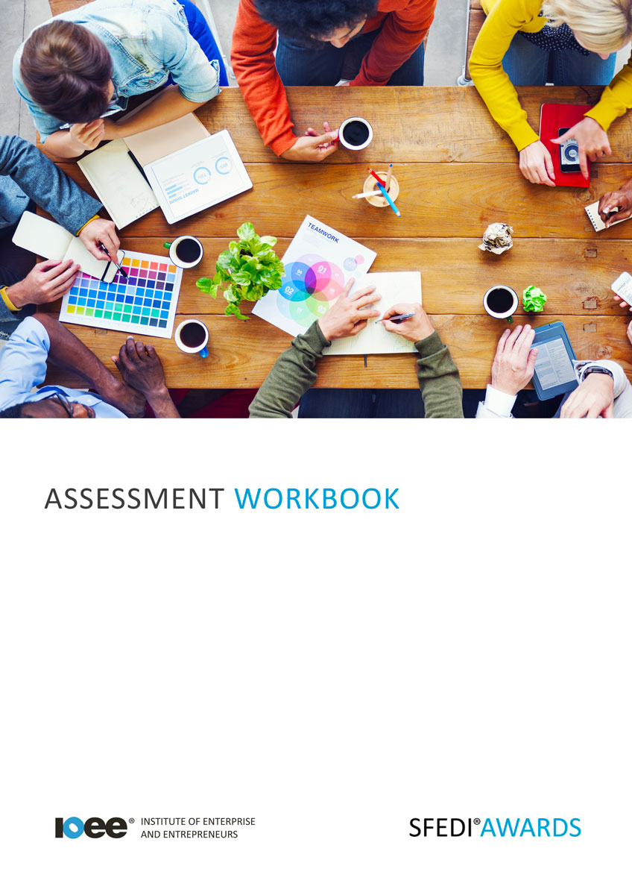

Understand the Challenges of Running a Business from Home
R/615/2748

Copyright © 2020 SFEDI Enterprises Ltd

All rights reserved. This book or any portion thereof may not be reproduced or used in any manner whatsoever without the express written permission of the publisher (address below).

Approved SFEDI Awards centres and learners undertaking a SFEDI Awards qualification may photocopy this document free of charge and/or include a PDF version on its intranet where it is only done so for the purposes of the approved delivery of this qualification.

SFEDI Enterprises Ltd t/a SFEDI Awards
19 Victoria Road
Darlington
DL1 5SF
www.sfedigroup.com

Every effort has been made to ensure that the information contained in this publication is true and accurate at the time of publication. However, SFEDI Enterprises t/a SFEDI Awards strives to continually develop and improve our qualifications and, as such, there may be occasions where changes are required. SFEDI Enterprises t/a SFEDI Awards does not accept liability for any loss or damage arising from the use of the information contained within this publication.

Introduction

This workbook has been developed so that you are able to collect and present evidence that demonstrates your knowledge and skills in relation to the challenges of running a business from home.

There are different sections that make up this workbook in order to make sure you are able to complete all of the tasks necessary but you will be provided with support as you move along by your Assessor.

Further learning materials and support is available through your studying membership of the Institute of Enterprise and Entrepreneurs. If you haven’t yet received your login please speak to your Assessor who will be happy to sort this out for you.
This unit contains two learning outcomes and will support you to be able to:
- Understand the benefits and challenges of running a business from home
- Understand how to create a professional image when running a business from home
The evidence within this workbook will be assessed by,

Assessor Name:

and will be quality assured by,

Internal Quality Assurer Name:

Your Assessor will support you to plan how best to demonstrate your knowledge and skills which may be through the completion of the activities within this workbook or may include additional tasks best suited to you.

If any additional tasks are to be completed these will be listed in the table below with target dates for which you should try your best to complete each task listed.

Task | Target Date | Re-planned Target Date
Completion of the activities included within this workbook

By signing below you agree to completing the work as detailed above and working with your Assessor to achieve this by the deadlines indicated.

Learner Name: | Signature: | Date:
Assessor Name: | Signature: | Date:

Activities

Activity 1
Using the table below, identify the benefits and challenges that working from home can bring

Benefits | Challenges
The benefits of running a business from home  are: | The challenges of running a business from home are:

Running a business takes more planning than simply making a coffee, sitting down at your computer and starting to talk to your customers. There are different administrative and legal requirements that you need to go through first, eg. speaking to your mortgage provider or landlord or speaking with the local planning office.
Using the table below, identify the different administrative and legal requirements that need to be
completed prior to starting to operate a business from your home

Administrative or legal requirement | Best place to get advice or support from

Using the table below, identify the types of equipment, both physical and virtual, that would be needed when running a business from home

Equipment needed | Is it physical or virtual? | Where can it be accessed from?

It’s not just about whether you want to work at home and the benefits and potential downfalls it can bring, there is someone else in the relationship, the customer, and creating a positive impression with them is important whether you work at home or not.

Using the box below, explain why it is important to creative a positive impression with your customers in order to meet the needs of the business. Make sure to provide examples of how a positive impression could be given when working from home

Using the table below, provide examples of what might potentially give a negative impression of the business, why it would give a negative impression and ways in which you could overcome the situation

Example | Why would it give a bad impression? | How could you overcome the situation?

Activity Mapping
Now you have completed the activities to demonstrate your knowledge and skills it is time for your Assessor to map your work against the standards listed below.
By doing this they will be making sure that the work you have provided by completing the activities
meets the requirements for you to gain your certificate.

Your Assessor will provide you with feedback on how you have done and whether any more work may be required.

Assessment Criterion - The learner can: | Activity Number or Reference Number of Additional Activities: | Assessor Signed Off (✓/✗):
Identify the benefits of working from home | 1
Identify the challenges of working from home | 1
Identify the administrative and legal requirements for running a business from home | 2
Identify the types of equipment, both physical and virtual, that would be needed when running a business from home | 3
Explain what is necessary to create a positive image when working from home | 4
Provide examples of what might produce a negative impression when working from home and methods of overcoming these | 4

Assessor Feedback

Authenticity Declarations

Learner Declaration

By signing this declaration you agree that the evidence provided within this workbook has been produced by you and meets the requirements of being authentic, sufficient, valid and current to the standards required.

Learner Signature: Date:

Assessor Declaration

By signing this declaration you agree that you have assessed all of the evidence produced within this workbook and have ensured that the work is that of the learner. You are also declaring that during the learning process you have ensured that the evidence is authentic, sufficient, valid and current to the standards required.

Assessor Signature: Date:

IQA Signature (if applicable): Date:

Additional Evidence Forms

Use these additional forms in order to record additional evidence for the activities within this workbook where additional space is required.

Ensure that each piece of evidence entered on these forms is clearly labelled with the corresponding activity number.

SFEDI Awards
19 Victoria Road
Darlington
DL1 5SF

customerservices@sfediawards.com 0845 224 5928
@sfediawards

