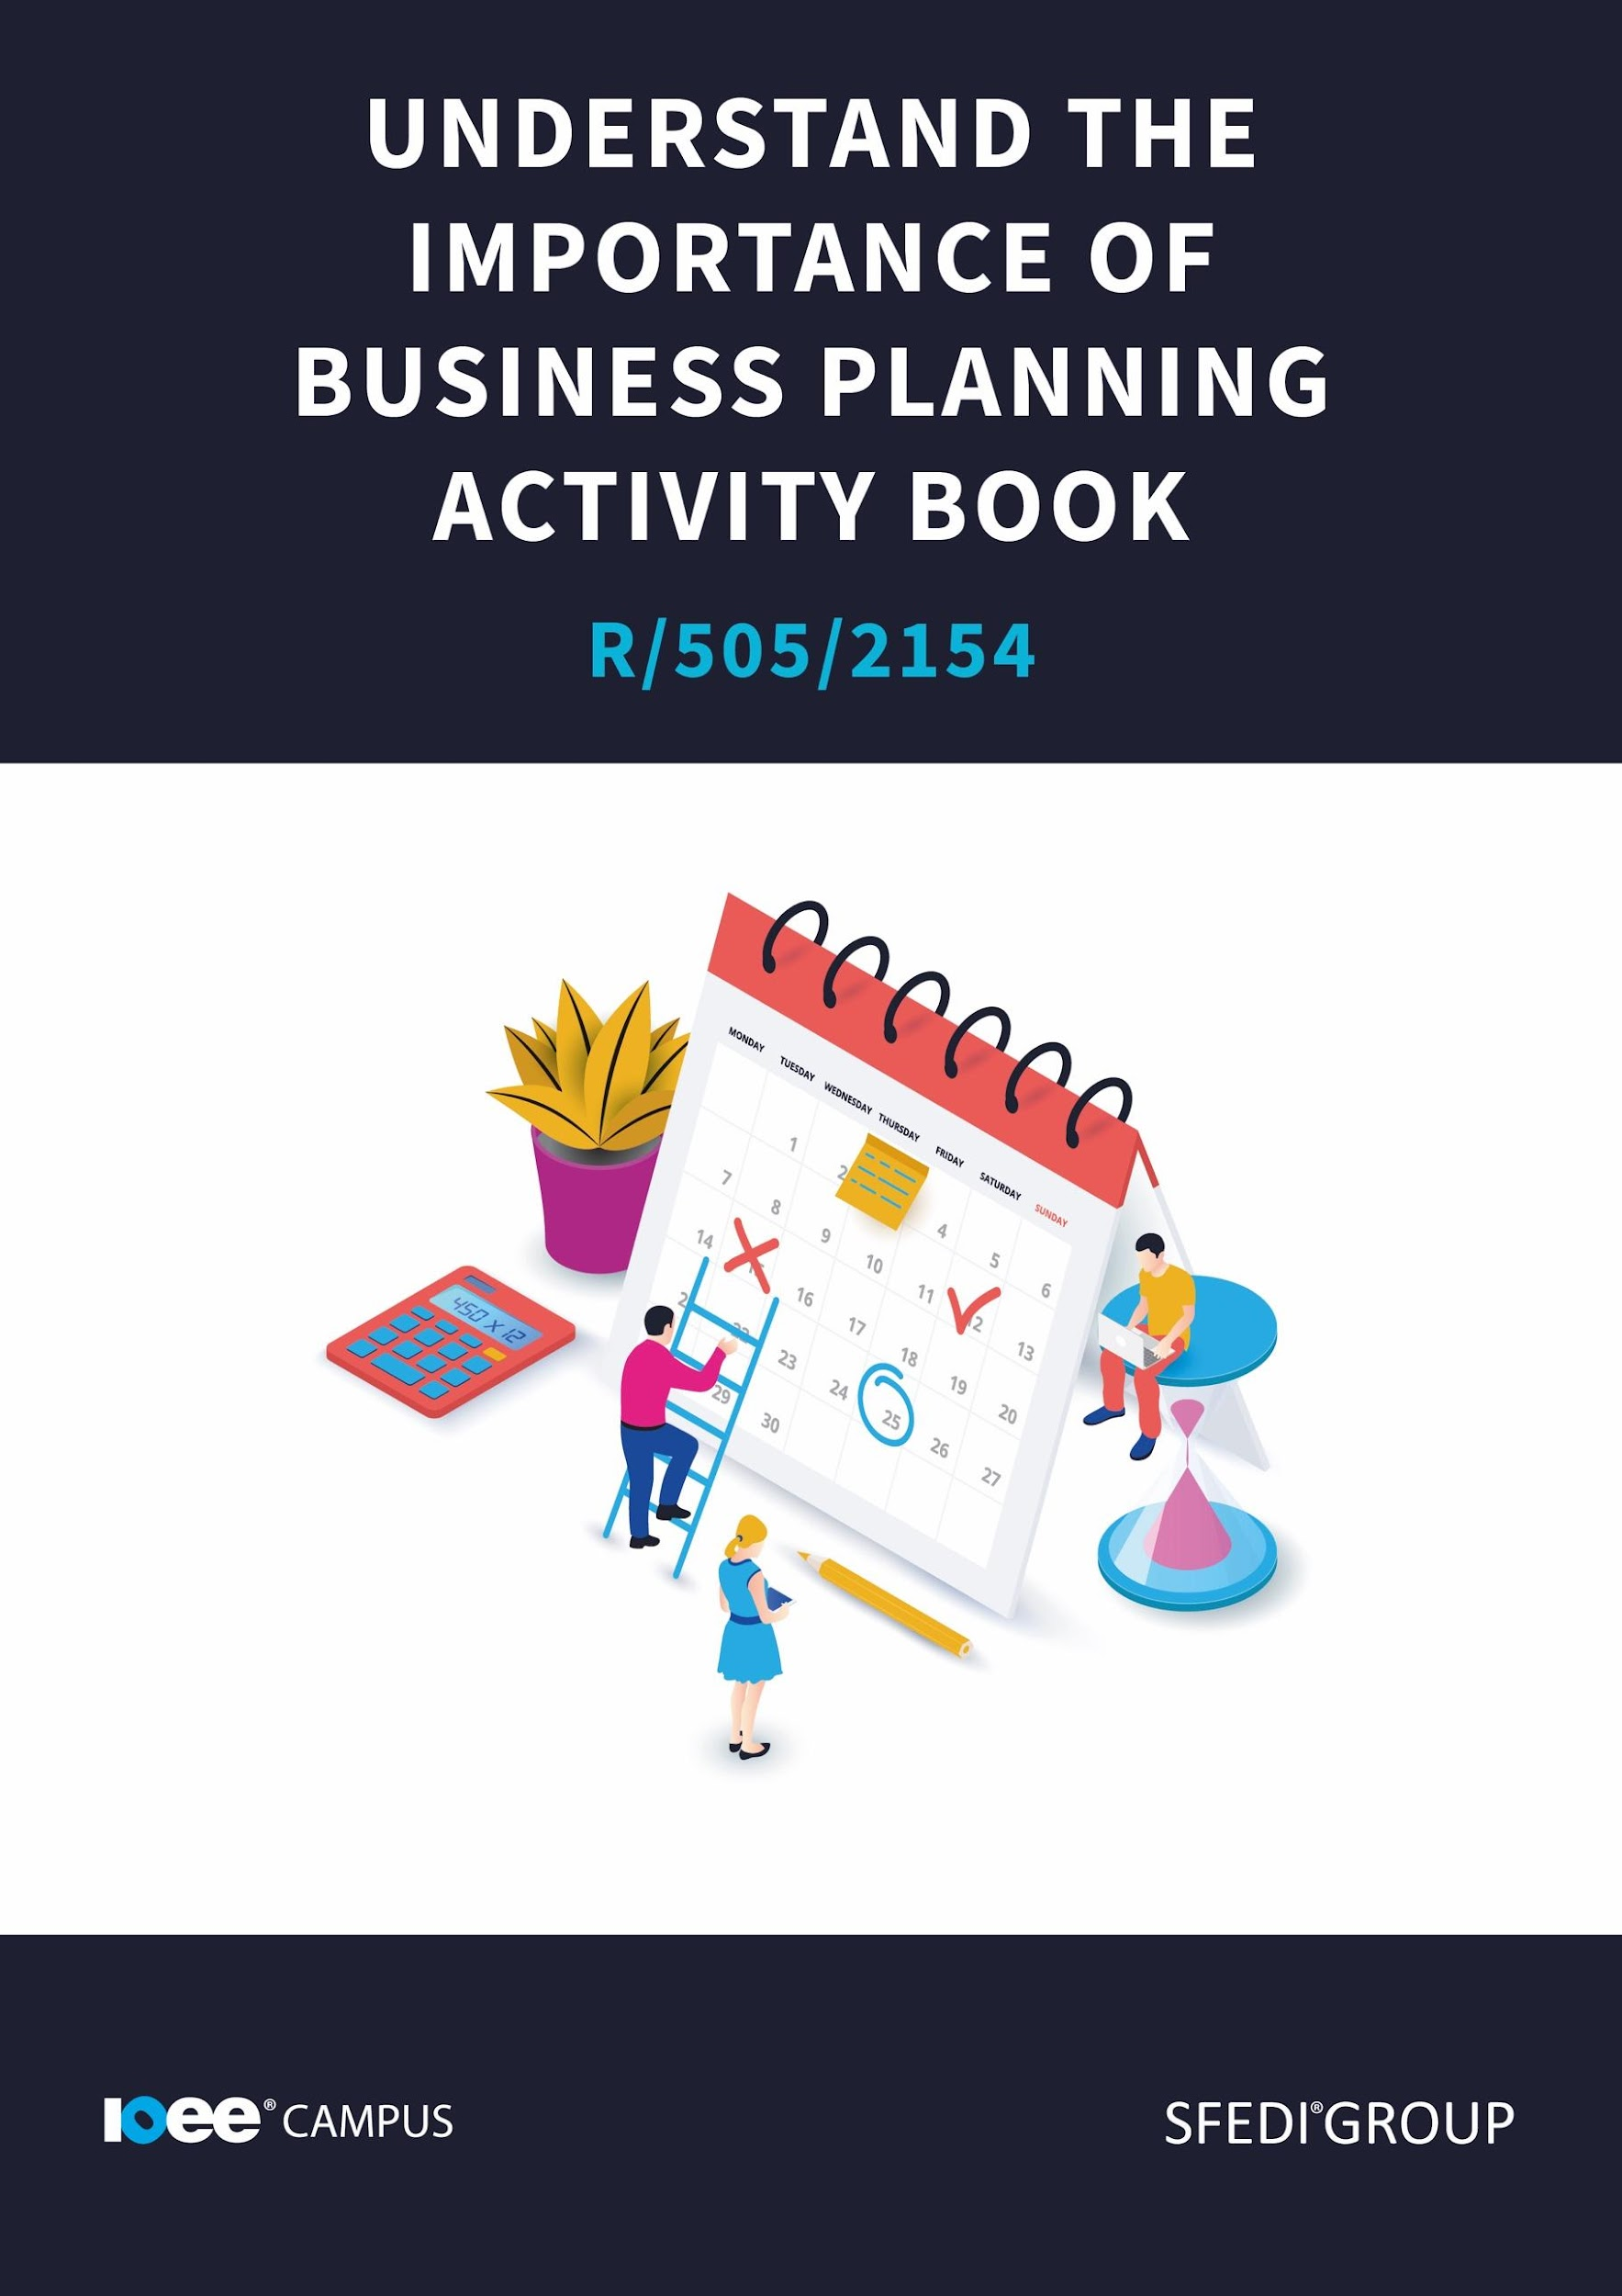

Introduction

This workbook has been developed so that you are able to collect and present evidence that demonstrates your knowledge and skills in relation to the importance of business planning.

There are different sections that make up this workbook in order to make sure you are able to complete all of the tasks necessary, but you will be provided with support as you move along by your Assessor.

Further learning materials and support is available through your studying membership of the Institute of Enterprise and Entrepreneurs. If you haven’t yet received your login, please speak to your Assessor who will be happy to sort this out for you.

This unit contains two learning outcomes and will support you to be able to:

- Understand the importance of business planning
- Understand the components of a business plan
- Understand the legislation that can affect the development of plans for a business

The evidence within this workbook will be assessed by,

Assessor Name:

and will be quality assured by,

Internal Quality Assurer Name:
Copyright © 2020 SFEDI Enterprises Ltd

All rights reserved. This book or any portion thereof may not be reproduced or used in any manner whatsoever without the express written permission of the publisher (address below).

Approved SFEDI Awards centres and learners undertaking a SFEDI Awards qualification may photocopy this document free of charge and/or include a PDF version on its intranet where it is only done so for the purposes of the approved delivery of this qualification.

SFEDI Enterprises Ltd t/a SFEDI Awards
19 Victoria Rd
Darlington
DL1 5SF
www.sfedigroup.com

Every effort has been made to ensure that the information contained in this publication is true and accurate at the time of publication. However, SFEDI Enterprises t/a SFEDI Awards strives to continually develop and improve our qualifications and, as such, there may be occasions where changes are required. SFEDI Enterprises t/a SFEDI Awards does not accept liability for any loss or damage arising from the use of the information contained within this publication.

Introduction

When setting up your own business, or starting a management role in a company, there are a few steps you need to take. One of these steps is to create a business plan or be aware of your company's business plan. A business plan will be similar, whether you’re setting up a business or starting to work for a business.

But what exactly is a business plan, and what goes into one?

Task - before we look at a definition and an example, let's have a think about what a business plan is and make a note of this. This will let you see if you know what a business plan is or whether you're starting from the beginning.

Your Assessor will support you to plan how best to demonstrate your knowledge and skills which may be through the completion of the activities within this workbook or may include additional tasks best suited to you.

If any additional tasks are to be completed these will be listed in the table below with target dates for which you should try your best to complete each task listed.

Task | Target Date | Re-planned Target Date
Completion of the activities included within this workbook

By signing below, you agree to completing the work as detailed above and working with your Assessor to achieve this by the deadlines indicated.

Learner Name:

Signature:

Date:

Assessor Name:

Signature:

Date:

Activity One

A business plan, or business planning, is a very useful way of having an overview of what you want your business to do, and how to get there. It is also useful for other people to see where you are planning on going with your business or management duties. These people may include suppliers, buyers or CEO’s.

“A stranger should be able to pick up your business plan, read it through and have a very distinct picture of what your business is, how it runs and how it will succeed.” (Bridge, 2021). It is really important that your business plan is really clear, concise and easy to understand. You want your business plan to tell the reader everything they need to know about your business, without giving them so much information they are confused.

How can a business plan help you start up or run a business?

As mentioned in the definition, a business plan is an outline of your business and a forecast of how you think your business will perform. This includes what has happened in the past and what you hope will happen in the future. By writing a business plan, you have to think about the challenges you have faced up to this point. Perhaps you were declined for a loan, perhaps your prototype product failed. It is important to note down anything that impacted your journey. You also have to forecast your business’ future, its sales figures or growth. A business plan is really useful in making you look into the future of your business and see where you are going.

A business plan also allows you to compile all of your important information, such as sales targets and employee growth targets, in one document. Not only does this improve your organizational skills, but it will allow your company to be more efficient. If you are intending on using the business plan to share with managers and supervisors, you will be able to express your goals and aims with them and provide context of what is happening within the business. This will help you work together in order to reach those targets.

Using the box below, explain a minimum of two ways in which a business plan can be used to benefit the starting and running of a business.

A business plan can be used for:

Activity Two

It is really important that your business plan focuses on the basics of your business, the more complex details and has a focus on the future. Let's look at what should be included.

Including the basics in your business plan is really important. The basics of your business plan would include the business name, the people that work there, what sector your business falls into, your target audience and the products or services you would be selling / supplying.

You should include the name of your business and the people that work there for many reasons. Not only will this allow you to identify your business, but you will have an up to date record of employees and a reminder of your business, should you need it. The next step would be to list what you sell or provide your customers. Does your business sell a product? Do you provide a service to the local area? By noting this in your business plan, you will be able to set yourself some S.M.A.R.T targets (more on that later) and be more focused.

It is also important to know who you are writing your plan for.
Below is a list of people who you may send your business plan to.

- Angel investors - these are people who will supply funding to your business venture in exchange for owning a percent of the business.
- Managing Director - writing an internal business plan will help you focus your vision, find your problem areas in how the company is run and let you focus on what can be improved. By the time you’ve finished writing it, you should have a clearer understanding of how your business will run.
- Commercial banks - If it’s a loan you’re looking for, banks will need to know more than your cool idea. Bankers are more formal when it comes to reviewing business plans. In other words, they won’t take a risk in an idea; they will be more focused on the end goal and potential benefits for them.
- Management - When managers inside your own company will read the business plan, they may use it as a resource to train staff members and remind themselves of the company’s goals. They may also use it to monitor the performance of the company and their branch.
- Venture capitalists - Venture Capitalists are attractive as they sometimes offer larger amounts of money. Potential business partners - You may be after a business partner. Make sure your plan includes details on: share of ownership, division of responsibility and what this means for the share of overall control. Business plans used this way must provide a clear picture of the structure of the business.
- Prospective key customers - While there are fewer reasons for customers to read your business plan, they may still do so. For example, they might be thinking about forming a long-term business relationship with you. They will be looking at how your business builds up a community.
- Critical suppliers - Your key suppliers will want to be sure your business can pay its bills. It is important that you include detailed financial reports and cash-flow forecasts. These will be important if you need to negotiate a contract vital to starting your business. They will want to know details on your current financial situation and growth forecast. If you can show growth potential, you are more likely to get a better set of terms with the suppliers.
- Strategic allies - It’s important to remember that strategic allies will approach you for a specific reason; similar customer bases, distribution crossovers, etc. So, prepare a section of your plan to present to a possible ally. It would be smart to present your business plan in stages, when you’re showing it to a strategic partner and ally (showing where you are and where you could go). Remember, a strategic ally can also become a competitor. So, you don’t want to provide them with sensitive details like marketing strategies or delicate financials until you’ve established trust. This sort of trust must not be built on a purely personal basis, but also protected based on a confidentiality agreement.
- Buyers - It may be that instead of starting your business you have already built a successful business and are looking to sell it. In this case you’ll be writing a business plan for potential buyers. You will need to demonstrate how the business is a good match for them, how profitable it is and what potential growth there is. Don’t forget to show that your business can run smoothly without you: if prospective buyers think your company can only succeed under your direction, they will not want to buy it off you.

Now you know who you are writing your plan for, it is important to know what goes into your plan. Below is a structure you can follow, including the names of the sections and what to include.

- Executive summary – This section of your business plan outlines your business, its aims and goals, and summarises your proposal.
- Business background – Use this section of your plan to explain what your business does and how it works, how you got to where you are now and provide a bit of information on your industry.
- Products or services – Here you will supply all the relevant information on the product or service you offer.
- Market breakdown – In this part, you will analyse the market your business is in, how the business and your industry is structured, your unique skills, using research on your industry and competitors
- Marketing strategy – How you plan to build awareness, will be your next focus. How will you market and sell your product or service? What tools and platforms will you use?
- Business operations – Next, describe all day-to-day operations. How does the business run? What does your production line work like? How long does it take from order in, to product out?
- Management – Then provide a snapshot of the key members of your team. Who are the senior members in your company and describe the roles of senior or important employees.
- The Proposal – Tell your reader exactly what you need, when you need it and what’s in it for them if they participate.
- Financial information and risks – It is really important that you break down your finances, including trading to date totals, sales projections for the future, cash flow projections, as well as a section evaluating risks to your business.
- Legal information – The final section includes any legal disclaimers, contracts or permits, as well as an overview of the regulations which may guide or restrict your trade.

Using the table below, identify the different sections that would make up a standard business plan and provide a short explanation of what should be included in that section.

Section | Description of information to include
e.g. executive summary | A short overview of the aims and objectives of the business including a description of the product or service, an idea of the size and type of market, how the business is viable and growth potential for the business. It should be short and to the point and is usually the last thing written in the business plan.

Activity Three

So now you know who you are writing your plan for, you know what needs to go into your plan, let's take a look at some of the goals you can set for yourself. Your plan will come in really handy in achieving these goals, but your plan will also come in handy when you are setting them. It is important that we look at a technique that will come up over and over in the world of business. S.M.A.R.T targets are something you will have to understand in order to set realistic and strong goals.

Specific - Make your targets as specific as you can make them. Focus on the details. What, specifically, do you want to achieve? The more specific your target is, the more focused you will be.

Measurable - you need to be able to measure your target. This means that you need to set a numerical limit on your targets. How much money do you want to make? How big of an impact do you want to make? How many people do you want to interview? These are just a few example questions you can ask yourself, but adding numbers and figures to your targets will give you an end goal.

Attainable - (closely linked to the meaning of the letter R in SMART) your goals need to be attainable. This means, they have to be possible. Your target should be something that is achievable, ambitious and challenging, but it is important that it is attainable

Realistic (+ relevant) - Make sure your goals are realistic, as mentioned above, and relevant to your life. Try to focus your goals on the area of your life you want to change. In your business plan, you will be focusing on your development or business growing. So try and make your goals relevant to your business.

Timely - set yourself a time limit. Instead of saying you want to make a million pounds, a timely goal would be making a million pounds in a year. (Remember to be realistic though).

Let's take a look at some examples of targets and S.M.A.R.T. targets. These targets may not be in your business plan, but they will allow you to understand the difference.

Target: I want to read more books

S.M.A.R.T Target: I want to read one fiction book and one non fiction book per month for a year.

Target: I want to start a course

S.M.A.R.T Target: I want to complete a CPD course in self awareness and emotional intelligence, and pass with a good grade, before the end of the year.

Task: Now try to come up with your own examples of a basic target and a smart target.

So now you know what a S.M.A.R.T target is, you will need to set some goals for your business. There are certain categories that these goals will fall into.

Financial Goals: These goals focus on bringing in more revenue. They look at everything to do with money. Whether that is how much profit you make, how to find cheaper suppliers or how to improve your cash flow.

Growth Goals: Growth goals focus on things that develop your business. These could be reaching new markets, developing a larger customer base, launching new services or selling new products. The growth goals will push your business to change and develop.

Customer Goals: These goals focus on customer care and service. They include improving customer relationships and improving the customer experience.

Employee Development Goals: You can even set goals for your employees. This doesn't just have to be sales targets, it can include things like increasing engagement and customer service.

Social Goals: These goals focus on the world around you. How does your business affect the world? How does your business affect the local community? Goals that stem from these answers are social goals. They could include things like being more eco-friendly, having more engagement with your local community.

Using the table below, identify a minimum of two goals that a business could work towards and explain how working towards a business plan can help a business to achieve them.

Business Goal | Benefit of a business plan to achieving the goal
e.g. achieve 12-month sales figures | The business plan helps to plan the resources needed to set up the business ready for trading and to make sure that enough products are available to meet planned demand. It also helps by setting out how the product will be marketed to customers to make sure they know where to buy from and how the business will deliver it to them.

Activity Four

Law and Order

One of the final sections of your business planning will be looking at the legalities of your business. What laws you will need to follow, what laws you will need to pay even closer attention to and what your business must do to fulfil its obligations. It is crucial that you are aware of things such as health and safety legislation, environmental laws, copyright and intellectual property rights as well as many more. Let's break some of these down.

Intellectual Property / Copyright Laws:
Before you begin selling products, designing products or even coming up with a company name, you will need to look into copyright laws. These laws protect property, ideas and concepts that people have designed or thought up. They stop people from copying work and mass producing prototypes that have yet to reach the market. If a company has copyrights or patents on an item, you won't be able to replicate it or copy it as it will breach the agreement. Your company name may be under copyright protection, the way your business makes a certain product may be protected. A product you may want to sell may have a patent on it, so make sure you research the intellectual property rights before jumping into your idea.

Environmental Laws:
Environmental laws may affect any type of business. These laws protect the environment and local community. It is important that your business follows good environmental practices, not only for the sake of the environment, but for the survival of your business. Your company may need to follow certain laws or agreements that focus on the disposal of waste, ways that you may manufacture goods or recommendations for your business may have a green policy that you need to follow.

Health and Safety Laws:
These laws protect customers, but also the staff who work for your company. Whether it is providing you with specialised equipment to make your job easier to do, or giving you regular breaks from your computer screen, these laws are put in place to keep you safe. Here are some examples of health and safety laws: Breaks from computer screens / or a change in activity from screen time to work away from a screen. Providing a safe environment for work. Hiring safety minded employees.

Employment Laws:
These laws protect the employees from unfair treatment and they stretch as far as the recruitment process. These laws will protect employees from things like unequal pay, discrimination and unfair dismissal.

Consumer Protection:
These laws protect the consumer when they interact or purchase goods or services from a company.

Examples of these laws include:
- Sale and Supply of Goods Act (this states that goods must be of satisfactory quality). Trade Description Act (goods and services must perform in the way advertised by the business).
- Consumer Credit Act (this protects the consumer when borrowing money or buying on credit). (Tutor2u.net)

Competition Law:
Competition laws are set in place to make the industry your business falls into, competitive and varied. These laws allow multiple businesses to operate at certain price points, without one company having a monopoly of an industry. The aim is to control the quality of the goods being sold, and the prices these goods are being sold at.

Using the table below, identify a minimum of two laws that can affect the starting and running of a business. Think of where you could find further information about the law and what impact it would have on a business. Try and think of laws that are most relevant to the type of business you are most interested in.

Type of law | Benefit of a business plan to Where can I find out more information? | Impact on business
e.g. copyright law for music | Further information could be found on the gov.uk or PRS websites | Businesses with customers, including staff members, who want to play music so that people can hear it need a licence otherwise they may be breaking copyright law and so could be fined.

Activity Mapping

Now you have completed the activities to demonstrate your knowledge and skills it is time for your Assessor to map your work against the standards listed below.

By doing this they will be making sure that the work you have provided by completing the activities meets the requirements for you to gain your certificate.

Your Assessor will provide you with feedback on how you have done and whether any more work may be required.

Assessment Criterion – The Leaner can: | Activity Number or Reference Number of Additional Activities: | Assessor Signed Off (✓/✗):
Explain the different uses of a business plan | 1
Explain how working to a business plan can help achieve business goals | 3
Provide two examples of goals that a business could set itself within the business plan | 3
Identify the different sections that make up a  business plan | 2
Identify the different types of legislation that can affect a business | 4
Explain how to access information about the  legislation identified | 4
Explain how the legislation identified can impact on  the business | 4

Assessor Feedback

Authenticity Declarations

Learner Declaration

By signing this declaration, you agree that the evidence provided within this workbook has been produced by you and meets the requirements of being authentic, sufficient, valid and current to the standards required.

Learner Signature:

Date:

Assessor Declaration

By signing this declaration, you agree that you have assessed all of the evidence produced within this workbook and have ensured that the work is that of the learner. You are also declaring that during the learning process you have ensured that the evidence is authentic, sufficient, valid and current to the standards required.

Assessor Signature:

Date:

IQA Signature (if applicable):

Date:

Additional Evidence Forms

Use these additional forms in order to record additional evidence for the activities within this workbook where additional space is required.

Ensure that each piece of evidence entered on these forms is clearly labelled with the corresponding activity number.

References & Useful Resources

References:

Bridge, R., 2021. How to write a business plan. [online] Entrepreneur Handbook. Available at: <https://entrepreneurhandbook.co.uk/business-plan/#:~:text=However%2C%20the%20core%20structure%20of%20any%20business%20plan,overview%20of%20the%20regulations%20which%20govern%20your%20trade> [Accessed 6 August 2021].

External Environment: Business & Legislation (GCSE) | tutor2u

Useful Links:

Business Plan Template | Write Your Free Business Plan (UK) | LawDepot

The purpose and contents of a business plan [Video]- https://www.youtube.com/watch?v=BaF3vkc-FvE

Step by Step business plan - https://www.youtube.com/watch?v=ZEMbKzy7FD8

How to write a business plan and start your own business - https://www.youtube.com/watch?v=Fqch5OrUPvA

SFEDI Enterprises Ltd t/a SFEDI Awards
19 Victoria Rd
Darlington
DL1 5SF
www.sfedigroup.com

customerservices@sfediawards.com
0845 224 5928
@sfediawards

