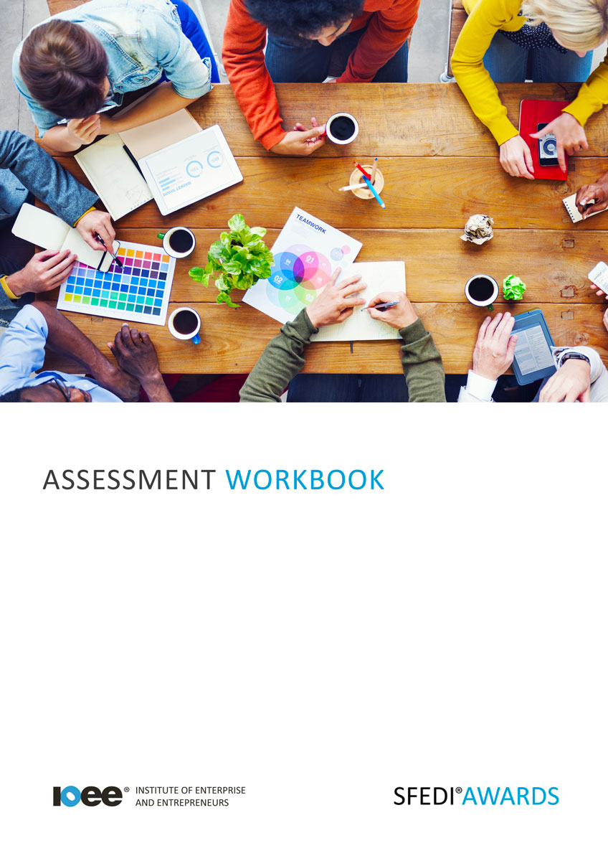

Understand the Importance of Business Planning
R/505/2154

Copyright © 2020 SFEDI Enterprises Ltd

All rights reserved. This book or any portion thereof may not be reproduced or used in any manner whatsoever without the express written permission of the publisher (address below).

Approved SFEDI Awards centres and learners undertaking a SFEDI Awards qualification may photocopy this document free of charge and/or include a PDF version on its intranet where it is only done so for the purposes of the approved delivery of this qualification.

SFEDI Enterprises Ltd t/a SFEDI Awards
19 Victoria Road
Darlington
DL1 5SF
www.sfedigroup.com

Every effort has been made to ensure that the information contained in this publication is true and accurate at the time of publication. However, SFEDI Enterprises t/a SFEDI Awards strives to continually develop and improve our qualifications and, as such, there may be occasions where changes are required. SFEDI Enterprises t/a SFEDI Awards does not accept liability for any loss or damage arising from the use of the information contained within this publication.

Introduction

This workbook has been developed so that you are able to collect and present evidence that demonstrates your knowledge and skills in relation to the importance of business planning.

There are different sections that make up this workbook in order to make sure you are able to complete all of the tasks necessary but you will be provided with support as you move along by your Assessor.

Further learning materials and support is available through your studying membership of the Institute of Enterprise and Entrepreneurs. If you haven’t yet received your login please speak to your Assessor who will be happy to sort this out for you.
This unit contains three learning outcomes and will support you to be able to:
- Understand the importance of business planning
- Understand the components of a business plan
- Understand the legislation that can affect the development of plans for a business
The evidence within this workbook will be assessed by,

Assessor Name:

and will be quality assured by,

Internal Quality Assurer Name:

Your Assessor will support you to plan how best to demonstrate your knowledge and skills which may be through the completion of the activities within this workbook or may include additional tasks best suited to you.

If any additional tasks are to be completed these will be listed in the table below with target dates for which you should try your best to complete each task listed.

Task | Target Date | Re-planned Target Date
Completion of the activities included within this workbook

By signing below you agree to completing the work as detailed above and working with your Assessor to achieve this by the deadlines indicated.

Learner Name: | Signature: | Date:
Assessor Name: | Signature: | Date:

Activities

Activity 1

Using the box below, explain a minimum of two ways in which a business plan can be used to benefit
the starting and running of a business

A business plan can be used for…

Activity 2

Using the table below, identify the different sections that would make up a standard business plan
and provide a short explanation of what should be included in that section

Section | Description of information to include
eg. executive summary | A short overview of the aims and objectives of the business including a description of the product or service, an idea of the size and type of  market, how the business is viable and growth potential for the business. It should be short and to the point and is usually the last thing written in the business plan

7

Activity 3

Using the table below, identify a minimum of two goals that a business could work towards and explain how working towards a business plan can help a business to achieve them

Business goal | Benefit of a business plan to achieving the goal
eg. achieve 12-month sales  figures | The business plan helps to plan the resources needed to set up the business ready for trading and to make sure that enough products are available to meet planned demand. It also helps by setting out how the product will be marketed to customers to make sure they know where to buy from and how the business will deliver it to them

8

Activity 4

Using the table below, identify a minimum of two laws that can affect the starting and running of a business. Think of where you could find further information about the law and what impact it would have on a business. Try and think of laws that are most relevant to the type of business you are most interested in

Type of law | Where can I find out more informa- tion? | Impact on business
eg. copyright law for music | Further information could be found on the gov.uk or PRS websites | Businesses with customers, including staff members, who want to play music so that people can hear it need a licence otherwise they may be breaking copyright law and so could be fined

Activity Mapping

Now you have completed the activities to demonstrate your knowledge and skills it is time for your Assessor to map your work against the standards listed below.
By doing this they will be making sure that the work you have provided by completing the activities
meets the requirements for you to gain your certificate.

Your Assessor will provide you with feedback on how you have done and whether any more work may be required.

Assessment Criterion - The learner can: | Activity Number or Reference Number of Additional Activities: | Assessor Signed  Off (✓/✗):
Explain the different uses of a business plan | 1
Explain how working to a business plan can help achieve business goals | 3
Provide two examples of goals that a business could set itself within the business plan | 3
Identify the different sections that make up a  business plan | 2
Identify the different types of legislation that can affect a business | 4
Explain how to access information about the  legislation identified | 4
Explain how the legislation identified can impact on  the business | 4

Assessor Feedback

Authenticity Declarations

Learner Declaration

By signing this declaration you agree that the evidence provided within this workbook has been produced by you and meets the requirements of being authentic, sufficient, valid and current to the standards required.

Learner Signature: Date:

Assessor Declaration

By signing this declaration you agree that you have assessed all of the evidence produced within this workbook and have ensured that the work is that of the learner. You are also declaring that during the learning process you have ensured that the evidence is authentic, sufficient, valid and current to the standards required.

Assessor Signature: Date:

IQA Signature (if applicable): Date:

Additional Evidence Forms

Use these additional forms in order to record additional evidence for the activities within this workbook where additional space is required.

Ensure that each piece of evidence entered on these forms is clearly labelled with the corresponding activity number.

SFEDI Awards
19 Victoria Road
Darlington
DL1 5SF

customerservices@sfediawards.com 0845 224 5928
@sfediawards

