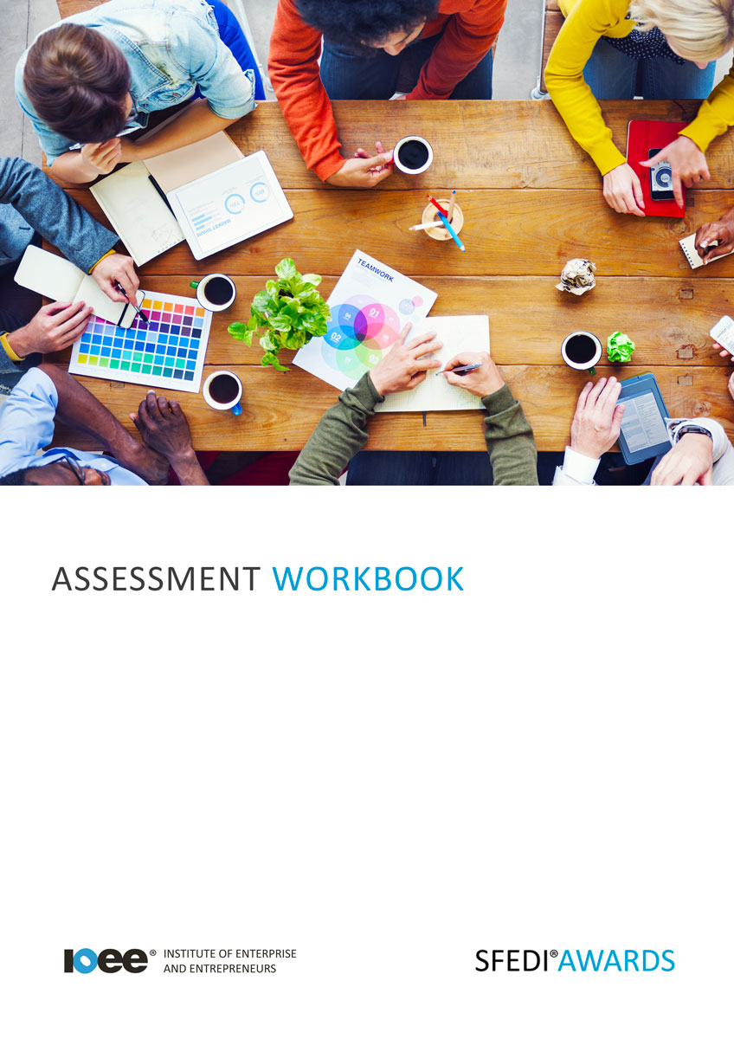

Understanding Business Relationships in a New Business
M/503/2963

Copyright © 2020 SFEDI Enterprises Ltd

All rights reserved. This book or any portion thereof may not be reproduced or used in any manner whatsoever without the express written permission of the publisher (address below).

Approved SFEDI Awards centres and learners undertaking a SFEDI Awards qualification may photocopy this document free of charge and/or include a PDF version on its intranet where it is only done so for the purposes of the approved delivery of this qualification.

SFEDI Enterprises Ltd t/a SFEDI Awards
19 Victoria Road
Darlington
DL1 5SF
www.sfedigroup.com

Every effort has been made to ensure that the information contained in this publication is true and accurate at the time of publication. However, SFEDI Enterprises t/a SFEDI Awards strives to continually develop and improve our qualifications and, as such, there may be occasions where changes are required. SFEDI Enterprises t/a SFEDI Awards does not accept liability for any loss or damage arising from the use of the information contained within this publication.

Introduction

This workbook has been developed so that you are able to collect and present evidence that demonstrates your knowledge and skills in relation to business relationships in a new business.

There are different sections that make up this workbook in order to make sure you are able to complete all of the tasks necessary but you will be provided with support as you move along by your Assessor.

Further learning materials and support is available through your studying membership of the Institute of Enterprise and Entrepreneurs. If you haven’t yet received your login please speak to your Assessor who will be happy to sort this out for you.
This unit contains two learning outcomes and will support you to be able to:
- Understand the importance of business contacts
- Understand how to build positive relationships
The evidence within this workbook will be assessed by,

Assessor Name:

and will be quality assured by,

Internal Quality Assurer Name:

Your Assessor will support you to plan how best to demonstrate your knowledge and skills which may be through the completion of the activities within this workbook or may include additional tasks best suited to you.

If any additional tasks are to be completed these will be listed in the table below with target dates for which you should try your best to complete each task listed.

Task | Target Date | Re-planned Target Date
Completion of the activities included within this workbook

By signing below you agree to completing the work as detailed above and working with your Assessor to achieve this by the deadlines indicated.

Learner Name: | Signature: | Date:
Assessor Name: | Signature: | Date:

Activities

Activity 1

No one is an island and interaction with others is key to starting and running a business whether that be suppliers, customers, support professionals, whoever you may come into contact with they all have their part to play in your success. But why is it important? What part do they play? How do they help you?

Using the box below, describe why it is important for a new business to establish these important business contacts

Activity 2

So it’s important to have the contacts but where are you supposed to find them? They aren’t just sitting there hoping you will give them a call, you need to make sure you find the right people that can best support you and that takes time and effort.
Using the box below, describe the different methods you can use to identify appropriate business
contacts that can support a new business to start and grow

7

Activity 3

Now think of your own business idea, what contacts do you think would best support you? Using the table below, list out the different contacts
you could engage with to get support and explain why they are useful

Business contact | Benefit the contact brings to the business | Method of keeping in regular touch with the contact

People buy from people and people deal with people so it’s important that, if you want the best possible relationship with your business contacts, you build a rapport. But what does that mean?
Using the box below, provide a definition for the term ‘rapport’ that would help another person to
understand what it means

Rapport means…

Thinking back to the contacts you listed earlier in activity 3, use the box below to provide examples of how you think you could build a rapport with the contacts to encourage them to want to deal with you

One important way of developing a relationship with business contacts is by keeping your commitments and acting in an open and honest way with them. Use the box below to explain why this is important and how it can help to develop that all important business relationship

In an increasingly global economy and multi-cultural society businesses have never before engaged with people from so many different cultures and backgrounds and it’s important when building the relationship to understand how to engage professionally.

Using the box below, identify ways in which differences between people from various cultures or backgrounds can affect business relationships and the way in which they are formed

Activity Mapping

Now you have completed the activities to demonstrate your knowledge and skills it is time for your Assessor to map your work against the standards listed below.
By doing this they will be making sure that the work you have provided by completing the activities
meets the requirements for you to gain your certificate.

Your Assessor will provide you with feedback on how you have done and whether any more work may be required.

Assessment Criterion - The learner can: | Activity Number or Reference Number of Additional Activities: | Assessor Signed  Off (✓/✗):
Describe why it is important for a new business to establish business contacts | 1
Describe how business contacts may be identified for  a new business | 2
Identify which business contacts are most likely to be of help to a new business | 3
Identify ways to keep in touch regularly with potential business contacts | 3
Identify ways of creating positive impressions and building rapport when meeting business contacts | 4
Explain why it is important to keep commitments and act honestly in business relationships | 5
Identify ways in which differences between people from various cultures or backgrounds can affect business relationships | 6

Assessor Feedback

Authenticity Declarations

Learner Declaration

By signing this declaration you agree that the evidence provided within this workbook has been produced by you and meets the requirements of being authentic, sufficient, valid and current to the standards required.

Learner Signature: Date:

Assessor Declaration

By signing this declaration you agree that you have assessed all of the evidence produced within this workbook and have ensured that the work is that of the learner. You are also declaring that during the learning process you have ensured that the evidence is authentic, sufficient, valid and current to the standards required.

Assessor Signature: Date:

IQA Signature (if applicable): Date:

Additional Evidence Forms

Use these additional forms in order to record additional evidence for the activities within this workbook where additional space is required.

Ensure that each piece of evidence entered on these forms is clearly labelled with the corresponding activity number.

SFEDI Awards
19 Victoria Road
Darlington
DL1 5SF

customerservices@sfediawards.com 0845 224 5928
@sfediawards

