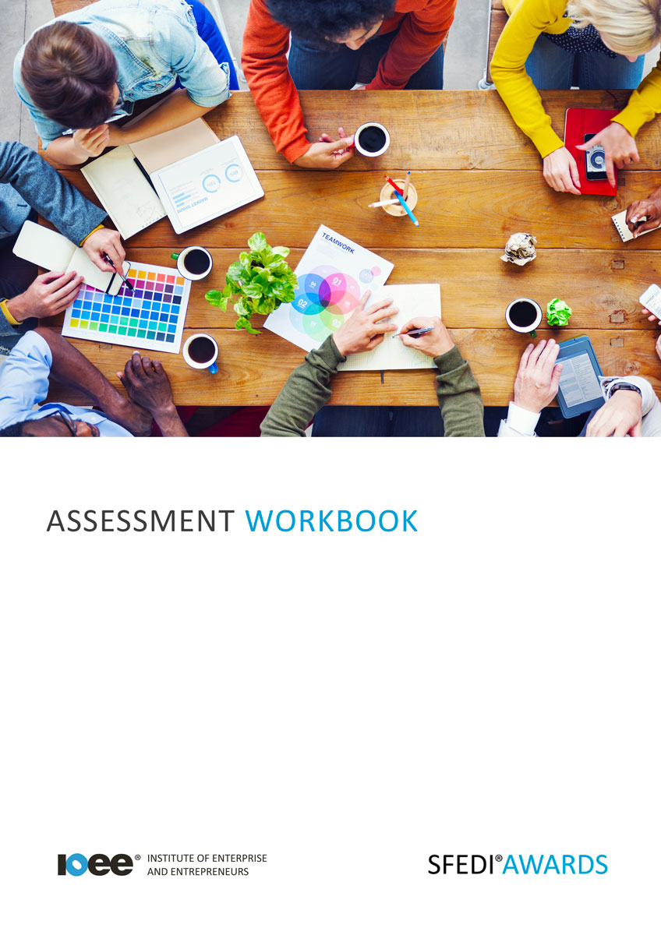

Understanding Finance in a Business Context
T/503/2964

Copyright © 2020 SFEDI Enterprises Ltd

All rights reserved. This book or any portion thereof may not be reproduced or used in any manner whatsoever without the express written permission of the publisher (address below).

Approved SFEDI Awards centres and learners undertaking a SFEDI Awards qualification may photocopy this document free of charge and/or include a PDF version on its intranet where it is only done so for the purposes of the approved delivery of this qualification.

SFEDI Enterprises Ltd t/a SFEDI Awards
19 Victoria Road
Darlington
DL1 5SF
www.sfedigroup.com

Every effort has been made to ensure that the information contained in this publication is true and accurate at the time of publication. However, SFEDI Enterprises t/a SFEDI Awards strives to continually develop and improve our qualifications and, as such, there may be occasions where changes are required. SFEDI Enterprises t/a SFEDI Awards does not accept liability for any loss or damage arising from the use of the information contained within this publication.

Introduction

This workbook has been developed so that you are able to collect and present evidence that
demonstrates your knowledge and skills in relation to finance within a business.

There are different sections that make up this workbook in order to make sure you are able to complete all of the tasks necessary but you will be provided with support as you move along by your Assessor.

Further learning materials and support is available through your studying membership of the Institute of Enterprise and Entrepreneurs. If you haven’t yet received your login please speak to your Assessor who will be happy to sort this out for you.
This unit contains three learning outcomes and will support you to be able to:
- Understand ways of financing a new business
- Understand how finance is managed in a business context
- Understand how cash flow is managed in a business
The evidence within this workbook will be assessed by,

Assessor Name:

and will be quality assured by,

Internal Quality Assurer Name:

Your Assessor will support you to plan how best to demonstrate your knowledge and skills which may be through the completion of the activities within this workbook or may include additional tasks best suited to you.
If any additional tasks are to be completed these will be listed in the table below with target dates for
which you should try your best to complete each task listed.

Task | Target Date | Re-planned Target Date
Completion of the activities included within this workbook

By signing below you agree to completing the work as detailed above and working with your Assessor
to achieve this by the deadlines indicated.

Learner Name: | Signature: | Date:
Assessor Name: | Signature: | Date:

Activities

Activity 1

Using the box below, identify the different types of costs associated with starting a business and indicate whether the cost is essential to starting a business or whether it could be delayed until the business has started in order to control the initial set up costs

Type of cost | Essential (E) or optional (O)

Now you know the types of costs that would be required to start a business, how could this be financed? Using the table below list the different ways of obtaining the money needed to start a business and the advantages and disadvantages of each

Finance option | Advantages | Disadvantages

Using the box below, provide a definition for the terms ‘income’, ‘expenditure’, ‘turnover’ and ‘cash flow’ that would help another person to understand what they mean

Income is…

Expenditure is…

Turnover is…

Cash flow is..

Using the box below, explain the difference between ‘gross’ and ‘net’ profit and the importance of
each to a business to assist in managing their finances correctly

Using the table below, identify the different financial records that are used by a business, provide a description of their main features and the importance of the document to the business in managing their finances appropriately

Financial record | Main features | Importance to the business

Using the box below, describe the factors that can or may affect cash flow within a business. Use examples of industries, eg. hairdressing or construction, to justify your reasons

Using the box below, describe the different ways a business can monitor its cash flow and how a cash flow forecast can help to guard against any of the fluctuations caused by the factors you have identified in activity 6

Cash flow can impact on a business from minor inconveniences through to ultimately causing it to close down and knowing how to manage cash shortfalls is important for all business owners.
Using the table below, identify the different ways a business could manage a cash shortfall and the
advantages and disadvantages of each

Shortfall management option | Advantages | Disadvantages

Now you have completed the activities to demonstrate your knowledge and skills it is time for your
Activity Mapping
Assessor to map your work against the standards listed below.
By doing this they will be making sure that the work you have provided by completing the activities
meets the requirements for you to gain your certificate.
Your Assessor will provide you with feedback on how you have done and whether any more work may
be required.

Assessment Criterion - The learner can: | Activity Number or Reference Number of Additional Activities: | Assessor Signed  Off (✓/✗):
Identify different types of costs associated with  starting a business | 1
Describe different ways of obtaining the money  needed to start a business | 2
Define income, expenditure, turnover and cash flow in a business context | 3
Explain the difference between ‘gross’ and ‘net’ profit | 4
Describe the financial records that should be kept by  a business | 5
Explain why it is important to keep financial records | 5
Describe the factors that affect cash flow in a  business | 6
Identify the features of a cash flow statement for a  business | 5/7
Explain how to manage temporary cash shortfalls to avoid longer term effects on a business | 8
Explain how business cash flow can be monitored | 7

Assessor Feedback

Authenticity Declarations

Learner Declaration

By signing this declaration you agree that the evidence provided within this workbook has been produced by you and meets the requirements of being authentic, sufficient, valid and current to the standards required.

Learner Signature: Date:

Assessor Declaration

By signing this declaration you agree that you have assessed all of the evidence produced within this workbook and have ensured that the work is that of the learner. You are also declaring that during the learning process you have ensured that the evidence is authentic, sufficient, valid and current to the standards required.

Assessor Signature: Date:

IQA Signature (if applicable): Date:

Additional Evidence Forms

Use these additional forms in order to record additional evidence for the activities within this
workbook where additional space is required.
Ensure that each piece of evidence entered on these forms is clearly labelled with the corresponding
activity number.

SFEDI Awards
19 Victoria Road
Darlington
DL1 5SF

customerservices@sfediawards.com 0845 224 5928
@sfediawards

