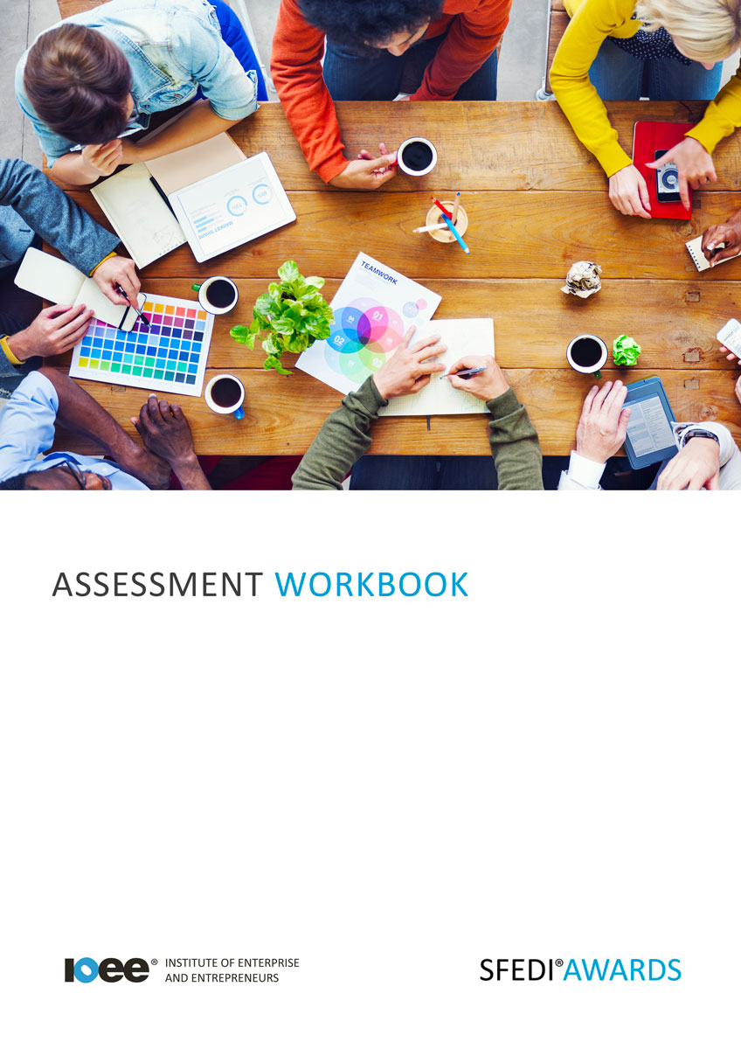

Understanding Negotiation of Deals in a New Business
A/503/2965

Copyright © 2020 SFEDI Enterprises Ltd

All rights reserved. This book or any portion thereof may not be reproduced or used in any manner whatsoever without the express written permission of the publisher (address below).

Approved SFEDI Awards centres and learners undertaking a SFEDI Awards qualification may photocopy this document free of charge and/or include a PDF version on its intranet where it is only done so for the purposes of the approved delivery of this qualification.

SFEDI Enterprises Ltd t/a SFEDI Awards
19 Victoria Road
Darlington
DL1 5SF
www.sfedigroup.com

Every effort has been made to ensure that the information contained in this publication is true and accurate at the time of publication. However, SFEDI Enterprises t/a SFEDI Awards strives to continually develop and improve our qualifications and, as such, there may be occasions where changes are required. SFEDI Enterprises t/a SFEDI Awards does not accept liability for any loss or damage arising from the use of the information contained within this publication.

Introduction

This workbook has been developed so that you are able to collect and present evidence that demonstrates your knowledge and skills in relation to the negotiation of deals within a business.

There are different sections that make up this workbook in order to make sure you are able to complete all of the tasks necessary but you will be provided with support as you move along by your Assessor.

Further learning materials and support is available through your studying membership of the Institute of Enterprise and Entrepreneurs. If you haven’t yet received your login please speak to your Assessor who will be happy to sort this out for you.
This unit contains two learning outcomes and will support you to be able to:
- Understand the importance of negotiation in a new business
- Understand how to negotiate deals for a business

The evidence within this workbook will be assessed by,

Assessor Name:

and will be quality assured by,

Internal Quality Assurer Name:

Your Assessor will support you to plan how best to demonstrate your knowledge and skills which may be through the completion of the activities within this workbook or may include additional tasks best suited to you.

If any additional tasks are to be completed these will be listed in the table below with target dates for which you should try your best to complete each task listed.

Task | Target Date | Re-planned Target Date
Completion of the activities included within this workbook

By signing below you agree to completing the work as detailed above and working with your Assessor to achieve this by the deadlines indicated.

Learner Name: | Signature: | Date:
Assessor Name: | Signature: | Date:

Activities

Activity 1
Using the box below, explain the importance of negotiation to the smooth running of a business. Think about negotiations with people and groups both internal and external to the business

Using the table below, identify those both within and outside of a business that might be involved in different types of negotiations, eg. suppliers and departments, and what types of negotiations they might be involved with

Person or group involved | Internal (I) or External  (E) to the business | Type of negotiation

Negotiating deals can be a positive experience but there are also risks involved in both completing a negotiation and the effect that negotiation could have on the business. Using the table below, identify the potential risks that can be involved in negotiation and the methods of minimising the negative effects they can have on a business

Type of risk | Method of minimising the impact on the business

So negotiation is important but so is negotiating effectively to make sure that you understand and
achieve the intended outcome of the negotiation. But what do you need to be a successful negotiator?

Using the table below, identify the techniques and skills required to be a successful negotiator and why it is important in the negotiation process

Technique or skill | Is it a technique (T) or a skill (S)? | How does it support the negotiation process?

Using the box below, explain the different stages in the process of negotiation that a business would follow to reach a mutually beneficial outcome for all of the parties involved

For a business of your choice, select an example of a negotiated deal and explain how the stages of the negotiation process you outlined in activity 5 were followed in order to meet the intended outcomes and what consequences reaching the deal had on the business

Now you have completed the activities to demonstrate your knowledge and skills it is time for your Assessor to map your work against the standards listed below.
Activity Mapping
By doing this they will be making sure that the work you have provided by completing the activities
meets the requirements for you to gain your certificate.

Your Assessor will provide you with feedback on how you have done and whether any more work may be required.

Assessment Criterion - The learner can: | Activity Number or Reference Number of Additional Activities: | Assessor Signed  Off (✓/✗):
Explain the role of negotiation in a business context | 1
Describe who might be involved in negotiations, for example suppliers | 2
Identify potential risks involved in negotiating deals | 3
Identify techniques which might be used to negotiate a deal for a business | 4
Describe the skills needed for successful negotiation | 4
Describe the stages in the process of negotiation for  a mutually beneficial outcome | 5
Describe the potential outcomes and consequences of negotiations for a business | 6

Assessor Feedback

Authenticity Declarations

Learner Declaration

By signing this declaration you agree that the evidence provided within this workbook has been produced by you and meets the requirements of being authentic, sufficient, valid and current to the standards required.

Learner Signature: Date:

Assessor Declaration

By signing this declaration you agree that you have assessed all of the evidence produced within this workbook and have ensured that the work is that of the learner. You are also declaring that during the learning process you have ensured that the evidence is authentic, sufficient, valid and current to the standards required.

Assessor Signature: Date:

IQA Signature (if applicable): Date:

Additional Evidence Forms

Use these additional forms in order to record additional evidence for the activities within this workbook where additional space is required.

Ensure that each piece of evidence entered on these forms is clearly labelled with the corresponding activity number.

SFEDI Awards
19 Victoria Road
Darlington
DL1 5SF

customerservices@sfediawards.com 0845 224 5928
@sfediawards

