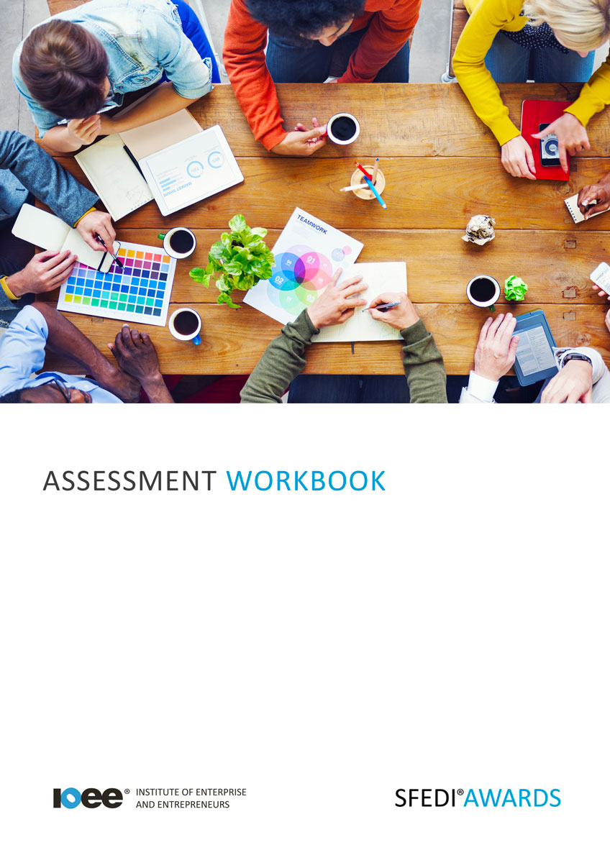

Universal Credit Y/617/1513

Copyright © 2020 SFEDI Enterprises Ltd

All rights reserved. This book or any portion thereof may not be reproduced or used in any manner whatsoever without the express written permission of the publisher (address below).

Approved SFEDI Awards centres and learners undertaking a SFEDI Awards qualification may photocopy this document free of charge and/or include a PDF version on its intranet where it is only done so for the purposes of the approved delivery of this qualification.

SFEDI Enterprises Ltd t/a SFEDI Awards
19 Victoria Road
Darlington
DL1 5SF
www.sfedigroup.com

Every effort has been made to ensure that the information contained in this publication is true and accurate at the time of publication. However, SFEDI Enterprises t/a SFEDI Awards strives to continually develop and improve our qualifications and, as such, there may be occasions where changes are required. SFEDI Enterprises t/a SFEDI Awards does not accept liability for any loss or damage arising from the use of the information contained within this publication.

Introduction

This workbook has been developed so that you are able to prepare yourself to apply for an online account required to administer your Universal Credit claims.

There are different sections that make up this workbook in order to make sure you are able to complete all of the tasks necessary but you will be provided with support as you move along by your Assessor.

Further learning materials and support is available through your studying membership of the Institute of Enterprise and Entrepreneurs. If you haven’t yet received your login please speak to your Assessor who will be happy to sort this out for you.
This unit contains three learning outcomes and will support you to be able to:
- Understand what is meant by Universal Credit
- Understand the structure of Universal Credit
- Understand how to make an application for Universal Credit

The evidence within this workbook will be assessed by,

Assessor Name:

and will be quality assured by,

Internal Quality Assurer Name:

Your Assessor will support you to plan how best to demonstrate your knowledge and skills which may be through the completion of the activities within this workbook or may include additional tasks best suited to you.

If any additional tasks are to be completed these will be listed in the table below with target dates for which you should try your best to complete each task listed.

Task | Target Date | Re-planned Target Date
Completion of the activities included within this workbook

By signing below you agree to completing the work as detailed above and working with your Assessor to achieve this by the deadlines indicated.

Learner Name: | Signature: | Date:
Assessor Name: | Signature: | Date:

Activities

Activity 1

The introduction of Universal Credit aims to simply the welfare system by combining benefits into one but which are they?
Use the box below to identify which benefits Universal Credit is replacing

Not everyone is eligible for Universal Credit and it’s important to understand who is and who isn’t. Use the table below to identify the eligibility requirements for Universal Credit and whether you think you meet them.

Eligibility Criteria | Do you meet this now? (Y/N)

Based on the information above do you think you would be eligible?

A big part of budgeting is understanding the amount of money coming into the household and to do this you need to understand the amounts that are available through Universal Credit.

Using the table below identify the standard amounts that are payable under Universal Credit and also the circumstances where additional amounts could be available.

Type of Payment | Amount Available (£)
Standard amount payable (single under 25)
Standard amount payable (single 25 and over)
Standard amount payable (couple both under 25)
Standard amount payable (couple either person 25 or over)
Additional payment type:
Additional payment type:
Additional payment type:
Additional payment type:
Additional payment type:
Additional payment type:
Additional payment type:
Additional payment type:

Using the box below explain the frequency and methods of payment used for Universal Credit, don’t forget to think about the different situations that can impact on how this is done, eg. country of residence, single/couple, employment.

Now think of your circumstances, how often would you be paid?

Country of residence

How often would you be paid?

Using the table below identify where you can find out more about Universal Credit including from central government and other support agencies

Source of Support | How can I access it?

Using the table below identify the information you will need to make a claim for Universal Credit and also the forms of ID that are acceptable

Information Type | Do you have it ready? (Y/N)
Information type:
Information type:
Information type:
Information type:
Information type:
Information type:
Information type:
ID type:
ID type:
ID type:

Using the box below, identify the steps that you need to take to complete your application for Universal Credit

And if you didn’t agree with the decision reached about your application, what steps could you take to challenge it?

Just making a claim for Universal Credit isn’t the end of what you need to do, there are different responsibilities you have to make sure you remain eligible to continue to receive it in the future.

Using the table below identify the responsibilities you have under the Claimant Commitment and how you intend to meet these

Commitment Type | How will you meet it?

Your eligibility for Universal Credit and the amounts you are eligible to receive can change over time and it’s important that you update your details when they do.

Using the box below describe the steps you would need to take to report a change in your circumstances

And what about if you are still struggling with money? There are other sources of information and support that you can access to help you out.

Use the table below to identify other sources of financial information and support that are available to you and how you could access them.

Source of information or support | How can you access them?

Activity Mapping

Now you have completed the activities to demonstrate your knowledge and skills it is time for your Assessor to map your work against the standards listed below.

By doing this they will be making sure that the work you have provided by completing the activities meets the requirements for you to gain your certificate.

Your Assessor will provide you with feedback on how you have done and whether any more work may be required.

Assessment Criterion - The learner can: | Activity Number or Reference Number of Additional Activities: | Assessor Signed Off (✓/✗):
Identify which benefits Universal Credit is replacing | 1
Identify the eligibility requirements for Universal Credit | 2
Identify standard payment amounts for Universal Credit and the circumstances that additional amounts may be available | 3
Assess own chances for eligibility of Universal Credit | 2
Identify how often and the methods used to make payments for Universal Credit for own geographical location | 4
Identify sources of additional information regarding Universal Credit | 5
Identify the information required to make a claim for Universal Credit | 6
Identify ID types that can be used to verify own identity | 6
Describe the steps within the application process for Universal Credit | 7
Identify what steps can be taken to challenge a decision regarding a Universal Credit application | 7
Identify own responsibilities moving forward from the time of the claim to ensure compliance with the requirements under the ‘Claimant Commitment’ | 8

Assessment Criterion - The learner can: | Activity Number or Reference Number of Additional Activities: | Assessor Signed Off (✓/✗):
Describe the steps to be taken to report a change in circumstances | 9
Identify additional finance support available if in financial difficulties | 10

Assessor Feedback

Authenticity Declarations

Learner Declaration

By signing this declaration you agree that the evidence provided within this workbook has been produced by you and meets the requirements of being authentic, sufficient, valid and current to the standards required.

Learner Signature: Date:

Assessor Declaration

By signing this declaration you agree that you have assessed all of the evidence produced within this workbook and have ensured that the work is that of the learner. You are also declaring that during the learning process you have ensured that the evidence is authentic, sufficient, valid and current to the standards required.

Assessor Signature: Date:

IQA Signature (if applicable): Date:

Additional Evidence Forms

Use these additional forms in order to record additional evidence for the activities within this workbook where additional space is required.

Ensure that each piece of evidence entered on these forms is clearly labelled with the corresponding activity number.

SFEDI Awards
19 Victoria Road
Darlington
DL1 5SF

customerservices@sfediawards.com 0845 224 5928
@sfediawards

