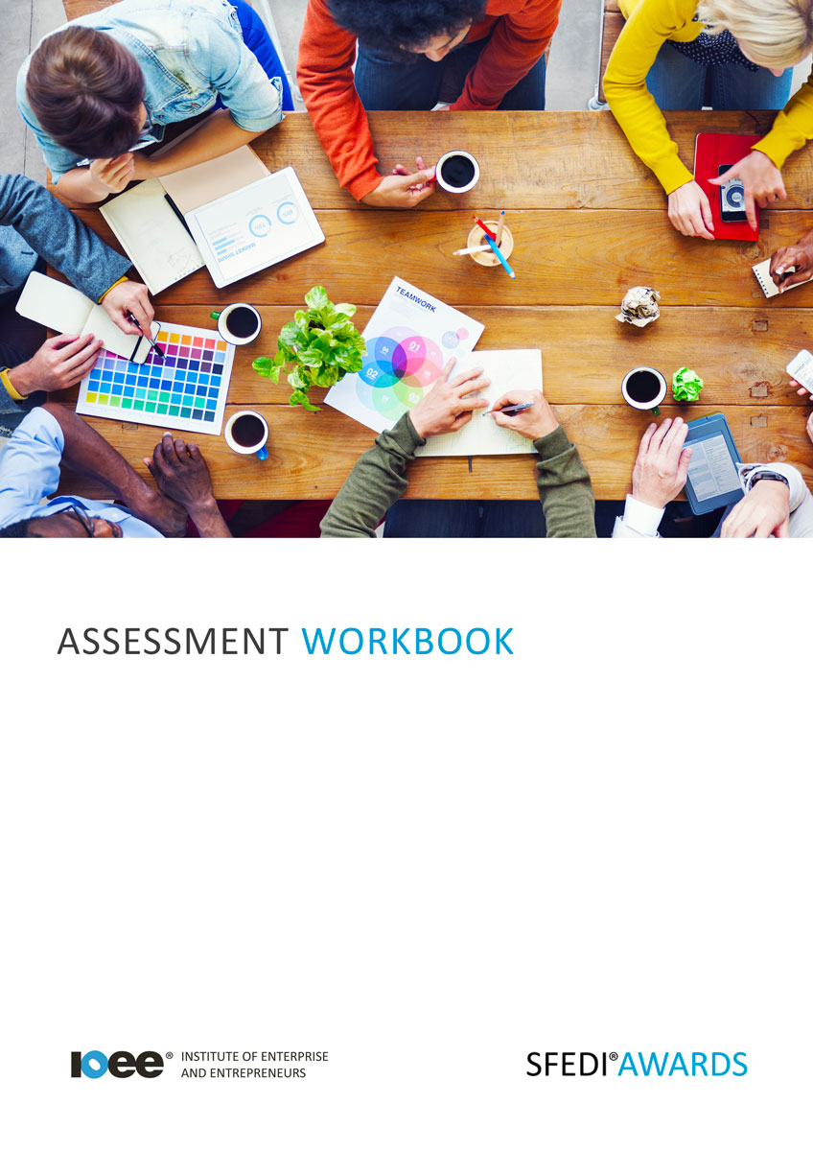

Working as Part of a Group T/615/2287

Copyright © 2020 SFEDI Enterprises Ltd

All rights reserved. This book or any portion thereof may not be reproduced or used in any manner whatsoever without the express written permission of the publisher (address below).

Approved SFEDI Awards centres and learners undertaking a SFEDI Awards qualification may photocopy this document free of charge and/or include a PDF version on its intranet where it is only done so for the purposes of the approved delivery of this qualification.

SFEDI Enterprises Ltd t/a SFEDI Awards
19 Victoria Road
Darlington
DL1 5SF
www.sfedigroup.com

Every effort has been made to ensure that the information contained in this publication is true and accurate at the time of publication. However, SFEDI Enterprises t/a SFEDI Awards strives to continually develop and improve our qualifications and, as such, there may be occasions where changes are required. SFEDI Enterprises t/a SFEDI Awards does not accept liability for any loss or damage arising from the use of the information contained within this publication.

Introduction

This workbook has been developed so that you are able to collect and present evidence that demonstrates your knowledge and skills in relation to working as part of a group.

There are different sections that make up this workbook in order to make sure you are able to complete all of the tasks necessary but you will be provided with support as you move along by your Assessor.

Further learning materials and support is available through your studying membership of the Institute of Enterprise and Entrepreneurs. If you haven’t yet received your login please speak to your Assessor who will be happy to sort this out for you.
This unit contains three learning outcomes and will support you to be able to:
- Understand how to contribute to working as part of a group in appropriate ways
- Demonstrate how to work as an effective group member
- Be able to review the group’s progress and own contribution to it
The evidence within this workbook will be assessed by,

Assessor Name:

and will be quality assured by,

Internal Quality Assurer Name:

Your Assessor will support you to plan how best to demonstrate your knowledge and skills which may be through the completion of the activities within this workbook or may include additional tasks best suited to you.

If any additional tasks are to be completed these will be listed in the table below with target dates for which you should try your best to complete each task listed.

Task | Target Date | Re-planned Target Date
Completion of the activities included within this workbook

By signing below you agree to completing the work as detailed above and working with your Assessor to achieve this by the deadlines indicated.

Learner Name: | Signature: | Date:
Assessor Name: | Signature: | Date:

Activities

Activity 1

The boxes within this workbook provide you with space to record how you have gotten on when working as part of a group.

You should use the boxes to record your actions and your thoughts as you progress through your group activity and, at the end, your Assessor will also sign to say they have witnessed you working effectively with others.

You will need to work with at least one other person towards completing one task, project or solving a problem.

You may not reach the end of the task, project or solving the problem but don’t worry, this is all about how you work with other people and what you can learn for future group working activities.

In the box below provide a description of the task, project of problem you are trying to solve

(What is the task, project or problem you are trying to solve? What is the intended outcome? Why is it important to you? How many people are you working with?)

Activity 1

It’s important to know how you are going to work together, what happens if you don’t agree? How do you make sure you can work effectively? How can you make sure you continue to be respectful to each other?

Setting ground rules can help to make sure that you stay on track and work well together but how can you work them out? Use the box below to explain the process you could follow to agree ground rules within your group

Now put this process into practice. Work with the members of your group to agree the ground rules for working together. List the rules you agree in the box below

Now you’ve got your group ready to work together and you know the task, project or problem you are trying to solve but what activities do you need to complete? Use the table below to record the activities agreed within the group that need to be completed, by when and by whom

Task to be completed | Target date | By whom
Using the box below describe how you decided on the tasks above, how did you reach the decisions as a group and how did you deal with any disagreements?

Now it’s time to work on your agreed tasks as a group. Make sure you keep in mind the ground rules you agreed and the tasks that were set but most of all that by working together rather than against each other you have more chance of completing your goals.

The following pages provide you with a diary to record what you have done during the different occasions that your group works together. You should record what you did, how you did it, what you learnt and how you worked with the other people in your group.

We have provided enough space to record five different occasions but use as many as you need dependent on how many times you work together as a group. Don’t forget you can add additional pages using the space at the back of the workbook if required.
Include as much detail as you can as it will be important later when you come to reflect on how well
you worked as a group.

Occasion 1
Description of the activities you completed during this session

Did the activities you completed help the group work towards the achievement of the task or project
or solving the problem you identified? (tick as appropriate)

Yes No

No

How well did the group work together during the completion of the activities? Did you have to overcome any challenges and if so, how? Did you follow the ground rules?

Did you ask for support from members of the group or others outside of the group to help you complete your tasks? If so, how did you do this and how did you follow their advice?

Did you support others in completing their tasks? If so, how did you do this and how did you make
sure the help you provided was effective?

Did you receive feedback on the work you completed during your activities? If so, how have you dealt with the feedback? Were there any improvements you made to your work as a result?

Occasion 2
Description of the activities you completed during this session

Did the activities you completed help the group work towards the achievement of the task or project
or solving the problem you identified? (tick as appropriate)

Yes No

How well did the group work together during the completion of the activities? Did you have to overcome any challenges and if so, how? Did you follow the ground rules?

Did you ask for support from members of the group or others outside of the group to help you complete your tasks? If so, how did you do this and how did you follow their advice?

Did you support others in completing their tasks? If so, how did you do this and how did you make
sure the help you provided was effective?

Did you receive feedback on the work you completed during your activities? If so, how have you dealt with the feedback? Were there any improvements you made to your work as a result?

Occasion 3
Description of the activities you completed during this session

Did the activities you completed help the group work towards the achievement of the task or project
or solving the problem you identified? (tick as appropriate)

Yes No

How well did the group work together during the completion of the activities? Did you have to overcome any challenges and if so, how? Did you follow the ground rules?

Did you ask for support from members of the group or others outside of the group to help you complete your tasks? If so, how did you do this and how did you follow their advice?

Did you support others in completing their tasks? If so, how did you do this and how did you make
sure the help you provided was effective?

Did you receive feedback on the work you completed during your activities? If so, how have you dealt with the feedback? Were there any improvements you made to your work as a result?

Occasion 4
Description of the activities you completed during this session

Did the activities you completed help the group work towards the achievement of the task or project
or solving the problem you identified? (tick as appropriate)

Yes No

How well did the group work together during the completion of the activities? Did you have to overcome any challenges and if so, how? Did you follow the ground rules?

Did you ask for support from members of the group or others outside of the group to help you complete your tasks? If so, how did you do this and how did you follow their advice?

Did you support others in completing their tasks? If so, how did you do this and how did you make
sure the help you provided was effective?

Did you receive feedback on the work you completed during your activities? If so, how have you dealt with the feedback? Were there any improvements you made to your work as a result?

Occasion 5
Description of the activities you completed during this session

Did the activities you completed help the group work towards the achievement of the task or project
or solving the problem you identified? (tick as appropriate)

Yes No

How well did the group work together during the completion of the activities? Did you have to overcome any challenges and if so, how? Did you follow the ground rules?

Did you ask for support from members of the group or others outside of the group to help you complete your tasks? If so, how did you do this and how did you follow their advice?

Did you support others in completing their tasks? If so, how did you do this and how did you make
sure the help you provided was effective?

Did you receive feedback on the work you completed during your activities? If so, how have you dealt with the feedback? Were there any improvements you made to your work as a result?

It’s now time for your Assessor to confirm the work you have been completing in your group to achieve the task, project or solve the problem you identified.
As the Assessor for I confirm that I have witnessed them work within a
group of at least two people including themselves demonstrating the following traits (delete if it was not witnessed):
- suggesting appropriate ground rules within their group
- contributing to the planning of the group and individual activities
- working with others in a positive way to carry out the individual and group tasks
- making suggestions appropriately
- dealing with instructions appropriately
- dealing with feedback appropriately
- supporting others to complete tasks
- asking for support when required
I also confirm that the records produced by are accurate and a true
reflection of their involvement with the group work.

Assessor Name: Signature: Date:

Activity 5

Now that you have completed your group work, how did you get on?

Using the box below and your earlier notes, describe how well the group worked together? Did you manage to complete the task, project or solve the problem you identified? Did you manage to stick to the ground rules you set? Did you have to overcome any challenges? Is there anything you would have done differently next time to make sure you worked better together?

20

Activity 6

Now think about your own abilities, behaviours, knowledge and skills and any gaps you may currently have that, once developed, would support you further in working better in a group setting.
Use the table below to identify the areas you could develop and the methods you could use to do so

Ability, behaviour, knowledge or skill to be developed | Method of development | Target date | Review method

Activity Mapping

Now you have completed the activities to demonstrate your knowledge and skills it is time for your Assessor to map your work against the standards listed below.
By doing this they will be making sure that the work you have provided by completing the activities
meets the requirements for you to gain your certificate.

Your Assessor will provide you with feedback on how you have done and whether any more work may be required.

Assessment Criterion - The learner can: | Activity Number or Reference Number of Additional Activities: | Assessor Signed  Off (✓/✗):
Suggest appropriate ground rules for working with others | 2/4
Contribute to the planning of group and individual activities | 3/4
Work with others in a positive way to carry out individual and group activities | 4
Make suggestions appropriately | 4
Deal with instructions appropriately | 4
Deal with feedback appropriately | 4
Support others and ask for support when required | 4
Review the progress the group has made in working together and own contribution to the progress | 4
Describe what went well and what went less well | 5
Suggest how to improve own skills in working with others | 6

Assessor Feedback

Authenticity Declarations

Learner Declaration

By signing this declaration you agree that the evidence provided within this workbook has been produced by you and meets the requirements of being authentic, sufficient, valid and current to the standards required.

Learner Signature: Date:

Assessor Declaration

By signing this declaration you agree that you have assessed all of the evidence produced within this workbook and have ensured that the work is that of the learner. You are also declaring that during the learning process you have ensured that the evidence is authentic, sufficient, valid and current to the standards required.

Assessor Signature: Date:

IQA Signature (if applicable): Date:

Additional Evidence Forms

Use these additional forms in order to record additional evidence for the activities within this workbook where additional space is required.

Ensure that each piece of evidence entered on these forms is clearly labelled with the corresponding activity number.

SFEDI Awards
19 Victoria Road
Darlington
DL1 5SF

customerservices@sfediawards.com 0845 224 5928
@sfediawards

