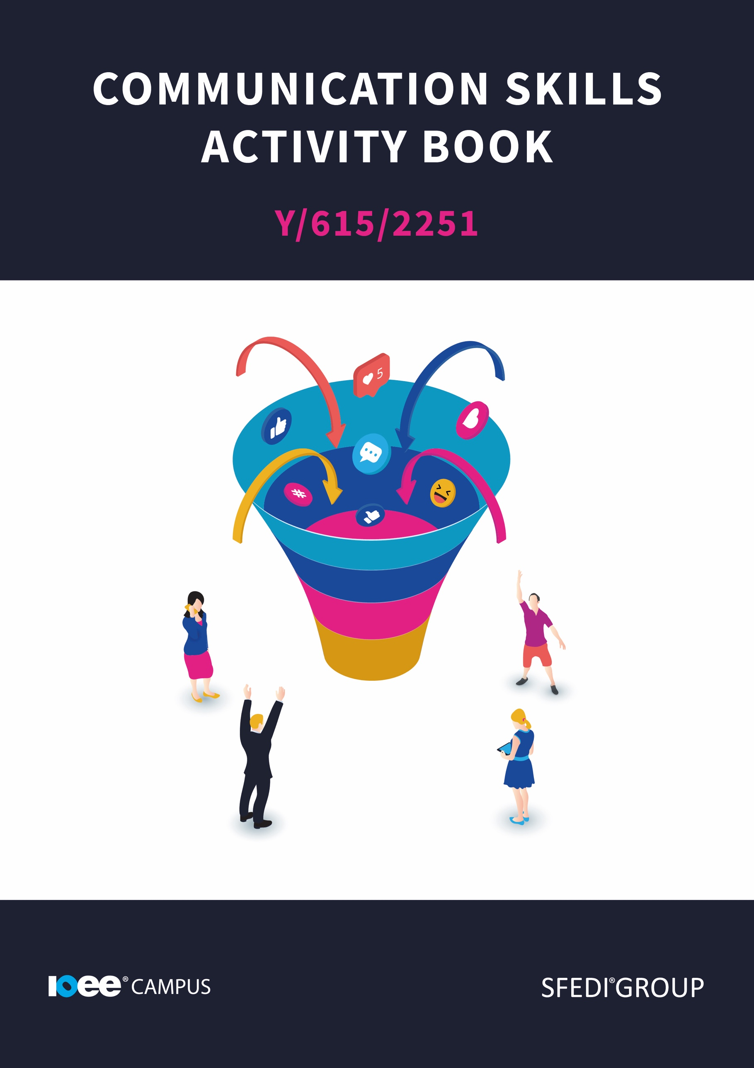

**Introduction**

This workbook has been developed so that you are able to collect and present evidence that demonstrates your knowledge and skills in relation to communication skills.

There are different sections that make up this workbook in order to make sure you are able to complete all of the tasks necessary, but you will be provided with support as you move along by your Assessor.

Further learning materials and support is available through your studying membership of the Institute of Enterprise and Entrepreneurs. If you haven’t yet received your login, please speak to your Assessor who will be happy to sort this out for you.

This unit contains three learning outcomes and will support you to be able to:

* Understand what is meant by effective communication
* Understand the impact of effective communication
* Understand how to develop own communication skills

The evidence within this workbook will be assessed by,

**Assessor Name:**

and will be quality assured by,

**Internal Quality Assurer Name:**

Copyright © 2020 SFEDI Enterprises Ltd

All rights reserved. This book or any portion thereof may not be reproduced or used in any manner whatsoever without the express written permission of the publisher (address below).

Approved SFEDI Awards centres and learners undertaking a SFEDI Awards qualification may photocopy this document free of charge and/or include a PDF version on its intranet where it is only done so for the purposes of the approved delivery of this qualification.

SFEDI Enterprises Ltd t/a SFEDI Awards

19 Victoria Rd

Darlington

DL1 5SF

www.sfedigroup.com

Every effort has been made to ensure that the information contained in this publication is true and accurate at the time of publication. However, SFEDI Enterprises t/a SFEDI Awards strives to continually develop and improve our qualifications and, as such, there may be occasions where changes are required. SFEDI Enterprises t/a SFEDI Awards does not accept liability for any loss or damage arising from the use of the information contained within this publication.



Your Assessor will support you to plan how best to demonstrate your knowledge and skills which may be through the completion of the activities within this workbook or may include additional tasks best suited to you.

If any additional tasks are to be completed these will be listed in the table below with target dates for which you should try your best to complete each task listed.

|  |  |  |
| --- | --- | --- |
| **Task** | **Target Date** | **Re-planned Target Date** |
| Completion of the activities included within this workbook |  |  |
|  |  |  |
|  |  |  |
|  |  |  |
|  |  |  |

By signing below, you agree to completing the work as detailed above and working with your Assessor to achieve this by the deadlines indicated.

**Learner Name:**

**Signature:**

**Date:**

**Assessor Name:**

**Signature:**

**Date:**



**An Introduction to Communication**

Every human communicates. Whether through speech, tone of voice, body language, various other verbal or non-verbal communication techniques, we all do communicate. We are social beings, and this need to communicate crosses over from our personal lives into our careers and education.

In our home lives, we may communicate in an ineffective, informal and relaxed way. But there may be times where effective communication, and well-developed communication skills, are needed. When you are at work, school, talking with new people or at a public event, your communication skills will be put to the test. So making sure you can effectively use your communication skills is really important.

**But what is effective communication?**

When we are communicating effectively, it involves a number of elements. Effective communication is a combination of good listening skills, knowing how to talk clearly and concisely, understanding what you are talking about and being aware of those nonverbal signs such as body language and gestures. Effective communication is “about understanding the emotion and intentions behind the information.” (HelpGuide.org). Taking information that has been given to you and understanding what it may mean when you look at the little details, and being able to interact with these details, is a sign of effective communication.

But let’s break these down and take a closer look at each area that forms effective communication.

**Listening Skills:**

Perhaps one of the most overlooked communication skills, listening is also perhaps one of the most important. When listening, it is important to actually take in the information. To listen and take everything in, you will have to actively listen to the speaker. Actively listening to what other people are saying and taking a moment to understand what they are telling you is sometimes more important than any other communication skill. Being able to hear what the person is saying, including those hidden pockets of information that may all be kept in the background, will let you speak to them and relate to the conversation in a more clear, concise and engaging way. Active listening is when you allow your brain to focus completely on what the person is telling you, which gives you much more focus and allows you to pick up on those little details that could make all of the difference.

Along with being able to pick out what they are saying and make a clear connection to the topic, you should also combine your listening skills with your body language.

**Body Language:**

Making sure you are listening and conveying this with your body is a great way to communicate. Body language is one of the first modes of communication that you will use frequently. We all react to what we are saying or situations we are in, and most of this reaction will come from our body language. Being aware of how your body reacts to certain things is really important. Are you the type to cross your arms when you are speaking publicly? Are you the kind of person who puts their hands in their pockets a lot? Perhaps this is giving off a signal that you are uncomfortable or feeling defensive. This may not be the signal you are meaning to give off, but universally, crossed arms is the sign for discomfort or upset.

Make sure you are aware of your body language. Pay close attention to the way you enter rooms, make first impressions and interact while people are talking. Fidgeting, moving around or walking away when someone is talking to you will tell the person speaking that you do not care to listen to what they have to say and would rather be doing something else.

Having open body language means that you are likely to come across as positive and welcoming. More people will want to talk to you and interact with you if you are approachable and welcoming. Take those extra few minutes to make an impression that you want to make. One aspect of your body language and openness that will make a huge difference is your ability to make eye contact.

**Eye Contact:**

Making occasional eye contact with the people you are talking to, is a quick way to make a connection to the people you talk to. This will instantly build a relationship with them and enable them to make a connection with your content.

By making eye contact, you are able to build this relationship within the first couple of minutes. But why is eye contact so important? When we make eye contact, we show the people we are talking to that we are interested in listening to what they're talking about. We show the person that they have our attention and that we are going to interact with what they are saying.

Sustaining eye contact for a long time can make people feel uncomfortable. We have to make sure that we are engaging with our listeners, making eye contact but not staring at them. Find that balance and make sure you’re engaging with the person you want to speak with.

**Speech:**

Another communication skill that you may be able to develop is your speech. As one of the widely known communication techniques, speech can be a really good way of communicating your ideas. You do have to be careful though. It is really important to say what you mean and mean what you say. If you add lots of layers, flowery language and fill your sentences with metaphors, you may lose what you are actually trying to communicate. In certain situations, it is important to keep the speech stripped back to what you have to say

So here are some tips for you to keep in mind when you are using speech.

* Be clear. When you are speaking to new people, you need to make sure you're saying your words clearly and make sure you don't add too many details. If you confuse the person you are talking to, you won't be getting the message across and they may get lost on one of your tangents. You also may need to work on your diction. Practising your speech, pronunciation and making sure people understand what you're saying should happen before you're pushed into those social situations, so have a try before that occasion comes.
* Be quick. If you want to be memorable, pick the most important bits of information and prioritise them. It is important you don't waffle on. Say what you need to say, keep it short and get all that important information out there. Whether you're asking questions in a shop, answering a question at a job interview or simply communicating with your neighbour, picking clear and quick statements makes your communication clearer.
* Don’t change directions. By this I mean don't use words like ‘but’ or ‘it could also’ too much. If you are constantly flipping back and forward, the person you are talking to may get lost. Thinking about situations like job interviews or meeting new people, making that impression really matters. If you keep changing the direction of the conversation, that impression may not be the best one. But don’t worry. Just remember to keep things moving in one direction with that key information and you'll be speaking clearly.

**Activity One**

Using the box below, provide a definition for the term ‘effective communication’ that would help another person to understand what it means. Make sure to use examples of what would be considered to be effective communication and explain why it is effective.

**Effective communication is:**

|  |
| --- |
|  |



**The Impact of Effective Communication**

When you are communicating with people, it can affect how people perceive you. It can also affect how you perceive yourself, your levels of self-belief and how proud you are of your accomplishments. It isn’t nice and it can feel like a lot of pressure but, when you understand how it impacts their impression and you start practising it for your own development, you should feel stress free in no time.

**But why does it affect people's perceptions?**

When you communicate with people for the first time, their first impression of you will be based on how you communicate verbally and non-verbally. Making sure you are clear, concise and approachable will tell people you are meeting that you are professional but also relaxed and confident. If you are too confident and come across rude, you will put people off talking to you, so it is very important that you find that perfect balance.

Being friendly and chatty whilst keeping to the point and ensuring you don't waffle on may sound difficult, but once you manage to do it once you will be able to do it over and over again.

**Why does it affect your own levels of self-belief?**

If you aren’t an effective communicator, you may make a negative impression on those around you. This in turn may affect your levels of self-esteem and belief. But it shouldn’t. Communication skills can be improved and developed, to make you sound more confident and approachable. So if you practice your communication skills and develop them, you should be feeling better about your abilities in no time.

It may also have an effect on your self-belief if you feel you can’t engage in conversations with the people around you. If you feel like your communication skills are not at the same level as the people you are talking to, you may feel like you stand out for all the wrong reasons. But don’t worry because these skills can be developed.

**Why does it affect the way you look at your achievements?**

If you struggle to communicate information about your achievements, you may be playing them down. If you aren’t able to tell people how proud you are of your achievements, you may start to feel like they’re not that big or special. If you feel like they're not that special, you may start to regret doing that thing that you were once proud of. If you start to regret your achievements, you may start to affect your perception of your own self-belief. You should also be careful not to brag about your achievements. Finding a balance between bragging and being too quiet about your achievements is really important when it comes to communicating.

Being an effective communicator, when it comes to your achievements, is a great way to tell people that you're qualified for the task. You may have some extra knowledge, some practical experience or even some valuable connections. By communicating about your achievements, you will let people know that you are the one to go to with questions or to ask how they can accomplish that achievement. You need to be proud of your achievements, tell the right people about them and know how to use those bits of information you have gained.

**Activity Two**

Effective communication can have an impact in many different situations and with many different people or groups of people. Using the boxes below, explain how effective communication can impact on:

Other people’s perceptions of your own character

|  |
| --- |
|  |

Your own levels of self-esteem and self-belief

|  |
| --- |
|  |

The achievement of your own personal goals

|  |
| --- |
|  |

**Good and Bad Communication**

We all have moments when our communication skills may not have done what we wanted them to do, or maybe something got a little lost in translation. We sometimes think of these experiences and feel embarrassed about what has happened or maybe we become nervous for the next time we need to use those skills. But it is important that we start to take those not-so-great experiences, and we turn them into lessons. That way we can take those negative experiences and use them to develop our skills.

Perhaps we had a moment when someone couldn’t quite understand what we were getting at, and maybe the story we were telling had gone on a bit too long. What can we take away from that lesson? We need to be more clear, concise and focused on the topic.

Was there a moment where your question got lost in a really long discussion that twisted and turned into something else. How do we improve that? We repeat the question in a clear, polite but maybe more direct way. By repeating the question you have another chance to get some answers, and by being more direct, you’ll be able to get more information.

Maybe we were asked a question and we knew the answer, but we didn’t really listen to the end of their sentence, so our answer wasn’t as focused as we had wanted it to be. What can we do here? Practising your active listening skills will let us listen to every detail that the other person is saying. This will give us a better understanding of the topic and allow us to give better advice.

Just as we all have moments we may not have enjoyed when it comes to communication, we all have moments where our communication skills have done exactly what we needed them to do.

Did you feel that a presentation you did went really well? Do you know why it went well?

Perhaps it was because you had done your research before the presentation. You made sure you knew all you could know about that topic in order to give a successful presentation. You made sure you knew what you were talking about so when people asked you questions, you were able to give them a clear and quick answer that gave them all of the information that they had asked for in as little time as possible.

You may have also worked on your speaking techniques which would have given you the edge when it comes to the other speakers at that presentation. Maybe your speech was clearer than the others. You have been able to stay on topic a lot more than the others. Maybe you had more control of your speech.

Did you successfully give someone advice that really made a difference to them? Do you know how you made such a difference?

Your advice may have come across in a kind and clear way, and what you said was targeted to that person. You were able to see what that person wanted to hear, and you used those communication skills to see what their body language was telling you, as well as their verbal communication. You were able to read between the lines a bit, and find a secret question that they wanted to ask but didn't actually tell you?

**Activity Three**

Think of the situations when you have applied your communication skills effectively and describe a situation, the skills you used and why it was effective. Think about what happened, how you applied the communication skills, how it had a **positive** impact and what you learnt in order to help you develop in the future.

|  |
| --- |
|  |



**Activity Four**

Even the best communicators in the world need to develop those skills. But you will need to find those skills. Having a look inward and finding areas that you need to develop is not an activity to rip your self-esteem apart, it is a chance to develop yourself.

Maybe you need to work on your body language, or maybe your speech needs some work. Do you tend to go off on a tangent? Make that your area for development.

For the next activity, you will need to reflect on your own communication skills. What do you need to develop and why have you chosen to do that?

|  |  |
| --- | --- |
| **Communication Skill** | **Why have you selected this particular skill for development?** |
|  |  |
|  |  |
|  |  |
|  |  |

**Developing Communication Skills**

When working on your communication skills, it would be useful to set yourself goals. Set some targets, some tasks and a deadline to make sure you're reflecting on these tasks as you go.

To take your listening skills to the next level, why don’t you practice using them. Have a conversation with someone and put your listening skills to the test. Try to remember what they have told you and make mental notes of the conversation.

When it comes to being more aware of your body language, one of the easy ways to practise is by looking at other people's body language and analyse how it makes you feel / what assumptions you make about that person. The next time you are out in public, have a look around. You see that person stood at the bus stop with their hood up, arms in their pockets and slouching against the wall? How does that make you feel? What do you think about that person based on their body language? Look around and find more examples of body language that you can make a mental note of and find the ones that create a good impression.

To practice your speech, think of a topic. Write that topic at the top of a piece of paper or type it on a blank document. Then explore that topic in a clear, concise and quick way.

Then go back through the document and edit it. Take out the bits that you don't need to have in there. Then take out bits that aren't quite what you meant. This is a good way to see if you waffle or not. Once you have managed to write down clear and concise statements, you'll be able to practise saying them to someone. Find a friend, family member or colleague and practise your statements with them.

Perhaps you want to work on your tone of voice, this is an easy one to mix in with the previous task. Work on your inflexion, the pitch and tone of your voice. There are some activities linked in the resources section to help with your communication, you can use these activities to develop your skills.

Now you need to think about how you are going to reflect on the success of these activities. How are you going to track whether these activities are working, how are you going to track your development?

This will depend on what you are wanting to develop and how you will go about developing those skills. If you are going to develop something like body language and gestures, it is easier to see. You may keep track of this progress by reflecting on the amount of gestures you use and how often you find yourself crossing your arms or with your hands in your pockets.

If you are trying to track something like your tone of voice or how clear your speech is, it may be a bit harder to track. You could track things like the amount of times you get asked to repeat yourself, and if the amount of times gets smaller and smaller, your development must be working.

There are many resources out there that will tell you how to measure effective communication and will highlight what you should be working on specifically. You can access one resource [here](https://www.bbc.co.uk/bitesize/guides/zvb8y9q/revision/1).

**Activity Five**

Now use the table below to plan how you can develop the communication skills you have identified. Think about the activities to be completed, the timescales for the activities to take place and the method you can use to review how successful the activities are in helping you to develop.

|  |  |  |  |
| --- | --- | --- | --- |
| **Communication Skill** | **Activity to be completed** | **Deadline for completion** | **Method of reviewing success of the outcome on your own development** |
|  |  |  |  |
|  |  |  |  |
|  |  |  |  |
|  |  |  |  |

**Activity Mapping**

Now you have completed the activities to demonstrate your knowledge and skills it is time for your Assessor to map your work against the standards listed below.

By doing this they will be making sure that the work you have provided by completing the activities meets the requirements for you to gain your certificate.

Your Assessor will provide you with feedback on how you have done and whether any more work may be required.

|  |  |  |
| --- | --- | --- |
| **Assessment Criterion – The Leaner can:** | **Activity Number or Reference Number of Additional Activities:** | **Assessor Signed Off (✓/✗):** |
| Explain what is meant by effective communication | 1 |  |
| Describe situations when own communication skills were used effectively | 3 |  |
| Explain how effective communication skills are important for the development of own enterprising character | 3/4/5 |  |
| Explain how effective communication can have an impact on:  other people’s perceptions of own enterprising character  own self-esteem and self-belief  achievement of personal goals | 2 |  |
| Select aspects of own communication skills to be developed | 4 |  |
| Explain why these have been selected | 4 |  |
| Plan activities to develop the aspects identified including:   * activity to be completed * timescales for the activity to take place * method of reviewing the outcome of the activity | 5 |  |

**Assessor Feedback**

|  |
| --- |
|  |

**Authenticity Declarations**

**Learner Declaration**

By signing this declaration, you agree that the evidence provided within this workbook has been produced by you and meets the requirements of being authentic, sufficient, valid and current to the standards required.

**Learner Signature:**

**Date:**

**Assessor Declaration**

By signing this declaration, you agree that you have assessed all of the evidence produced within this workbook and have ensured that the work is that of the learner. You are also declaring that during the learning process you have ensured that the evidence is authentic, sufficient, valid and current to the standards required.

**Assessor Signature:**

**Date:**

**IQA Signature (if applicable):**

**Date:**

**Additional Evidence Forms**

Use these additional forms in order to record additional evidence for the activities within this workbook where additional space is required.

Ensure that each piece of evidence entered on these forms is clearly labelled with the corresponding activity number.

|  |
| --- |
|  |

|  |
| --- |
|  |

|  |
| --- |
|  |

**References & Useful Resources**

**References:**

[Effective Communication - HelpGuide.org](https://www.helpguide.org/articles/relationships-communication/effective-communication.htm)

**Useful resources:**

[How to Improve Your Communication Skills - 4 Steps - YouTube](https://www.youtube.com/watch?v=DSaj9qMwvLI)

[49 Communication Activities, Exercises, and Games (positivepsychology.com)](https://positivepsychology.com/communication-games-and-activities/)

[Team Building Exercises: Communication - From MindTools.com](https://www.mindtools.com/pages/article/team-building-communication.htm)

<https://teambuilding.com/blog/communication-games>

[Voice Inflection Example - YouTube](https://www.youtube.com/watch?v=b0N0ufRKjKQ)

[Communication - Communication - GCSE Hospitality (CCEA) Revision - BBC Bitesize](https://www.bbc.co.uk/bitesize/guides/zvb8y9q/revision/1)

SFEDI Enterprises Ltd t/a SFEDI Awards

19 Victoria Rd

Darlington

DL1 5SF

www.sfedigroup.com

customerservices@sfediawards.com

0845 224 5928

@sfediawards